## Visoka skola strukovnih studija za informacione i komunikacione tehnologije

**CyberBook**

<https://worsening-helmet.000webhostapp.com/>

Smer: Internet tehnologije

Modul: Web programiranje

Predmet: Praktikum iz PHP-a

Andrej Zarkovski 22/18

**Sadržaj**

1.Uvod................................................................................................................................... 6

**Korišćeni programski jezici** 6

**Opis funkcionalnosti** 6

2.Organizacija 8

**Organizaciona šema** 8

**Mapa sajta** 9

**Dizajn baze** 11

**Struktura projekta** 12

**Opis stranica sajta** 14

index.php 14

shop.php 21

contact.php 24

about.php 25

cart.php 26

login.php 27

register.php 28

admin.php 29

admin_add_book.php 30

admin_update_book.php 31

admin_delete_book.php 32

3. Kodovi............ 33

PHP 33

index.php 33

Views 36

home.php 36

shop.php 40

contact.php 49

about.php 51

cart.php 53

login.php 54

register.php 57

error_page.php 60

admin 61

admin.php 61

admin_add_book.php 63

admin_delete_book.php 67

admin_update_book.php 68

fixed 72

head.php 72

header.php 73

main_intro_slider.php 77

main_intro.php 80

bullet_points.php 81

footer.php 82

models 86

pages.php 86

account 87

logout.php 87

login 88

login_processor.php 88

register 90

register_activator.php 90

register_processor.php 91

author 94

add_author.php 94

get_all.php 95

back-type 96

add_back_type.php 96

get_all.php 97

book 98

add_book.php 98

delete_book.php 103

get_all.php 105

get_book.php 106

get_book_rand_discount.php 108

get_books_by_criteria.php 109

get_cheapest_book.php 114

update_book.php 115

category 119

add_category.php 119

get_all.php 120

get_rand_categories.php 121

image 122

add_image.php 122

functions.php 123

get_images_by_book.php 124

move_books_to_tmp.php 125

resize_image.php 126

language 127

add_language.php 127

get_all.php 128

log 129

get_log_all.php 129

get_page_access_last_24h.php 130

get_page_access_percentages.php 131

log.php 132

mailer 133

send_mail.php 133

menu 135

select.php 135

newsletter 136

register_subscriber.php 136

online_tracker 138

get_online_users.php 138

set_user_online_status.php 139

update_user_online_activity.php 140

public 141

author_info_word.php 141

books_cheapest_excel_export.php 142

resend_activation_link.php 144

send_contact_form.php 146

publisher 148

add_publisher.php 148

get_all.php 149

sort 150

get_criterias_by_area.php 150

user 151

select.php 151

utilities 152

json_utilities.php 152

shuffled_number_array.php 153

JavaScript 154

main.js 154

home.js 155

shop.js 160

contact.js 166

cart.js 168

admin-content.js 170

login.js 181

register.js 183

SCSS 186

main.scss 186

# Uvod

## **Korišćeni programski jezici**

Za izradu sajta korišćene su sledeće tehnologije:

* + - PHP (Xampp)
    - HTML 5
    - CSS 3/ SASS
    - Bootstrap
    - JavaScript
    - jQuery
    - Visual Studio Code
    - Photoshop

## **Opis funkcionalnosti**

Sajt poseduje sledeće funkcionalnosti:

* Dinamicko ucitavanje podataka iz baze
* Slajder proizvoda sa najvecim popustom
* Pretplata na newsletter
* Filtriranje proizvoda po kriterijumima, sortiranje istih
* Dodavanje proizvoda u korpu
* Exportovanje najjeftinijih proizvoda u formi excel dokumenta
* Export informacija o autoru
* Logovanje/registracija
* Prikaz broja online korisnika
* Prikaz statistike za pristup stranicama (admin)
* Dodavanje, azuriranje, brisanje proizvoda (admin panel)

# Organizacija

## **Organizaciona šema**

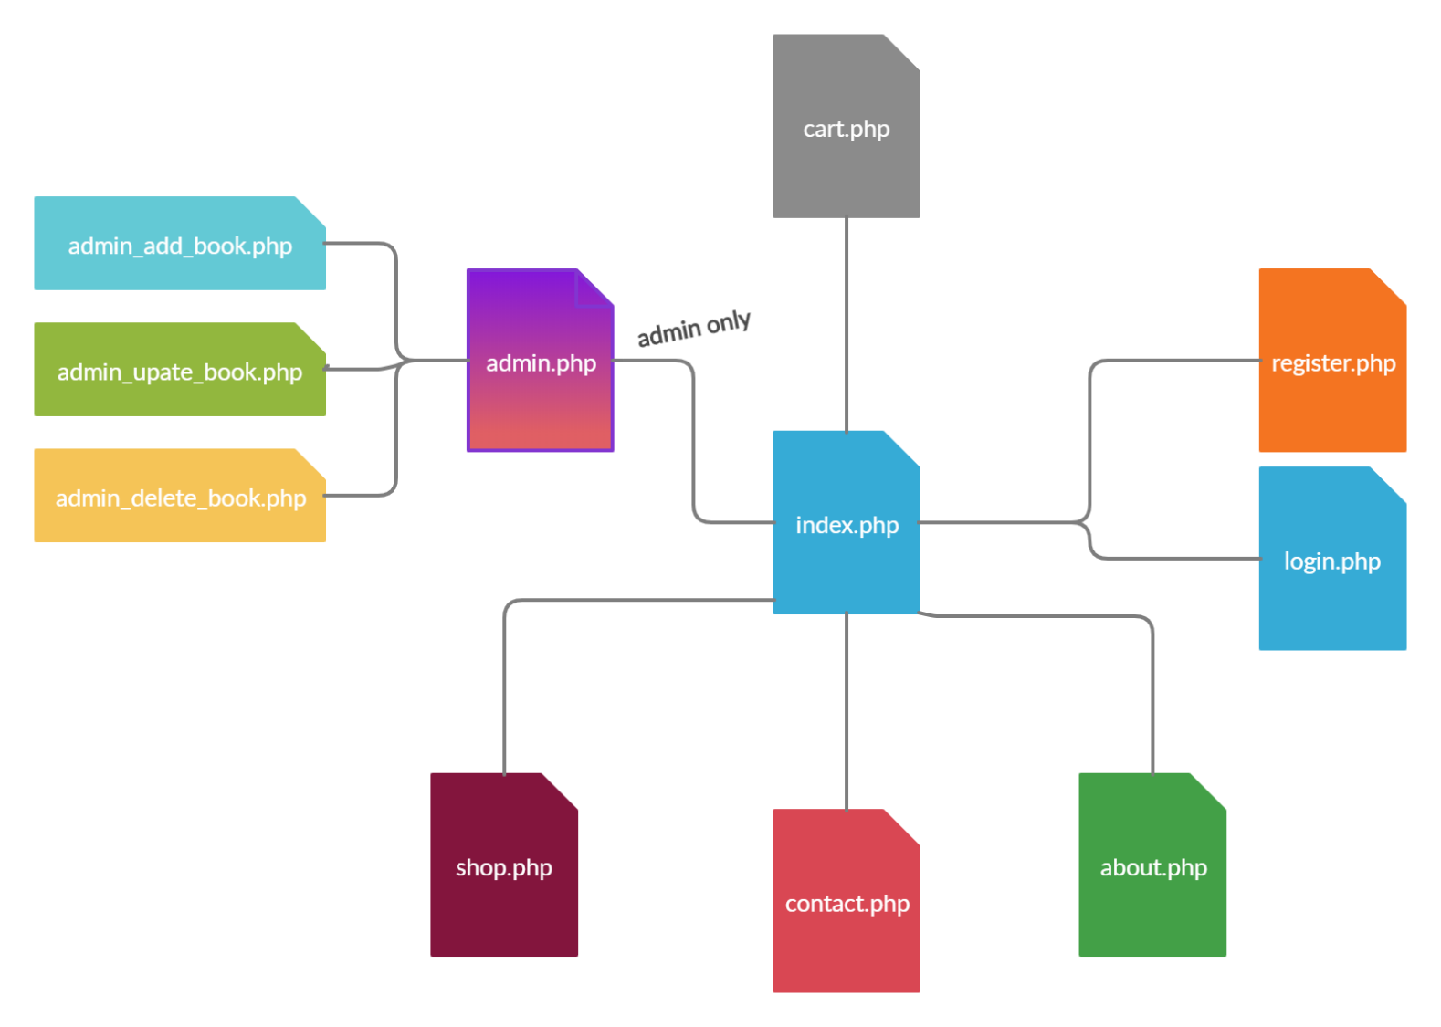

## **Mapa sajta**

<?xml version="1.0" encoding="UTF-8"?>

<urlset

      xmlns="http://www.sitemaps.org/schemas/sitemap/0.9"

      xmlns:xsi="http://www.w3.org/2001/XMLSchema-instance"

      xsi:schemaLocation="http://www.sitemaps.org/schemas/sitemap/0.9

            http://www.sitemaps.org/schemas/sitemap/0.9/sitemap.xsd">

<!-- created with Free Online Sitemap Generator www.xml-sitemaps.com -->

<url>

  <loc>https://worsening-helmet.000webhostapp.com</loc>

  <lastmod>2020-06-15</lastmod>

  <changefreq>daily</changefreq>

  <priority>1.00</priority>

</url>

<url>

  <loc>https://worsening-helmet.000webhostapp.com/index.php?page=1</loc>

  <lastmod>2020-06-15</lastmod>

  <changefreq>daily</changefreq>

  <priority>0.90</priority>

</url>

<url>

  <loc>https://worsening-helmet.000webhostapp.com/index.php?page=2</loc>

  <lastmod>2020-05-15</lastmod>

  <changefreq>monthly</changefreq>

  <priority>0.6</priority>

</url>

<url>

  <loc>https://worsening-helmet.000webhostapp.com/index.php?page=3</loc>

  <lastmod>2019-06-15</lastmod>

  <changefreq>daily</changefreq>

  <priority>0.50</priority>

</url>

<url>

  <loc>https://worsening-helmet.000webhostapp.com/index.php?page=4</loc>

  <lastmod>2020-06-08</lastmod>

  <changefreq>weekly</changefreq>

  <priority>0.80</priority>

</url>

<url>

  <loc>https://worsening-helmet.000webhostapp.com/index.php?page=5</loc>

  <lastmod>2020-06-08</lastmod>

  <changefreq>weekly</changefreq>

  <priority>0.80</priority>

</url>

<url>

  <loc>https://worsening-helmet.000webhostapp.com/index.php?page=6</loc>

  <lastmod>2020-05-08</lastmod>

  <changefreq>monthly</changefreq>

  <priority>0.70</priority>

</url>

<url>

  <loc>https://worsening-helmet.000webhostapp.com/index.php?page=7</loc>

  <lastmod>2020-05-08</lastmod>

  <changefreq>monthly</changefreq>

  <priority>0.70</priority>

</url>

<url>

  <loc>https://worsening-helmet.000webhostapp.com/index.php?page=8</loc>

  <lastmod>2020-05-08</lastmod>

  <changefreq>monthly</changefreq>

  <priority>0.70</priority>

</url>

<url>

  <loc>https://worsening-helmet.000webhostapp.com/index.php?page=9</loc>

  <lastmod>2020-05-08</lastmod>

  <changefreq>monthly</changefreq>

  <priority>0.70</priority>

</url>

<url>

  <loc>https://worsening-helmet.000webhostapp.com/index.php?page=10</loc>

  <lastmod>2020-06-08</lastmod>

  <changefreq>weekly</changefreq>

  <priority>0.80</priority>

</url>

</urlset>

## **Dizajn baze**

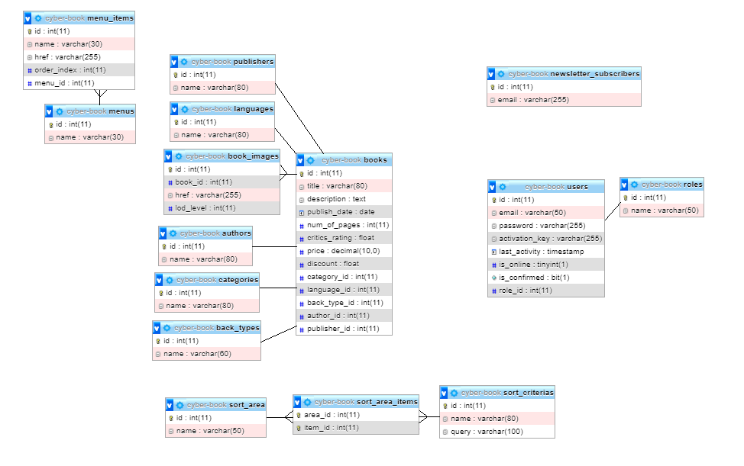

## **Struktura projekta**

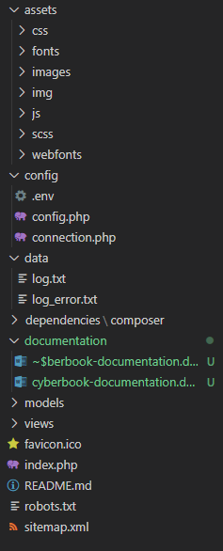

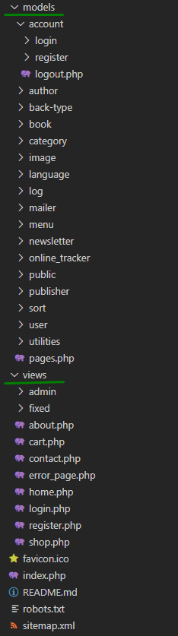

## **Opis stranica sajta**

### index.php

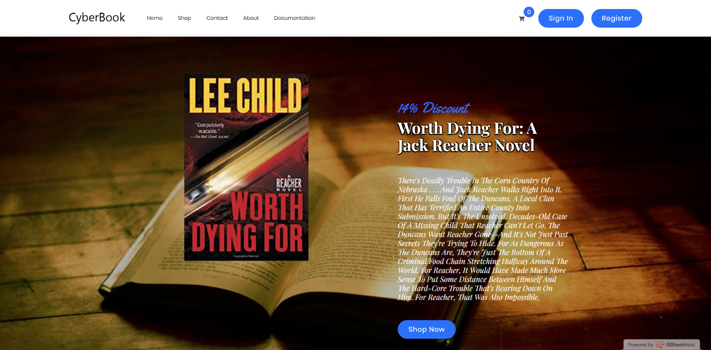

Na pocetnom delu indeks stranice nalazi se meni, dugmad za logovanje/registraciju, dugme za korpu, i uvodni deo za stranicu (sekcija sa slikom knjige).

Pri ucitavanju stranice bira se random knjiga od top 10 knjiga, sortirane po najvecem popustu u opadajucem redosledu.



Potom imamo sekciju sa kategorijama.

Pri ucitavanju stranice biraju se 3 random kategorije iz baze i prikazuju u sekciji.

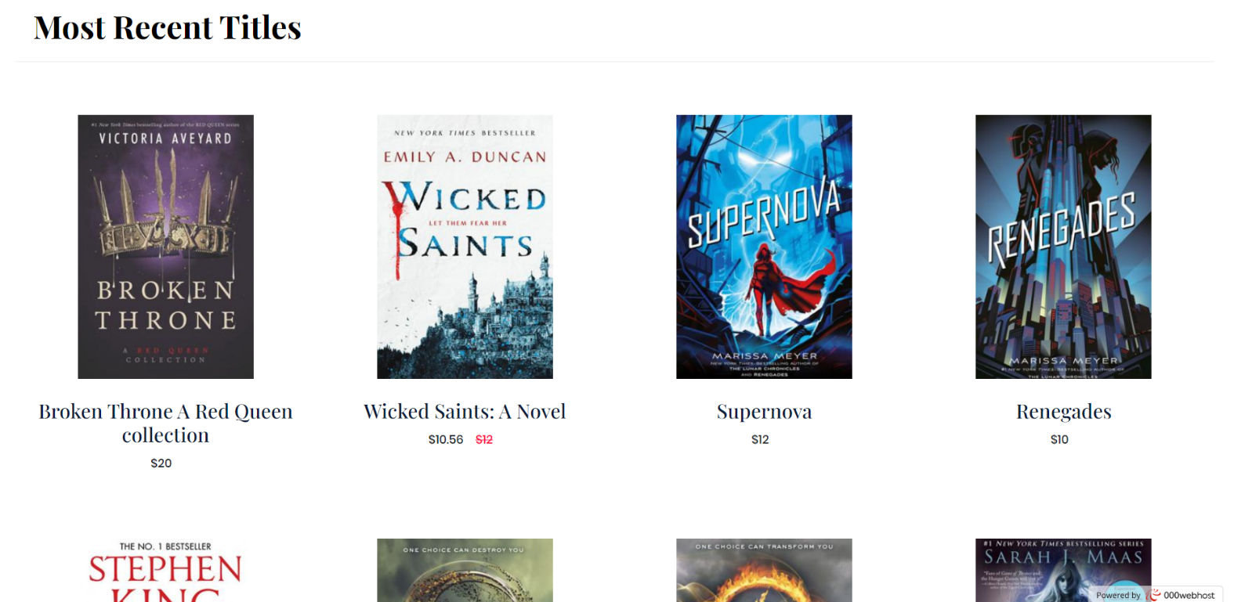

Zatim imamo sekciju sa najskorije dodatim knjigama.

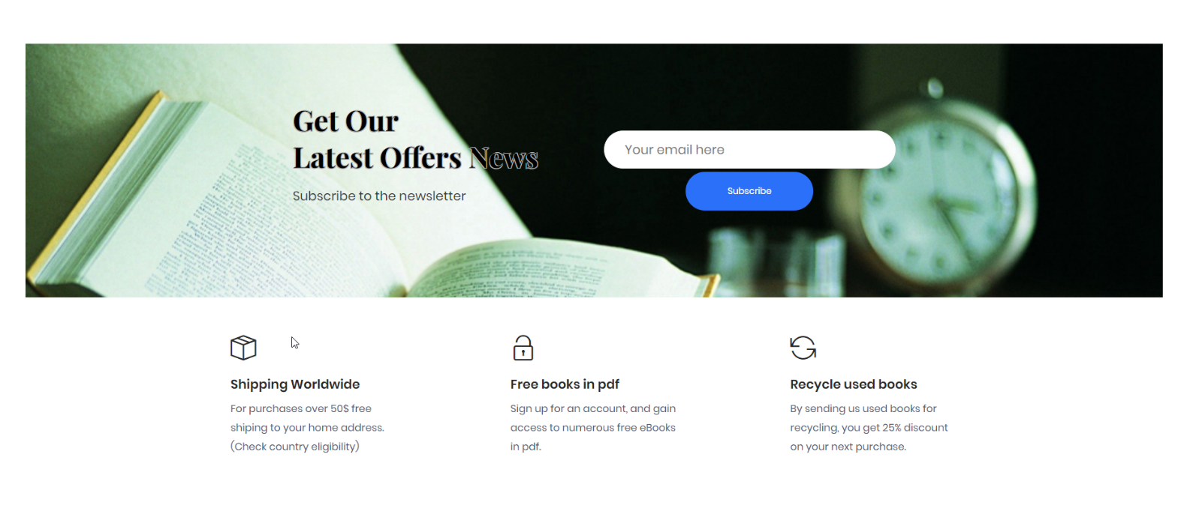

Ispod toga nalazi se deo za pretplatu na newsletter kao i staticki deo sa informacijama o sajtu.

Unosom email-a i klikom na »Subscribe«, ukoliko niste vec zabelezni u bazu kao pretplatnik, salje vam se mail o uspesnosti pretplate.

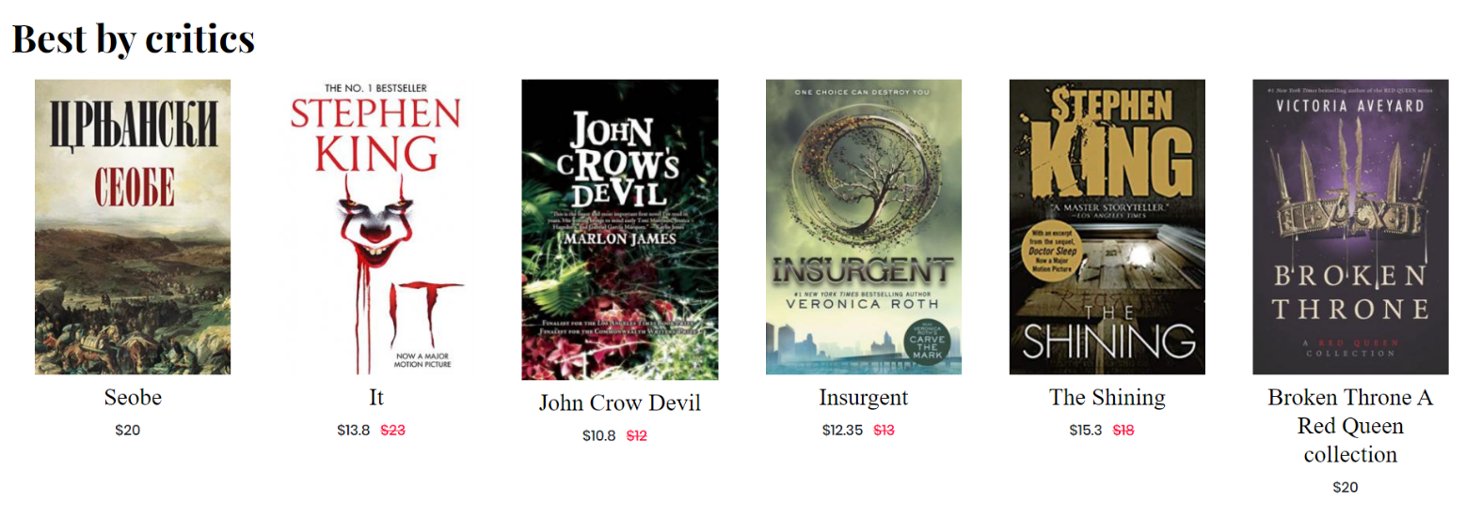

Posle ide sekcija za prikaz najbolje ocenjenih knjiga od strane kriticara.

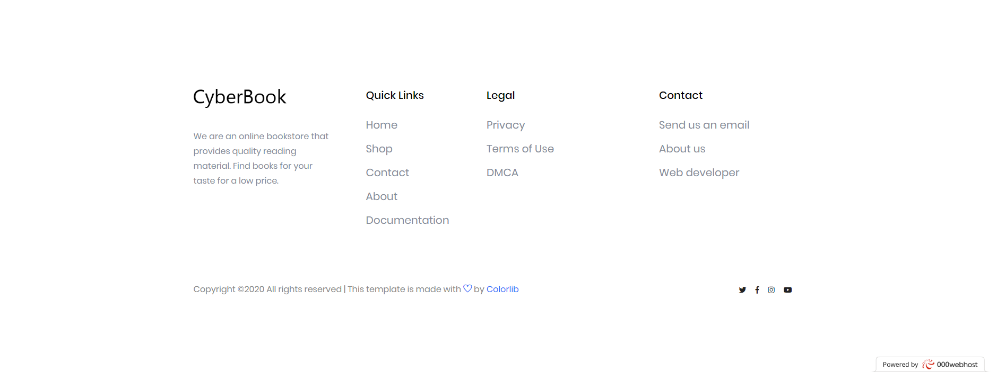

I na kraju futer sekcija.

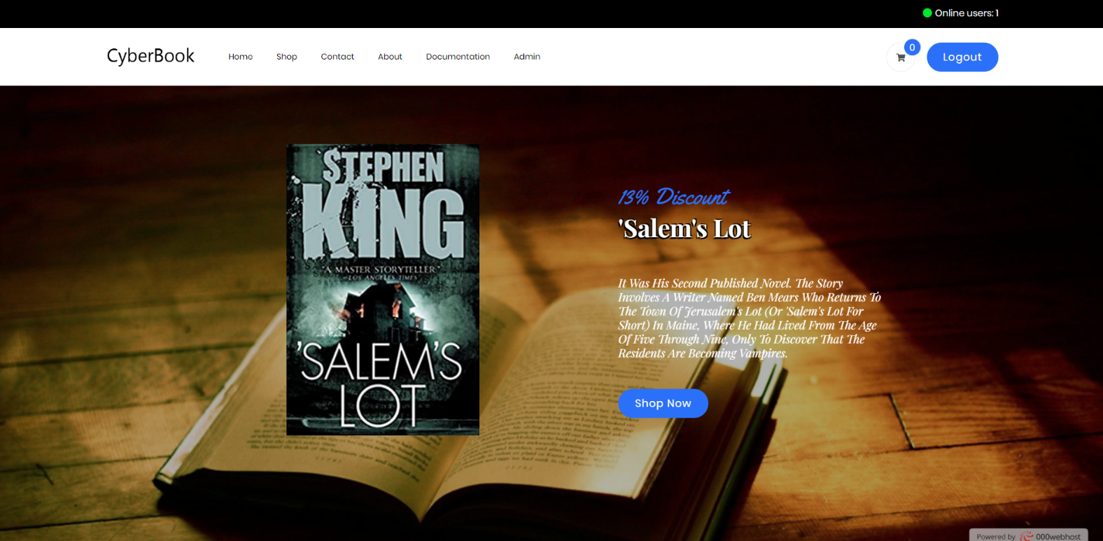

Izgled stranice index za ulogovane korisnike.

Ne-admin korisnici nemaju samo Admin link u meniju.

Na crnoj traci, krajnje gorem delu, nalazi se prikaz broja trenutno ulogovanih korisnika.

### shop.php



Pocetni deo shop-a.

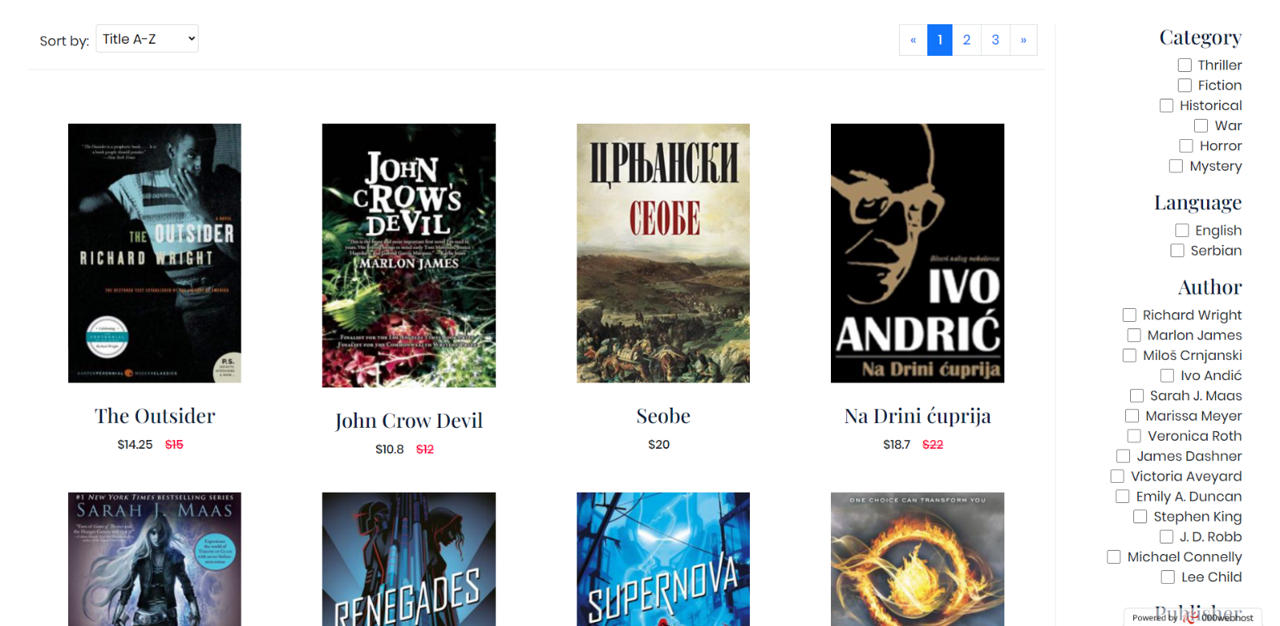

Shop sa kontrolama za sort, filter i paginaciju proizvoda.

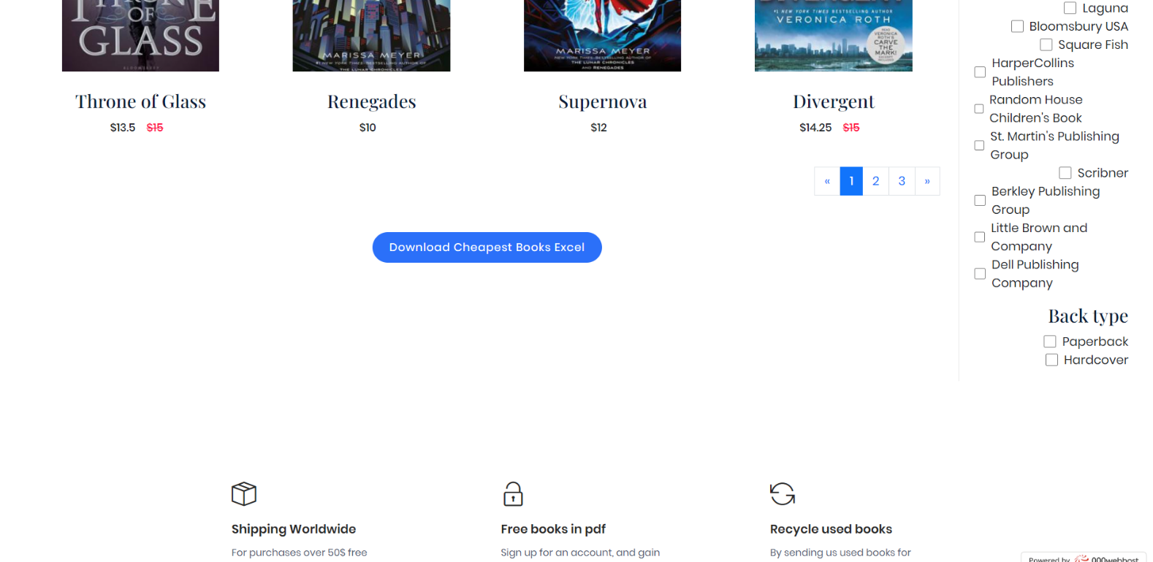

Dugme sa export najjeftinijh knjiga u formi excel dokumenta.

### contact.php

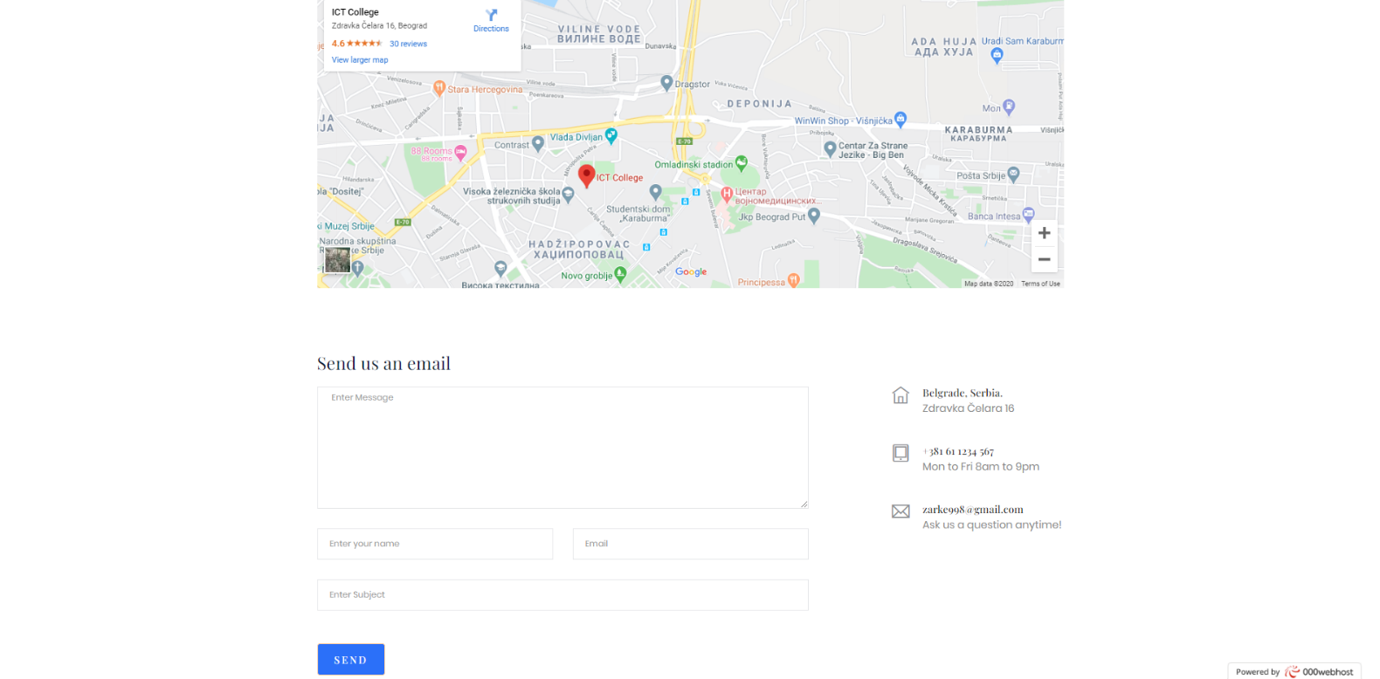

Kontakt forma sa poljima sa slanje poruke, kao i lokacija preduzeca.

### about.php

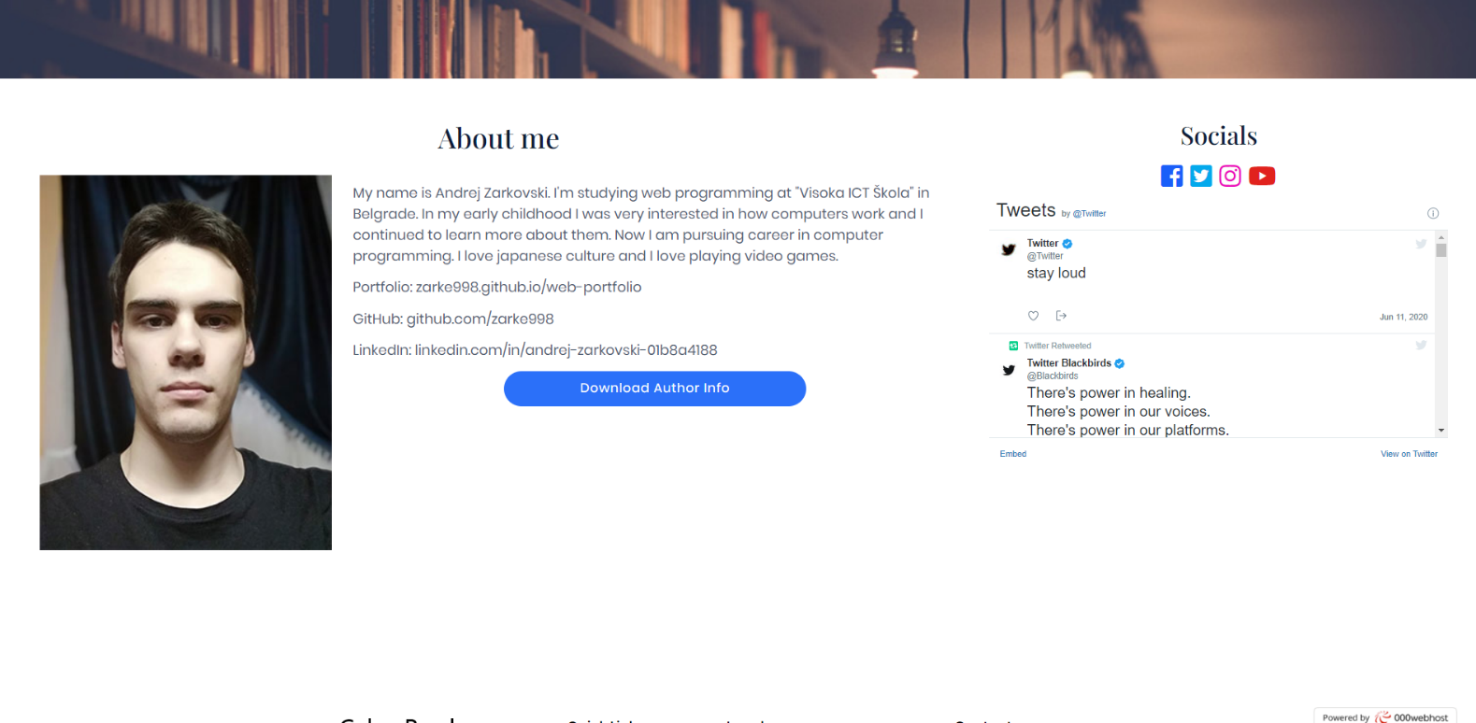

Stranica sa informacijama o autoru, dugmetu za export informacija u formi word dokumenta, kao i linkovi ka socijalnim mrezama i ugradjen twitter frame.

### cart.php

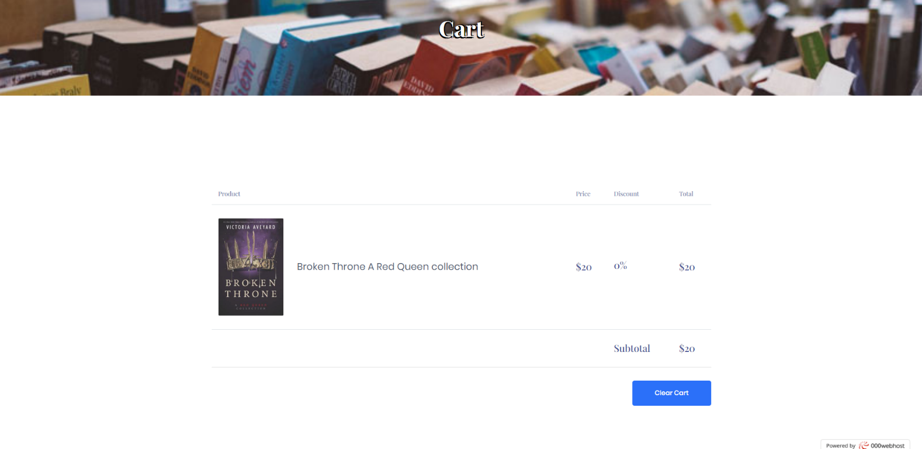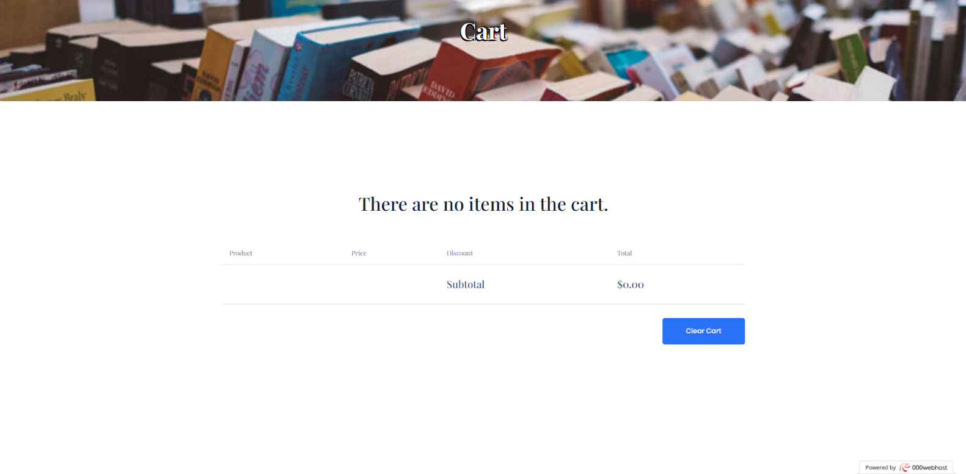

Izgled stranice korpe sa i bez proizvoda.

### login.php

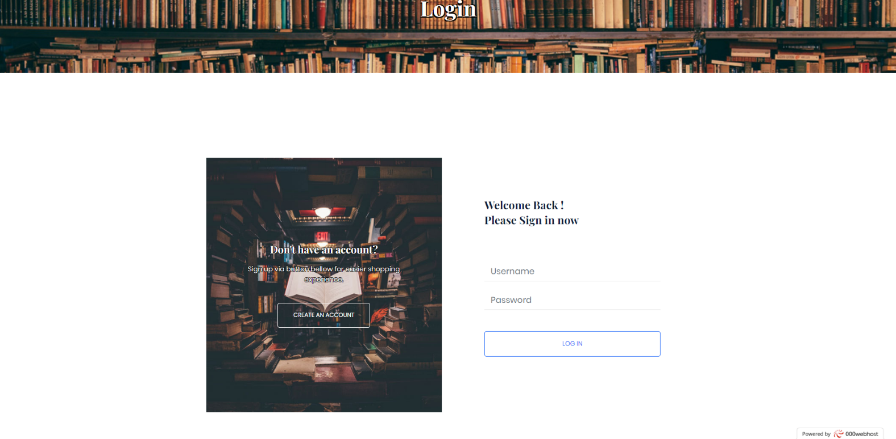

Izgled stranice za logovanje.

### register.php

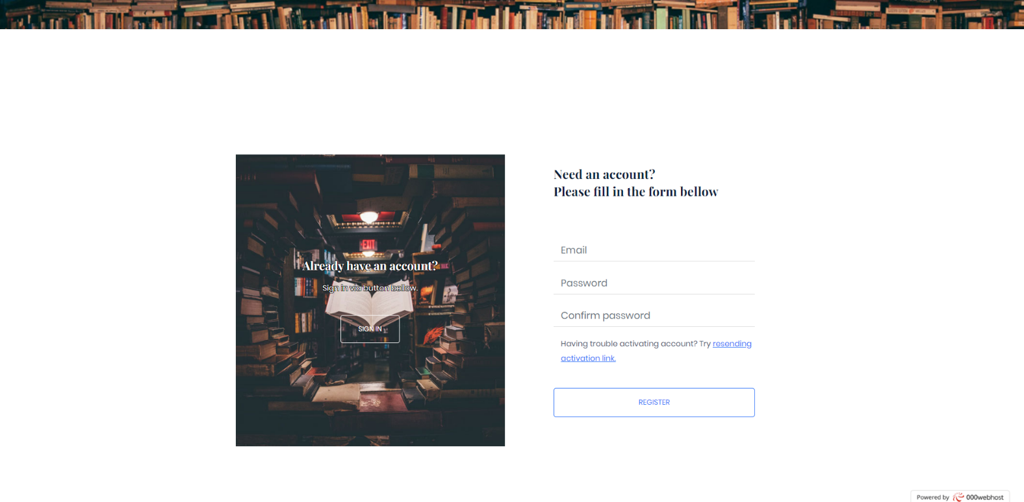

Izgled stranice za registraciju.

### admin.php

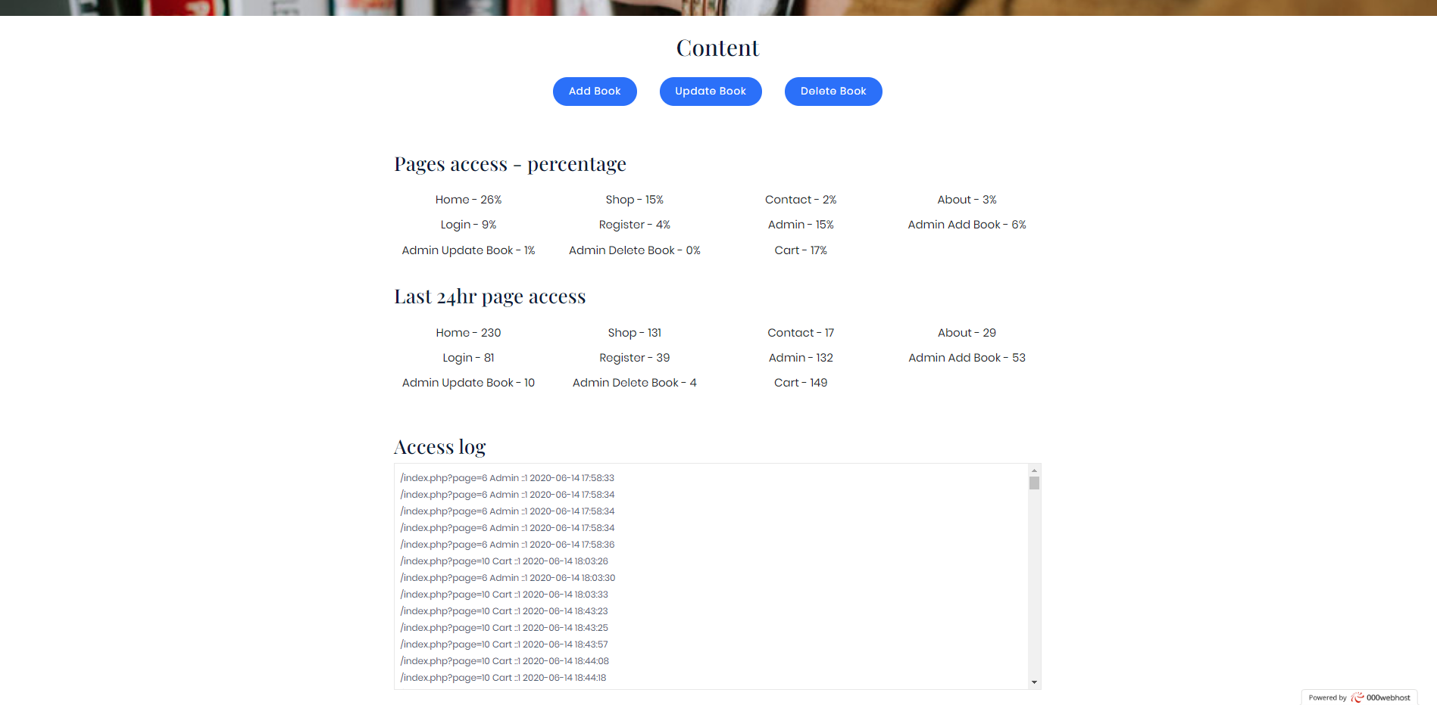

Izgled stranice admin panel-a.

Kod dela »Content« nalaze se dugmad za pristup stranicama za upravljanje sadrzajem knjiga.

Odmah ispod se nalazi sekcija sa prikazom broja pristupa stranicama u procentima, kao i broja pristupa stranicama u poslednja 24h.

A na kraju se nalazi prikaz celog log fajla.

### admin_add_book.php

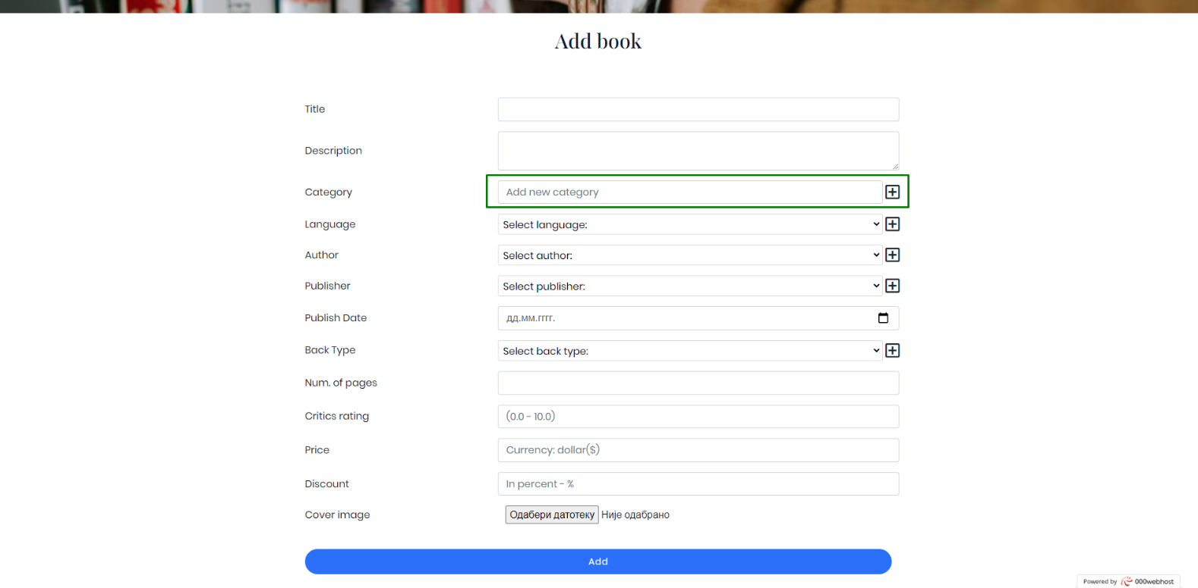

Stranica za dodavanje knjige u bazu sa poljima za informacije o knjizi.

Klikom na dugme »+«, dodaje se nova kategorija, jezik itd. i vezuju se za dodatu knjigu.

### admin_update_book.php

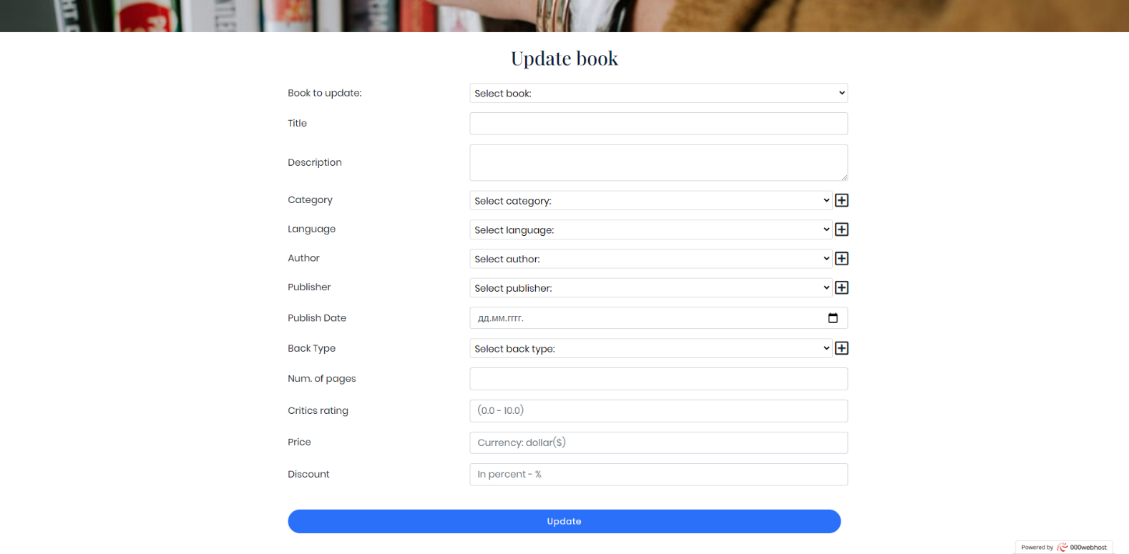

Stranica za azuriranje knjige.

Isti prinicp rada kao za dodavanje knjige.

### admin_delete_book.php

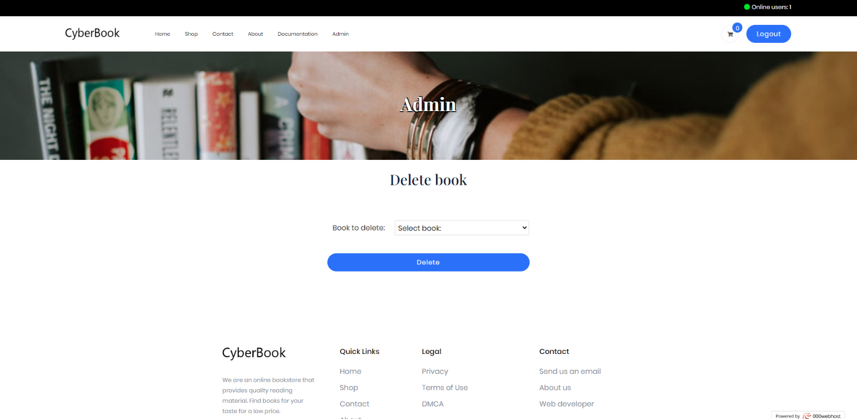

Stranica za brisanje knjige.

# 3. Kodovi

## PHP

### index.php

<?php

    if(session_status() == PHP_SESSION_NONE)

        session_start();

    ob_start();

    include "models/pages.php";

    require_once "models/online_tracker/udpate_user_activity.php";

    if(isset($_SESSION["user"])){

        update_user_activity($_SESSION["user"]->id);

    }

    $website_name = "CyberBook";

    $page_id = Pages::Home;

    $page_src;

    $page_title;

    $main_intro_slider = false;

    $scripts = ["/assets/js/cyber-book/main.js"];

    if(isset($_GET["page"]))

        $page_id = $_GET["page"];

    $admin_pages = [Pages::Admin, Pages::Admin_Add_Book, Pages::Admin_Update_Book, Pages::Admin_Delete_Book];

    switch($page_id){

        case Pages:: Home :

            $page_src = "views/home.php";

            $page_title = "Home";

            $main_intro_slider = true;

            $scripts[] = "/assets/js/cyber-book/home.js";

            break;

        case Pages::Shop :

            $page_src = "views/shop.php";

            $page_title = "Shop";

            $scripts[] = "/assets/js/cyber-book/shop.js";

            break;

        case Pages::Contact :

            $page_src = "views/contact.php";

            $page_title = "Contact";

            $scripts[] = "/assets/js/cyber-book/contact.js";

            break;

        case Pages::About :

            $page_src = "views/about.php";

            $page_title = "About";

            break;

        case Pages::Login :

            $page_src = "views/login.php";

            $page_title = "Login";

            $scripts[] = "/assets/js/cyber-book/login.js";

            break;

        case Pages::Register :

            $page_src = "views/register.php";

            $page_title = "Register";

            $scripts[] = "/assets/js/cyber-book/register.js";

            break;

        case Pages::Admin :

            $page_src = "views/admin/admin.php";

            $page_title = "Admin";

            break;

        case Pages::Admin_Add_Book :

            $page_src = "views/admin/admin_add_book.php";

            $page_title = "Admin";

            $scripts[] = "/assets/js/cyber-book/admin-content.js";

            break;

        case Pages::Admin_Update_Book :

            $page_src = "views/admin/admin_update_book.php";

            $page_title = "Admin";

            $scripts[] = "/assets/js/cyber-book/admin-content.js";

            break;

        case Pages::Admin_Delete_Book :

            $page_src = "views/admin/admin_delete_book.php";

            $page_title = "Admin";

            $scripts[] = "/assets/js/cyber-book/admin-content.js";

            break;

        case Pages::Cart :

            $page_src = "views/cart.php";

            $page_title = "Cart";

            $scripts[] = "/assets/js/cyber-book/cart.js";

            break;

        default : // 404

            $page_src = "views/error_page.php";

            $page_title = "Error";

            $error_title = "404 - Page not found.";

            $error_msg = "We are sorry, the page you are looking for doesn't exist.";

            break;

    }

    if(in_array($page_id, $admin_pages) and (!isset($_SESSION["user"]) or $_SESSION["user"]->role_id != 1)){

        $page_src = "views/error_page.php";

        $page_title = "Error";

        $error_title = "403 - Forbidden Access";

        $error_msg = "We are sorry, but this page is forbidden for non-admin users.";

    }

    include "views/fixed/head.php";

    echo getHead($website_name." | ".$page_title);

    include "views/fixed/header.php";

    if($main_intro_slider)

        include "views/fixed/main_intro_slider.php";

    else

    {

        include "views/fixed/main_intro.php";

        echo getMainIntro($page_title);

    }

    include $page_src;

    include "views/fixed/footer.php";

    echo getFooter($scripts);

    ob_end_flush();

?>

### Views

#### home.php

<?php

    if(!defined("ROOT"))

        define("ROOT",$_SERVER["DOCUMENT_ROOT"]);

        require_once ROOT."/models/pages.php";

?>

<main>

        <!-- Category Area Start-->

        <section class="category-area section-padding30">

            <div class="container-fluid">

                <!-- Section Tittle -->

                <div class="row">

                    <div class="col-lg-12">

                        <div class="section-tittle text-center mb-85">

                            <h2>Shop by Category</h2>

                        </div>

                    </div>

                </div>

                <div id="main-shop-categories" class="row justify-content-center">

                    <?php

                        require_once ROOT."/models/category/get_rand_categories.php";

                        require_once ROOT."/models/utilities/shuffled_number_array.php";

                        $categories_rand = get_rand_categories(3);

                        $array_rand = generate_shuffled_number_array(3);

                        for($i = 0; $i < 3; $i++): ?>

                            <div class="col-xl-4 col-lg-6">

                                <div class="single-category mb-30">

                                    <div class="category-img category-random" data-id="<?=$categories_rand[$array_rand[$i]]->id?>">

                                        <a href="index.php?page=<?=Pages::Shop?>">

                                            <img src="/assets/images/category-wallpapers/wallpaper-<?=$array_rand[$i] + 1?>.jpg" alt="Category wallpaper">

                                            <div class="category-caption">

                                                <h2 class="text-stroke-black-1 mr-3"><?=$categories_rand[$array_rand[$i]]->name?></h2>

                                            </div>

                                        </a>

                                    </div>

                                </div>

                            </div>

                        <?php endfor; ?>

                </div>

            </div>

        </section>

        <!-- Category Area End-->

        <!-- Latest Products Start -->

        <section class="latest-product-area pb-3">

            <div class="container-fluid px-4 px-md-5">

                <div class="row product-btn d-flex align-items-end">

                    <!-- Section Tittle -->

                    <div class="col-12">

                        <div class="section-tittle mb-30">

                            <h2>Most Recent Titles</h2>

                        </div>

                    </div>

                </div>

                <!-- Nav Card -->

                <div class="tab-content" id="nav-tabContent">

                    <!-- card one -->

                    <div class="most-popular-titles tab-pane fade show active" id="nav-home" role="tabpanel" aria-labelledby="nav-home-tab">

                        <div id="most-recent-titles" class="row justify-content-center">

                        </div>

                    </div>

                </div>

                <!-- End Nav Card -->

            </div>

        </section>

        <!-- Latest Products End -->

        <!-- Latest Offers Start -->

        <div class="latest-wrapper lf-padding">

            <div id="newsletter-area" class="latest-area latest-height d-flex align-items-center">

                <div class="container">

                    <div class="row d-flex align-items-center">

                        <div class="col-xl-5 col-lg-5 col-md-6 offset-xl-1 offset-lg-1">

                            <div class="latest-caption">

                                <h2 class="text-stroke-white-1">Get Our<br>Latest Offers News</h2>

                                <p>Subscribe to the newsletter</p>

                            </div>

                        </div>

                         <div class="col-xl-5 col-lg-5 col-md-6 ">

                            <div class="latest-subscribe">

                                <form id="newsletterControls" action="#">

                                    <input id="newsletterEmail" type="email" placeholder="Your email here">

                                    <button id="newsletterBtn">Subscribe</button>

                                </form>

                            </div>

                        </div>

                    </div>

                </div>

            </div>

        </div>

        <!-- Latest Offers End -->

        <?php

            include ROOT."/views/fixed/bullet_points.php";

        ?>

        <!-- Gallery Start-->

        <div id="best-by-critics">

            <div class="section-tittle mb-30 ml-4">

                <h2>Best by critics</h2>

            </div>

            <div id="bestByCriticsContainer" class="row mx-0 px-4 justify-content-center latest-product-area">

                <div class="col-lg-2 col-sm-4 col-6 px-4 px-lg-2 mb-4 best-by-critics-item text-center">

                    <img src="assets/images/book-cover-1.jpg" alt="">

                    <a href="#">Green Dress with details</a>

                </div>

                <div class="col-lg-2 col-sm-4 col-6 px-4 px-lg-2 mb-4 best-by-critics-item">

                    <img src="assets/images/book-cover-1.jpg" alt="">

                </div>

                <div class="col-lg-2 col-sm-4 col-6 px-4 px-lg-2 mb-4 best-by-critics-item">

                    <img src="assets/images/book-cover-1.jpg" alt="">

                </div>

                <div class="col-lg-2 col-sm-4 col-6 px-4 px-lg-2 mb-4 best-by-critics-item">

                    <img src="assets/images/book-cover-1.jpg" alt="">

                </div>

                <div class="col-lg-2 col-sm-4 col-6 px-4 px-lg-2 mb-4 best-by-critics-item">

                    <img src="assets/images/book-cover-1.jpg" alt="">

                </div>

                <div class="col-lg-2 col-sm-4 col-6 px-4 px-lg-2 mb-4 best-by-critics-item">

                    <img src="assets/images/book-cover-1.jpg" alt="">

                </div>

            </div>

        </div>

        <!-- Gallery End-->

    </main>

#### shop.php

<?php

    if(!defined("ROOT"))

        define("ROOT", $_SERVER["DOCUMENT_ROOT"]);

    require_once ROOT."/models/sort/get_criterias_by_area.php";

    require_once ROOT."/models/category/get_all.php";

    require_once ROOT."/models/language/get_all.php";

    require_once ROOT."/models/author/get_all.php";

    require_once ROOT."/models/publisher/get_all.php";

    require_once ROOT."/models/back-type/get_all.php";

?>

<div id="shop-main">

<section class="latest-product-area latest-padding">

    <div class="row px-4 mx-0">

        <div class="col-12 col-md-9 col-xl-10 order-2 order-md-1">

            <div class="container-fluid">

                <div id="shop-upper-controls" class="row product-btn d-flex justify-content-center justify-content-sm-between ">

                    <div class="select-this d-flex align-items-center mr-2 mb-3">

                        <div class="featured">

                            <span>Sort by: </span>

                        </div>

                        <form action="#">

                            <div class="select-itms ml-2">

                                <select name="select" id="sort-select">

                                    <?php

                                        $sort_criterias = get_criterias_by_area("shop_sort");

                                        foreach($sort_criterias as $crit) : ?>

                                            <option value="<?= $crit->sort_id ?>"><?= $crit->sort_name ?></option>

                                    <?php endforeach; ?>

                                </select>

                            </div>

                        </form>

                    </div>

                    <nav aria-label="Pagination ml-2 mb-3">

                        <ul class="pagination">

                            <li class="page-item">

                                <a class="page-link page-link-arrow" href="#" data-increment="-1" aria-label="Previous">

                                    <span aria-hidden="true">&laquo;</span>

                                    <span class="sr-only">Previous</span>

                                </a>

                            </li>

                            <div class="pagination-pages d-flex">

                            </div>

                            <li class="page-item">

                                <a class="page-link page-link-arrow" href="#" data-increment="1" aria-label="Next">

                                    <span aria-hidden="true">&raquo;</span>

                                    <span class="sr-only">Next</span>

                                </a>

                            </li>

                        </ul>

                    </nav>

                </div>

                <!-- Nav Card -->

                <div class="tab-content" id="nav-tabContent">

                    <!-- card one -->

                    <div class="tab-pane fade show active" id="nav-home" role="tabpanel" aria-labelledby="nav-home-tab">

                        <div id="shop-container" class="row justify-content-center">

                            <div class="col-lg-3 col-sm-4 col-6">

                                <div class="single-product mb-60">

                                    <div class="product-img">

                                        <img src="assets/images/book-cover-1.jpg" alt="">

                                    </div>

                                    <div class="product-caption">

                                        <div class="product-ratting">

                                            <i class="far fa-star"></i>

                                            <i class="far fa-star"></i>

                                            <i class="far fa-star"></i>

                                            <i class="far fa-star low-star"></i>

                                            <i class="far fa-star low-star"></i>

                                        </div>

                                        <h4><a href="#">Green Dress with details</a></h4>

                                        <div class="price">

                                            <ul>

                                                <li>$40.00</li>

                                                <li class="discount">$60.00</li>

                                            </ul>

                                        </div>

                                    </div>

                                </div>

                            </div>

                            <div class="col-lg-3 col-sm-4 col-6">

                                <div class="single-product mb-60">

                                    <div class="product-img">

                                        <img src="assets/images/book-cover-1.jpg" alt="">

                                    </div>

                                    <div class="product-caption">

                                        <div class="product-ratting">

                                            <i class="far fa-star"></i>

                                            <i class="far fa-star"></i>

                                            <i class="far fa-star"></i>

                                            <i class="far fa-star low-star"></i>

                                            <i class="far fa-star low-star"></i>

                                        </div>

                                        <h4><a href="#">Green Dress with details</a></h4>

                                        <div class="price">

                                            <ul>

                                                <li>$40.00</li>

                                                <li class="discount">$60.00</li>

                                            </ul>

                                        </div>

                                    </div>

                                </div>

                            </div>

                            <div class="col-lg-3 col-sm-4 col-6">

                                <div class="single-product mb-60">

                                    <div class="product-img">

                                        <img src="assets/images/book-cover-1.jpg" alt="">

                                    </div>

                                    <div class="product-caption">

                                        <div class="product-ratting">

                                            <i class="far fa-star"></i>

                                            <i class="far fa-star"></i>

                                            <i class="far fa-star"></i>

                                            <i class="far fa-star low-star"></i>

                                            <i class="far fa-star low-star"></i>

                                        </div>

                                        <h4><a href="#">Green Dress with details</a></h4>

                                        <div class="price">

                                            <ul>

                                                <li>$40.00</li>

                                                <li class="discount">$60.00</li>

                                            </ul>

                                        </div>

                                    </div>

                                </div>

                            </div>

                            <div class="col-lg-3 col-sm-4 col-6">

                                <div class="single-product mb-60">

                                    <div class="product-img">

                                        <img src="assets/images/book-cover-1.jpg" alt="">

                                    </div>

                                    <div class="product-caption">

                                        <div class="product-ratting">

                                            <i class="far fa-star"></i>

                                            <i class="far fa-star"></i>

                                            <i class="far fa-star"></i>

                                            <i class="far fa-star low-star"></i>

                                            <i class="far fa-star low-star"></i>

                                        </div>

                                        <h4><a href="#">Green Dress with details</a></h4>

                                        <div class="price">

                                            <ul>

                                                <li>$40.00</li>

                                                <li class="discount">$60.00</li>

                                            </ul>

                                        </div>

                                    </div>

                                </div>

                            </div>

                            <div class="col-lg-3 col-sm-4 col-6">

                                <div class="single-product mb-60">

                                    <div class="product-img">

                                        <img src="assets/images/book-cover-1.jpg" alt="">

                                    </div>

                                    <div class="product-caption">

                                        <div class="product-ratting">

                                            <i class="far fa-star"></i>

                                            <i class="far fa-star"></i>

                                            <i class="far fa-star"></i>

                                            <i class="far fa-star low-star"></i>

                                            <i class="far fa-star low-star"></i>

                                        </div>

                                        <h4><a href="#">Green Dress with details</a></h4>

                                        <div class="price">

                                            <ul>

                                                <li>$40.00</li>

                                                <li class="discount">$60.00</li>

                                            </ul>

                                        </div>

                                    </div>

                                </div>

                            </div>

                            <div class="col-lg-3 col-sm-4 col-6">

                                <div class="single-product mb-60">

                                    <div class="product-img">

                                        <img src="assets/images/book-cover-1.jpg" alt="">

                                    </div>

                                    <div class="product-caption">

                                        <div class="product-ratting">

                                            <i class="far fa-star"></i>

                                            <i class="far fa-star"></i>

                                            <i class="far fa-star"></i>

                                            <i class="far fa-star low-star"></i>

                                            <i class="far fa-star low-star"></i>

                                        </div>

                                        <h4><a href="#">Green Dress with details</a></h4>

                                        <div class="price">

                                            <ul>

                                                <li>$40.00</li>

                                                <li class="discount">$60.00</li>

                                            </ul>

                                        </div>

                                    </div>

                                </div>

                            </div>

                            <div class="col-lg-3 col-sm-4 col-6">

                                <div class="single-product mb-60">

                                    <div class="product-img">

                                        <img src="assets/images/book-cover-1.jpg" alt="">

                                    </div>

                                    <div class="product-caption">

                                        <div class="product-ratting">

                                            <i class="far fa-star"></i>

                                            <i class="far fa-star"></i>

                                            <i class="far fa-star"></i>

                                            <i class="far fa-star low-star"></i>

                                            <i class="far fa-star low-star"></i>

                                        </div>

                                        <h4><a href="#">Green Dress with details</a></h4>

                                        <div class="price">

                                            <ul>

                                                <li>$40.00</li>

                                                <li class="discount">$60.00</li>

                                            </ul>

                                        </div>

                                    </div>

                                </div>

                            </div>

                            <div class="col-lg-3 col-sm-4 col-6">

                                <div class="single-product mb-60">

                                    <div class="product-img">

                                        <img src="assets/images/book-cover-1.jpg" alt="">

                                    </div>

                                    <div class="product-caption">

                                        <div class="product-ratting">

                                            <i class="far fa-star"></i>

                                            <i class="far fa-star"></i>

                                            <i class="far fa-star"></i>

                                            <i class="far fa-star low-star"></i>

                                            <i class="far fa-star low-star"></i>

                                        </div>

                                        <h4><a href="#">Green Dress with details</a></h4>

                                        <div class="price">

                                            <ul>

                                                <li>$40.00</li>

                                                <li class="discount">$60.00</li>

                                            </ul>

                                        </div>

                                    </div>

                                </div>

                            </div>

                        </div>

                    </div>

                </div>

                <div class="d-flex justify-content-center justify-content-md-end">

                    <nav aria-label="Pagination">

                        <ul class="pagination">

                            <li class="page-item">

                                <a class="page-link page-link-arrow" href="#" data-increment="-1" aria-label="Previous">

                                    <span aria-hidden="true">&laquo;</span>

                                    <span class="sr-only">Previous</span>

                                </a>

                            </li>

                            <div class="pagination-pages d-flex">

                            </div>

                            <li class="page-item">

                                <a class="page-link page-link-arrow" href="#" data-increment="1" aria-label="Next">

                                    <span aria-hidden="true">&raquo;</span>

                                    <span class="sr-only">Next</span>

                                </a>

                            </li>

                        </ul>

                    </nav>

                </div>

                <div class="d-flex justify-content-center">

                    <a id="export-books-btn" href="models/public/books_cheapest_excel_export.php" class="btn header-btn d-inline-block mx-auto mt-5 mb-5">Download cheapest books excel</a>

                </div>

                <!-- End Nav Card -->

            </div>

        </div>

        <div class="col-12 col-md-3 order-1 order-md-2 col-xl-2 pr-4 shop-filters mb-4">

            <div class="shop-filter">

                <h4 class="text-left text-md-right">Category</h4>

                <ul class="d-flex flex-row flex-wrap flex-md-column align-items-end">

                    <?php

                        $categories = get_all_categories();

                        foreach($categories as $c) : ?>

                            <li class="d-flex align-items-center ml-2">

                                <input type="checkbox" class="shop-category mr-2" name="shop-categories[]" value="<?= $c->id ?>" />

                                <span><?= $c->name ?></span>

                            </li>

                    <?php endforeach; ?>

                </ul>

            </div>

            <div class="shop-filter">

                <h4 class="text-left text-md-right">Language</h4>

                <ul class="d-flex flex-row flex-wrap flex-md-column align-items-end">

                    <?php

                        $languages = get_all_languages();

                        foreach($languages as $l) : ?>

                            <li class="d-flex align-items-center ml-2">

                                <input type="checkbox" class="shop-category mr-2" name="shop-languages[]" value="<?= $l->id ?>" />

                                <span><?= $l->name ?></span>

                            </li>

                    <?php endforeach; ?>

                </ul>

            </div>

            <div class="shop-filter">

                <h4 class="text-left text-md-right">Author</h4>

                <ul class="d-flex flex-row flex-wrap flex-md-column align-items-end">

                    <?php

                        $authors = get_all_authors();

                        foreach($authors as $a) : ?>

                            <li class="d-flex align-items-center ml-2">

                                <input type="checkbox" class="shop-category mr-2" name="shop-authors[]" value="<?= $a->id ?>" />

                                <span><?= $a->name ?></span>

                            </li>

                    <?php endforeach; ?>

                </ul>

            </div>

            <div class="shop-filter">

                <h4 class="text-left text-md-right">Publisher</h4>

                <ul class="d-flex flex-row flex-wrap flex-md-column align-items-end">

                    <?php

                        $publishers = get_all_publishers();

                        foreach($publishers as $p) : ?>

                            <li class="d-flex align-items-center ml-2">

                                <input type="checkbox" class="shop-category mr-2" name="shop-publishers[]" value="<?= $p->id ?>" />

                                <span><?= $p->name ?></span>

                            </li>

                    <?php endforeach; ?>

                </ul>

            </div>

            <div class="shop-filter">

                <h4 class="text-left text-md-right">Back type</h4>

                <ul class="d-flex flex-row flex-wrap flex-md-column align-items-end">

                    <?php

                        $back_types = get_all_back_types();

                        foreach($back_types as $bt) : ?>

                            <li class="d-flex align-items-center ml-2">

                                <input type="checkbox" class="shop-category mr-2" name="shop-back-types[]" value="<?= $bt->id ?>" />

                                <span><?= $bt->name ?></span>

                            </li>

                    <?php endforeach; ?>

                </ul>

            </div>

        </div>

    </div>

</section>

<?php

    include ROOT."/views/fixed/bullet_points.php";

?>

</div>

#### contact.php

<section class="contact-section">

    <div class="container">

        <div id="google-maps-contact" class="d-none d-sm-block mb-5 pb-4">

            <iframe src="https://www.google.com/maps/embed?pb=!1m18!1m12!1m3!1d2830.3553901537102!2d20.482367231596694!3d44.81432404626031!2m3!1f0!2f0!3f0!3m2!1i1024!2i768!4f13.1!3m3!1m2!1s0x475a7a9609031735%3A0xc17ed71f59ac4725!2sICT%20College!5e0!3m2!1sen!2srs!4v1591432939074!5m2!1sen!2srs" width="600" height="450" frameborder="0" style="border:0;" allowfullscreen="" aria-hidden="false" tabindex="0"></iframe>

        </div>

        <div class="row">

            <div class="col-12">

                <h2 id="contact-title" class="contact-title">Send us an email</h2>

            </div>

            <div class="col-lg-8">

                <form class="form-contact contact_form" action="contact_process.php" method="post" id="contactForm">

                    <div class="row">

                        <div class="col-12">

                            <div class="form-group">

                                <textarea class="form-control w-100" name="contactMessage" id="message" cols="30" rows="9" onfocus="this.placeholder = ''" onblur="this.placeholder = 'Enter Message'" placeholder=" Enter Message"></textarea>

                            </div>

                        </div>

                        <div class="col-sm-6">

                            <div class="form-group">

                                <input class="form-control valid" name="contactName" id="name" type="text" onfocus="this.placeholder = ''" onblur="this.placeholder = 'Enter your name'" placeholder="Enter your name">

                            </div>

                        </div>

                        <div class="col-sm-6">

                            <div class="form-group">

                                <input class="form-control valid" name="contactEmail" id="email" type="email" onfocus="this.placeholder = ''" onblur="this.placeholder = 'Enter email address'" placeholder="Email">

                            </div>

                        </div>

                        <div class="col-12">

                            <div class="form-group">

                                <input class="form-control" name="contactSubject" id="subject" type="text" onfocus="this.placeholder = ''" onblur="this.placeholder = 'Enter Subject'" placeholder="Enter Subject">

                            </div>

                        </div>

                    </div>

                    <div class="form-group mt-3">

                        <button id="contactBtn" type="button" class="button button-contactForm boxed-btn">Send</button>

                    </div>

                </form>

            </div>

            <div class="col-lg-3 offset-lg-1">

                <div class="media contact-info">

                    <span class="contact-info__icon"><i class="ti-home"></i></span>

                    <div class="media-body">

                        <h3>Belgrade, Serbia.</h3>

                        <p>Zdravka Čelara 16</p>

                    </div>

                </div>

                <div class="media contact-info">

                    <span class="contact-info__icon"><i class="ti-tablet"></i></span>

                    <div class="media-body">

                        <h3>+381 61 1234 567</h3>

                        <p>Mon to Fri 8am to 9pm</p>

                    </div>

                </div>

                <div class="media contact-info">

                    <span class="contact-info__icon"><i class="ti-email"></i></span>

                    <div class="media-body">

                        <h3>zarke998@gmail.com</h3>

                        <p>Ask us a question anytime!</p>

                    </div>

                </div>

            </div>

        </div>

    </div>

</section>

#### about.php

<div id="about-main" class="container-fluid px-4 my-5">

    <div class="row mx-0">

        <div class="col-sm-12 offset-sm-0 offset-md-0 col-md-8">

            <div class="row mx-0">

                <div class="col-12 text-center mb-3">

                    <h2>About me</h2>

                </div>

                <div class="col-8 offset-2 col-sm-6 offset-sm-3 offset-md-0 col-md-4 mb-4">

                    <img src="/assets/images/profile.jpg" alt="Profile image" class="w-100">

                </div>

                <div id="about-info" class="col-12 col-md-8">

                    <p>My name is Andrej Zarkovski. I'm studying web programming at "Visoka ICT Škola" in Belgrade. In my early childhood I was very interested in how computers work and I continued to learn more about them. Now I am pursuing career in computer programming. I love japanese culture and I love playing video games.</p>

                    <div id="about-info-links">

                        <p>Portfolio: <a href="https://zarke998.github.io/web-portfolio" target="_blank">zarke998.github.io/web-portfolio</a></p>

                        <p>GitHub: <a href="https://github.com/zarke998" target="_blank">github.com/zarke998</a></p>

                        <p>LinkedIn: <a href="https://www.linkedin.com/in/andrej-zarkovski-01b8a4188" target="_blank">linkedin.com/in/andrej-zarkovski-01b8a4188</a></p>

                    </div>

                    <a id="author-word-btn" href="models/public/author_info_word.php" class="btn header-btn mx-auto d-block w-50 mb-5">Download Author info</a>

                </div>

            </div>

        </div>

        <div class="col-12 col-md-4">

            <div id="about-socials mb-5">

                <h3 class="text-center mb-3">Socials</h3>

                <div id="about-socials-links" class="d-flex justify-content-center">

                    <a href="https://facebook.com" target="_blank"><i class="fab fa-facebook-square"></i></a>

                    <a href="https://twitter.com" target="_blank"><i class="fab fa-twitter-square"></i></a>

                    <a href="https://instagram.com" target="_blank"><i class="fab fa-instagram"></i></a>

                    <a href="https://youtube.com" target="_blank"><i class="fab fa-youtube"></i></a>

                </div>

            </div>

            <div id="about-twitter-embed">

                <a class="twitter-timeline" data-height="400" href="https://twitter.com/Twitter?ref_src=twsrc%5Etfw">Tweets by Twitter</a> <script async src="https://platform.twitter.com/widgets.js" charset="utf-8"></script>

            </div>

        </div>

    </div>

</div>

#### cart.php

<section class="cart_area section_padding">

    <div class="container">

      <h2 id="cart-info" class="text-center mb-5">There are no items in the cart.</h2>

      <div class="cart_inner">

        <div class="table-responsive">

          <table class="table">

            <thead>

              <tr>

                <th scope="col">Product</th>

                <th scope="col">Price</th>

                <th scope="col">Discount</th>

                <th scope="col">Total</th>

              </tr>

            </thead>

            <tbody>

              <tr id="cart-subtotal">

                <td></td>

                <td></td>

                <td>

                  <h5>Subtotal</h5>

                </td>

                <td>

                  <h5 id="cart-subtotal-price">$0.00</h5>

                </td>

              </tr>

            </tbody>

          </table>

          <div class="checkout_btn_inner float-right">

            <a id="clear-cart-btn"class="btn_1" href="#">Clear cart</a>

          </div>

        </div>

      </div>

  </section>

#### login.php

<?php

    if(session_status() == PHP_SESSION_NONE)

        session_start();

    if(!defined("ROOT"))

        define("ROOT",$_SERVER["DOCUMENT_ROOT"]);

    include_once ROOT."/models/pages.php";

    require_once ROOT."/models/account/login/login_processor.php";

    // require_once ROOT."/config/config.php";

    if(isset($_POST["login"])){

        ob_clean();

        header("Content-Type: application/json");

        $err_json = "";

        if(login($_POST["email"], $_POST["password"], $err_json)){

            http_response_code(200);

            if($_SESSION["user"]->role_id == 1)

                echo json_encode(["message" => "index.php?page=".Pages::Admin]);

            else

                echo json_encode(["message" => "index.php"]);

        }

        else{

            echo $err_json;

        }

        ob_end_flush();

        exit;

    }

?>

<section class="login_part section_padding ">

    <div class="container">

        <div class="row align-items-center">

            <div class="col-lg-6 col-md-6">

                <div id="login-side-section" class="login_part_text text-center">

                    <div class="login_part_text_iner">

                        <h2 class="text-stroke-black-1">Don't have an account?</h2>

                        <p class="text-stroke-black-1">Sign up via button bellow for easier shopping experience.</p>

                        <a href="index.php?page=<?= Pages::Register?>" class="btn_3">Create an Account</a>

                    </div>

                </div>

            </div>

            <div class="col-lg-6 col-md-6">

                <div class="login_part_form">

                    <div class="login_part_form_iner">

                        <h3>Welcome Back ! <br>

                            Please Sign in now</h3>

                        <form class="row contact_form" action="#" method="post">

                            <?php

                                if(isset($_SESSION["activation_successful"])): ?>

                                <div class="valid-feedback d-block ml-4">

                                    Account activated successfuly. Please login.

                                </div>

                            <?php endif;

                                unset($_SESSION["activation_successful"]);

                            ?>

                            <div class="col-md-12 form-group p_star">

                                <input type="text" class="form-control" id="loginEmail" name="email" value=""

                                    placeholder="Username">

                                <div class="invalid-feedback">

                                    Looks good!

                                </div>

                            </div>

                            <div class="col-md-12 form-group p_star">

                                <input type="password" class="form-control" id="loginPassword" name="password" value=""

                                    placeholder="Password">

                                    <div class="invalid-feedback">

                                    Looks good!

                                </div>

                            </div>

                            <div class="col-md-12 form-group">

                                <button id="loginBtn" type="button" value="on" class="btn_3">

                                    log in

                                </button>

                            </div>

                        </form>

                    </div>

                </div>

            </div>

        </div>

    </div>

</section>

#### register.php

<?php

    if(session_status() == PHP_SESSION_NONE)

        session_start();

    if(!defined("ROOT"))

        define("ROOT",$_SERVER["DOCUMENT_ROOT"]);

    require_once ROOT."/models/pages.php";

    require_once ROOT."/config/config.php";

    require_once ROOT."/models/account/register/register_processor.php";

    require_once ROOT."/models/account/register/register_activator.php";

    if(isset($_POST["register"])){

        ob_clean();

        header("Content-Type: application/json");

        $err_json = "";

        if(register($_POST["email"], $_POST["password"], $err_json)){

            http_response_code(200);

            echo json_encode(["message" => "Register successful. Please confirm your email via activation link in your inbox."]);

        }

        else{

            echo $err_json;

        }

        ob_end_flush();

        exit;

    }

    else if(isset($_GET["uid"]) and isset($_GET["activation_key"])){

        if(activate_account($_GET["uid"], $_GET["activation_key"])){

            ob_clean();

            $_SESSION["activation_successful"] = true;

            header("Location: index.php?page=".Pages::Login);

            ob_end_flush();

            exit;

        }

        else{

            $activation_error_msg = "Error activating account. Try resending activation link.";

        }

    }

?>

<section class="login_part section_padding ">

    <div class="container">

        <div class="row align-items-center">

            <div class="col-lg-6 col-md-6">

                <div id="register-side-section" class="login_part_text text-center w-100">

                    <div class="login_part_text_iner">

                        <h2 class="text-stroke-black-1">Already have an account?</h2>

                        <p class="text-stroke-black-1">Sign in via button bellow.</p>

                        <a href="index.php?page=<?= Pages::Login?>" class="btn_3">Sign in</a>

                    </div>

                </div>

            </div>

            <div class="col-lg-6 col-md-6">

                <div class="login_part_form">

                    <div class="login_part_form_iner">

                        <h3>Need an account? <br>

                            Please fill in the form bellow</h3>

                        <form class="row contact_form" action="index.php?page=<?= Pages::Register ?>" method="post">

                            <div class="col-md-12 form-group p_star">

                                <input type="text" class="form-control" id="registerEmail" name="email" value=""

                                    placeholder="Email">

                                    <div class="invalid-feedback">

                                        Looks good!

                                    </div>

                            </div>

                            <div class="col-md-12 form-group p_star">

                                <input type="password" class="form-control" id="registerPassword" name="password" value=""

                                    placeholder="Password">

                                <div class="invalid-feedback">

                                    Looks good!

                                </div>

                            </div>

                            <div class="col-md-12 form-group p_star">

                                <input type="password" class="form-control" id="registerConfirmPassword" value=""

                                    placeholder="Confirm password">

                                <div class="invalid-feedback">

                                    Looks good!

                                </div>

                            </div>

                            <p id="resendActivationLink" class="ml-4">Having trouble activating account? Try <a href="">resending activation link.</a></p>

                            <div class="col-md-12 form-group">

                                <button id="registerBtn" type="button" name="submit" value="submit" class="btn_3">

                                    register

                                </button>

                            </div>

                            <?php

                                if(isset($activation_error_msg)): ?>

                                <div class="invalid-feedback d-block">

                                    <?= $activation_error_msg ?>

                                </div>

                            <?php endif; ?>

                        </form>

                    </div>

                </div>

            </div>

        </div>

    </div>

</section>

#### error_page.php

<div id="error-container" class="container mt-5">

    <h2><?= $error_title ?></h2>

    <p class="mt-4"><?= $error_msg ?></p>

</div>

#### admin

##### admin.php

<?php

    if(!defined("ROOT"))

        define("ROOT", $_SERVER["DOCUMENT_ROOT"]);

    require_once ROOT."/models/pages.php";

    require_once ROOT."/models/log/get_page_access_percentages.php";

    require_once ROOT."/models/log/get_page_access_last_24h.php";

    require_once ROOT."/models/log/get_log_all.php";

?>

<div id="admin-container" class="container">

    <div id="admin-content-section" class="mt-4">

        <h2 class="text-center my-4">Content</h2>

        <div class="d-flex flex-column flex-md-row justify-content-center">

            <a href="index.php?page=<?= Pages::Admin_Add_Book ?>" class="btn header-btn mx-3 mb-3">Add book</a>

            <a href="index.php?page=<?= Pages::Admin_Update_Book ?>" class="btn header-btn mx-3 mb-3">Update book</a>

            <a href="index.php?page=<?= Pages::Admin_Delete_Book ?>" class="btn header-btn mx-3 mb-3">Delete book</a>

        </div>

    </div>

    <div id="admin-statistic-section" class="my-5">

        <div id="admin-pages-percent">

            <h3>Pages access - percentage</h3>

            <ul class="row my-4">

                <?php

                    $page_percentages = get_page_access_percentages();

                    foreach($page_percentages as $key => $value): ?>

                        <li class="col-3 text-center"><?=$key?> - <?=$value?>%</li>

                <?php endforeach;?>

            </ul>

        </div>

        <div id="admin-pages-last-24">

            <h3>Last 24hr page access</h3>

            <ul class="row my-4">

                <?php

                    $page_access_last_24h = get_page_access_last_24h();

                    foreach($page_access_last_24h as $key => $value): ?>

                        <li class="col-3 text-center"><?=$key?> - <?=$value?></li>

                <?php endforeach;?>

            </ul>

        </div>

    </div>

    <div id="admin-page-access-log">

        <h3>Access log</h3>

        <div id="admin-log-window">

            <p>

                <?php

                    $log = get_log_all();

                    foreach($log as $line) : ?>

                        <?=$line?><br>

                <?php endforeach;?>

            </p>

        </div>

    </div>

</div>

##### admin_add_book.php

<?php

    if(!defined("ROOT"))

        define("ROOT", $_SERVER["DOCUMENT_ROOT"]);

    require_once ROOT."/models/language/get_all.php";

    require_once ROOT."/models/author/get_all.php";

    require_once ROOT."/models/publisher/get_all.php";

    require_once ROOT."/models/back-type/get_all.php";

    require_once ROOT."/models/category/get_all.php";

?>

<div id="admin-add-book-container" class="container-fluid admin-content-container">

    <h2 class="text-center my-4">Add book</h2>

    <div class="row mx-0">

        <form class="my-5 col-sm-8 offset-sm-2 px-1 col-md-6 offset-md-3" action="#" method="post">

            <div class="form-group row align-items-center">

                <span class="col-sm-4">Title</span>

                <input class="form-control col-sm-8" type="text" name="bookTitle" />

            </div>

            <div class="form-group row align-items-center">

                <span class="col-sm-4">Description</span>

                <textarea class="form-control col-sm-8" type="text" name="bookDescription"></textarea>

            </div>

            <div class="form-group row align-items-center">

                <span class="col-sm-4">Category</span>

                <div class="col-sm-8 px-0 d-flex align-items-center book-prop-add">

                    <input class="form-control" type="text" name="bookCategoryNew" placeholder="Add new category" />

                    <select name="bookCategory">

                        <option value="0">Select category:</option>

                        <?php

                            $categories = get_all_categories();

                            foreach($categories as $c) : ?>

                                <option value="<?=$c->id?>"><?=$c->name?></option>

                        <?php endforeach; ?>

                    </select>

                    <i class="far fa-plus-square"></i>

                </div>

            </div>

            <div class="form-group row align-items-center">

                <span class="col-sm-4">Language</span>

                <div class="col-sm-8 px-0 d-flex align-items-center book-prop-add">

                    <input class="form-control" type="text" name="bookLanguageNew" placeholder="Add new language"/>

                    <select name="bookLanguage">

                        <option value="0">Select language:</option>

                        <?php

                            $languages = get_all_languages();

                            foreach($languages as $l) : ?>

                                <option value="<?=$l->id?>"><?=$l->name?></option>

                        <?php endforeach; ?>

                    </select>

                    <i class="far fa-plus-square"></i>

                </div>

            </div>

            <div class="form-group row align-items-center">

                <span class="col-sm-4">Author</span>

                <div class="col-sm-8 px-0 d-flex align-items-center book-prop-add">

                    <input class="form-control" type="text" name="bookAuthorNew" placeholder="Add new author" />

                    <select name="bookAuthor">

                        <option value="0">Select author:</option>

                        <?php

                            $authors = get_all_authors();

                            foreach($authors as $a) : ?>

                                <option value="<?=$a->id?>"><?=$a->name?></option>

                        <?php endforeach; ?>

                    </select>

                    <i class="far fa-plus-square"></i>

                </div>

            </div>

            <div class="form-group row align-items-center">

                <span class="col-sm-4">Publisher</span>

                <div class="col-sm-8 px-0 d-flex align-items-center book-prop-add">

                    <input class="form-control" type="text" name="bookPublisherNew" placeholder="Add new publisher"/>

                    <select name="bookPublisher">

                        <option value="0">Select publisher:</option>

                        <?php

                            $publishers = get_all_publishers();

                            foreach($publishers as $p) : ?>

                                <option value="<?=$p->id?>"><?=$p->name?></option>

                        <?php endforeach; ?>

                    </select>

                    <i class="far fa-plus-square"></i>

                </div>

            </div>

            <div class="form-group row align-items-center">

                <span class="col-sm-4">Publish Date</span>

                <input class="form-control col-sm-8" type="date" name="bookPublishDate"/>

            </div>

            <div class="form-group row align-items-center">

                <span class="col-sm-4">Back Type</span>

                <div class="col-sm-8 px-0 d-flex align-items-center book-prop-add">

                    <input class="form-control" type="text" name="bookBackTypeNew" placeholder="Add new back type"/>

                    <select name="bookBackType">

                        <option value="0">Select back type:</option>

                        <?php

                            $back_types = get_all_back_types();

                            foreach($back_types as $bt) : ?>

                                <option value="<?=$bt->id?>"><?=$bt->name?></option>

                        <?php endforeach; ?>

                    </select>

                    <i class="far fa-plus-square"></i>

                </div>

            </div>

            <div class="form-group row align-items-center">

                <span class="col-sm-4">Num. of pages</span>

                <input class="form-control col-sm-8" type="text" name="bookNumOfPages" />

            </div>

            <div class="form-group row align-items-center">

                <span class="col-sm-4">Critics rating</span>

                <input class="form-control col-sm-8" type="text" name="bookCriticsRating" placeholder="(0.0 - 10.0)"/>

            </div>

            <div class="form-group row align-items-center">

                <span class="col-sm-4">Price</span>

                <input class="form-control col-sm-8" type="text" name="bookPrice" placeholder="Currency: dollar($)" />

            </div>

            <div class="form-group row align-items-center">

                <span class="col-sm-4">Discount</span>

                <input class="form-control col-sm-8" type="text" name="bookDiscount" placeholder="In percent - %" />

            </div>

            <div class="form-group row align-items-center">

                <span class="col-sm-4">Cover image</span>

                <input class="col-sm-8" type="file" name="bookCoverImage" />

            </div>

            <a id="admin-add-book-btn" href="#" class="btn header-btn w-100 mt-4">Add</a>

        </form>

    </div>

</div>

##### admin_delete_book.php

<?php

    if(!defined("ROOT"))

        define("ROOT", $_SERVER["DOCUMENT_ROOT"]);

    require_once ROOT."/models/book/get_all.php";

?>

<div id="admin-delete-book-container" class="container admin-content-container">

    <h2 class="text-center my-4">Delete book</h2>

    <div class="row mx-0">

        <form class="my-5 col-sm-8 offset-sm-2 px-1 col-md-6 offset-md-3" action="#" method="post">

            <div class="form-group row align-items-center mx-0">

                <span class="col-sm-4">Book to delete: </span>

                <div class="col-sm-8 px-0 d-flex align-items-center book-prop-add">

                    <select name="bookId">

                        <option value="0">Select book:</option>

                        <?php

                            $books = get_all_books(BOOK_TITLE_ONLY);

                            foreach($books as $b) : ?>

                                <option value="<?=$b->id?>"><?=$b->title?></option>

                        <?php endforeach; ?>

                    </select>

                </div>

            </div>

            <a id="admin-delete-book-btn" href="#" class="btn header-btn w-100 mt-4">Delete</a>

        </form>

    </div>

</div>

##### admin_update_book.php

<?php

    if(!defined("ROOT"))

        define("ROOT", $_SERVER["DOCUMENT_ROOT"]);

    require_once ROOT."/models/language/get_all.php";

    require_once ROOT."/models/author/get_all.php";

    require_once ROOT."/models/publisher/get_all.php";

    require_once ROOT."/models/back-type/get_all.php";

    require_once ROOT."/models/book/get_all.php";

    require_once ROOT."/models/category/get_all.php";

?>

<div id="admin-add-book-container" class="container-fluid admin-content-container">

    <h2 class="text-center my-4">Update book</h2>

    <div class="row mx-0">

        <form class="col-sm-8 offset-sm-2 px-1 col-md-6 offset-md-3" action="#" method="post">

            <div class="form-group row align-items-center">

                <span class="col-sm-4">Book to update: </span>

                <div class="col-sm-8 px-0 d-flex align-items-center book-prop-add">

                    <select name="bookId">

                        <option value="0">Select book:</option>

                        <?php

                            $books = get_all_books(BOOK_TITLE_ONLY);

                            foreach($books as $b) : ?>

                                <option value="<?=$b->id?>"><?=$b->title?></option>

                        <?php endforeach; ?>

                    </select>

                </div>

            </div>

            <div class="form-group row align-items-center">

                <span class="col-sm-4">Title</span>

                <input class="form-control col-sm-8" type="text" name="bookTitle" />

            </div>

            <div class="form-group row align-items-center">

                <span class="col-sm-4">Description</span>

                <textarea class="form-control col-sm-8" type="text" name="bookDescription"></textarea>

            </div>

            <div class="form-group row align-items-center">

                <span class="col-sm-4">Category</span>

                <div class="col-sm-8 px-0 d-flex align-items-center book-prop-add">

                    <input class="form-control" type="text" name="bookCategoryNew" placeholder="Add new category" />

                    <select name="bookCategory">

                        <option value="0">Select category:</option>

                        <?php

                            $categories = get_all_categories();

                            foreach($categories as $c) : ?>

                                <option value="<?=$c->id?>"><?=$c->name?></option>

                        <?php endforeach; ?>

                    </select>

                    <i class="far fa-plus-square"></i>

                </div>

            </div>

            <div class="form-group row align-items-center">

                <span class="col-sm-4">Language</span>

                <div class="col-sm-8 px-0 d-flex align-items-center book-prop-add">

                    <input class="form-control" type="text" name="bookLanguageNew" placeholder="Add new language"/>

                    <select name="bookLanguage">

                        <option value="0">Select language:</option>

                        <?php

                            $languages = get_all_languages();

                            foreach($languages as $l) : ?>

                                <option value="<?=$l->id?>"><?=$l->name?></option>

                        <?php endforeach; ?>

                    </select>

                    <i class="far fa-plus-square"></i>

                </div>

            </div>

            <div class="form-group row align-items-center">

                <span class="col-sm-4">Author</span>

                <div class="col-sm-8 px-0 d-flex align-items-center book-prop-add">

                    <input class="form-control" type="text" name="bookAuthorNew" placeholder="Add new author" />

                    <select name="bookAuthor">

                        <option value="0">Select author:</option>

                        <?php

                            $authors = get_all_authors();

                            foreach($authors as $a) : ?>

                                <option value="<?=$a->id?>"><?=$a->name?></option>

                        <?php endforeach; ?>

                    </select>

                    <i class="far fa-plus-square"></i>

                </div>

            </div>

            <div class="form-group row align-items-center">

                <span class="col-sm-4">Publisher</span>

                <div class="col-sm-8 px-0 d-flex align-items-center book-prop-add">

                    <input class="form-control" type="text" name="bookPublisherNew" placeholder="Add new publisher"/>

                    <select name="bookPublisher">

                        <option value="0">Select publisher:</option>

                        <?php

                            $publishers = get_all_publishers();

                            foreach($publishers as $p) : ?>

                                <option value="<?=$p->id?>"><?=$p->name?></option>

                        <?php endforeach; ?>

                    </select>

                    <i class="far fa-plus-square"></i>

                </div>

            </div>

            <div class="form-group row align-items-center">

                <span class="col-sm-4">Publish Date</span>

                <input class="form-control col-sm-8" type="date" name="bookPublishDate"/>

            </div>

            <div class="form-group row align-items-center">

                <span class="col-sm-4">Back Type</span>

                <div class="col-sm-8 px-0 d-flex align-items-center book-prop-add">

                    <input class="form-control" type="text" name="bookBackTypeNew" placeholder="Add new back type"/>

                    <select name="bookBackType">

                        <option value="0">Select back type:</option>

                        <?php

                            $back_types = get_all_back_types();

                            foreach($back_types as $bt) : ?>

                                <option value="<?=$bt->id?>"><?=$bt->name?></option>

                        <?php endforeach; ?>

                    </select>

                    <i class="far fa-plus-square"></i>

                </div>

            </div>

            <div class="form-group row align-items-center">

                <span class="col-sm-4">Num. of pages</span>

                <input class="form-control col-sm-8" type="text" name="bookNumOfPages" />

            </div>

            <div class="form-group row align-items-center">

                <span class="col-sm-4">Critics rating</span>

                <input class="form-control col-sm-8" type="text" name="bookCriticsRating" placeholder="(0.0 - 10.0)"/>

            </div>

            <div class="form-group row align-items-center">

                <span class="col-sm-4">Price</span>

                <input class="form-control col-sm-8" type="text" name="bookPrice" placeholder="Currency: dollar($)" />

            </div>

            <div class="form-group row align-items-center">

                <span class="col-sm-4">Discount</span>

                <input class="form-control col-sm-8" type="text" name="bookDiscount" placeholder="In percent - %" />

            </div>

            <a id="admin-update-book-btn" href="#" class="btn header-btn w-100 mt-4">Update</a>

        </form>

    </div>

</div>

#### fixed

##### head.php

<?php

    function getHead($title){

        return '

        <!doctype html>

        <html class="no-js" lang="zxx">

            <head>

                <meta charset="utf-8">

                <meta http-equiv="x-ua-compatible" content="ie=edge">

                <title>'.$title.'</title>

                <meta name="author" content="Andrej Zarkovski">

                <meta name="keywords" content="book, store, online bookstore, cheap, modern">

                <meta name="description" content="Online book store. Here you can find the most modern books to read, and never be out of touch with the reading culture. Find the books that you want and need for very low prices.">

                <meta name="viewport" content="width=device-width, initial-scale=1">

                <link rel="manifest" href="site.webmanifest">

                <link rel="shortcut icon" type="image/x-icon" href="favicon.ico">

                <!-- CSS here -->

                    <link rel="stylesheet" href="/assets/css/bootstrap.min.css">

                    <link rel="stylesheet" href="/assets/css/owl.carousel.min.css">

                    <link rel="stylesheet" href="/assets/css/flaticon.css">

                    <link rel="stylesheet" href="/assets/css/slicknav.css">

                    <link rel="stylesheet" href="/assets/css/animate.min.css">

                    <link rel="stylesheet" href="/assets/css/magnific-popup.css">

                    <link rel="stylesheet" href="/assets/css/fontawesome-all.min.css">

                    <link rel="stylesheet" href="/assets/css/themify-icons.css">

                    <link rel="stylesheet" href="/assets/css/slick.css">

                    <link rel="stylesheet" href="/assets/css/nice-select.css">

                    <link rel="stylesheet" href="/assets/css/style.css">

                    <link rel="stylesheet" href="/assets/css/main.css">

           </head>';

        }

?>

##### header.php

<?php

    if(session_status() == PHP_SESSION_NONE)

        session_start();

    if(!defined("ROOT"))

        define("ROOT", $_SERVER["DOCUMENT_ROOT"]);

    include_once ROOT."/models/pages.php";

    require_once ROOT."/models/online_tracker/get_online_users.php";

?>

<body>

<header>

        <!-- Header Start -->

       <div class="header-area">

            <div class="main-header ">

                    <?php

                        if(!isset($_SESSION["user"])) : ?>

                            <div class="header-top top-bg hide-header-top">

                    <?php else: ?>

                        <div class="header-top top-bg">

                    <?php endif; ?>

                            <div class="container-fluid">

                                <div class="col-xl-12">

                                        <div class="row d-flex justify-content-end align-items-center">

                                            <div class="header-info-left d-flex d-none">

                                                <div class="flag d-none">

                                                    <img src="assets/img/icon/header_icon.png" alt="">

                                                </div>

                                                <div class="select-this d-none">

                                                    <form action="#">

                                                        <div class="select-itms">

                                                            <select name="select" id="select1">

                                                                <option value="">USA</option>

                                                                <option value="">SPN</option>

                                                                <option value="">CDA</option>

                                                                <option value="">USD</option>

                                                            </select>

                                                        </div>

                                                    </form>

                                                </div>

                                                <ul class="contact-now d-none">

                                                    <li>+777 2345 7886</li>

                                                </ul>

                                            </div>

                                            <div class="header-info-right d-none">

                                                <ul>

                                                    <li><a href="login.html">My Account </a></li>

                                                    <li><a href="product_list.html">Wish List  </a></li>

                                                    <li><a href="cart.html">Shopping</a></li>

                                                    <li><a href="cart.html">Cart</a></li>

                                                    <li><a href="checkout.html">Checkout</a></li>

                                                </ul>

                                            </div>

                                            <?php

                                                if(isset($_SESSION["user"])) : ?>

                                                    <span id="online-users-status"><i class="fas fa-circle mr-1"></i>Online users: <?=get_online_users()?></span>

                                            <?php endif;?>

                                        </div>

                                </div>

                            </div>

                        </div>

               <div class="header-bottom  header-sticky">

                    <div class="container-fluid">

                        <div class="row align-items-center">

                            <!-- Logo -->

                            <div class="col-xl-1 col-lg-1 col-md-1 col-sm-3">

                                <div class="logo">

                                  <a href="index.php"><img src="assets/img/logo2.png" alt=""></a>

                                </div>

                            </div>

                            <div class="col-xl-6 col-lg-8 col-md-7 col-sm-5">

                                <!-- Main-menu -->

                                <div class="main-menu f-left ml-5 d-none d-lg-block">

                                    <nav>

                                        <ul id="navigation">

                                            <?php

                                                require_once ROOT."/models/menu/select.php";

                                                if(isset($_SESSION["user"]) and $_SESSION["user"]->role_id == 1)

                                                    $menu = get_menu_by_name("header-admin");

                                                else

                                                    $menu = get_menu_by_name("header");

                                                if($menu != null)

                                                    foreach($menu as $menu_item): ?>

                                                        <li><a href="<?= $menu_item->href ?>"><?= $menu_item->item_name ?></a></li>

                                                    <?php endforeach;

                                            ?>

                                            <?php

                                                if(isset($_SESSION["user"])) : ?>

                                                    <li class="d-none cart-nav"><a href="index.php?page=<?=Pages::Cart?>">Cart</a></li>

                                                    <li class="d-none logout-nav"><a href="models/account/logout.php">Logout</a></li>

                                            <?php else: ?>

                                                    <li class="d-none cart-nav"><a href="index.php?page=<?=Pages::Cart?>">Cart</a></li>

                                                    <li class="d-none login-nav"><a href="index.php?page=<?=Pages::Login?>">Sign in</a></li>

                                                    <li class="d-none register-nav"><a href="index.php?page=<?=Pages::Register?>">Register</a></li>

                                            <?php endif; ?>

                                        </ul>

                                    </nav>

                                </div>

                            </div>

                            <div id="cart-account-btns" class="col-xl-5 col-lg-3 col-md-3 col-sm-3 fix-card ">

                                <ul class="header-right f-right d-none d-lg-block d-flex justify-content-between">

                                        <div id="shopping-cart" class="shopping-card">

                                            <span>0</span>

                                            <a href="index.php?page=<?=Pages::Cart?>"><i class="fas fa-shopping-cart"></i></a>

                                        </div>

                                    </li>

                                    <?php

                                        if(isset($_SESSION["user"])) : ?>

                                            <li id="logout-btn" class="d-lg-block"> <a href="models/account/logout.php" class="btn header-btn">Logout</a></li>

                                        <?php else: ?>

                                            <li id="login-btn" class="d-lg-block"> <a href="index.php?page=<?= Pages::Login ?>" class="btn header-btn">Sign in</a></li>

                                            <li id="register-btn" class="d-lg-block"> <a href="index.php?page=<?= Pages::Register ?>" class="btn header-btn">Register</a></li>

                                        <?php endif; ?>

                                </ul>

                            </div>

                            <!-- Mobile Menu -->

                            <div class="col-12">

                                <div class="mobile_menu d-block d-lg-none"></div>

                            </div>

                        </div>

                    </div>

               </div>

            </div>

       </div>

        <!-- Header End -->

</header>

##### main_intro_slider.php

<?php

    if(!defined("ROOT"))

        define("ROOT", $_SERVER["DOCUMENT_ROOT"]);

    require_once ROOT."/models/pages.php";

    require_once ROOT."/models/book/get_book_rand_discount.php";

    $book_rand_discount = get_book_rand_discount();

?>

<div class="slider-area ">

            <!-- Mobile Menu -->

            <div class="slider-active">

                <div id="main-intro-slider" class="single-slider slider-height" data-background="assets/img/hero/h1_hero.jpg">

                    <div class="container">

                        <div class="row d-flex justify-content-between pt-8 pb-5">

                            <div class="col-xl-6 col-lg-6 col-md-6 col-sm-6 d-none d-md-block">

                                <div id="main-intro-slider-image" class="hero__img" data-animation="fadeIn" data-delay=".4s">

                                    <img src="<?=$book_rand_discount->cover_url?>" alt="">

                                </div>

                            </div>

                            <div class="col-xl-5 col-lg-5 col-md-5 col-sm-8 mt-5">

                                <div id="main-intro-slider-info" class="hero__caption">

                                    <span data-animation="fadeInRight" data-delay=".4s"><?=$book_rand_discount->discount?>% Discount</span>

                                    <h1 class="text-stroke-black-2"data-animation="fadeInRight" data-delay=".6s"><?=$book_rand_discount->title?></h1>

                                    <p class="mt-5" data-animation="fadeInRight" data-delay=".8s"><?=$book_rand_discount->description?></p>

                                    <!-- Hero-btn -->

                                    <div class="hero__btn" data-animation="fadeInRight" data-delay="1s">

                                        <a href="index.php?page=<?=Pages::Shop?>" class="btn hero-btn">Shop Now</a>

                                    </div>

                                </div>

                            </div>

                        </div>

                    </div>

                </div>

            </div>

        </div>

##### main_intro.php

<?php

    function getMainIntro($title){

        $container_identifier = strtolower($title)."-main-intro";

        return '

        <div id="'.$container_identifier.'" class="main-intro slider-area ">

        <!-- Mobile Menu -->

            <div class="single-slider slider-height2 d-flex align-items-center">

                <div class="container">

                    <div class="row">

                        <div class="col-xl-12">

                            <div class="hero-cap text-center">

                                <h2 class="text-stroke-black-2">'.$title.'</h2>

                            </div>

                        </div>

                    </div>

                </div>

            </div>

        </div>';

    }

?>

##### bullet_points.php

<div class="shop-method-area section-padding30 py-5 bullet-points">

    <div class="container">

        <div class="row d-flex justify-content-between">

            <div class="col-xl-3 col-lg-3 col-md-6">

                <div class="single-method mb-40">

                    <i class="ti-package"></i>

                    <h6>Shipping Worldwide</h6>

                    <p>For purchases over 50$ free shiping to your home address.(Check country eligibility)</p>

                </div>

            </div>

            <div class="col-xl-3 col-lg-3 col-md-6">

                <div class="single-method mb-40">

                    <i class="ti-unlock"></i>

                    <h6>Free books in pdf</h6>

                    <p>Sign up for an account, and gain access to numerous free eBooks in pdf.</p>

                </div>

            </div>

            <div class="col-xl-3 col-lg-3 col-md-6">

                <div class="single-method mb-40">

                    <i class="ti-reload"></i>

                    <h6>Recycle used books</h6>

                    <p>By sending us used books for recycling, you get 25% discount on your next purchase.</p>

                </div>

            </div>

        </div>

    </div>

</div>

##### footer.php

<?php

    if(!defined("ROOT"))

        define("ROOT", $_SERVER["DOCUMENT_ROOT"]);

    require_once ROOT."/models/menu/select.php";

    function getFooter($scripts){

        $scriptTags = "";

        if($scripts != null)

            foreach($scripts as $script){

                $scriptTags.= "<script src=\"$script\"></script>";

            }

        $quick_links = "";

        $menu = get_menu_by_name("header");

        foreach($menu as $menu_item){

            $quick_links.= '<li><a href="'.$menu_item->href.'">'.$menu_item->item_name.'</a></li>';

        }

        $legal = "";

        $legal_menu = get_menu_by_name("footer-legal");

        foreach($legal_menu as $menu_item){

            $legal.= '<li><a href="'.$menu_item->href.'">'.$menu_item->item_name.'</a></li>';

        }

        $contact = "";

        $contact_menu = get_menu_by_name("footer-contact");

        foreach($contact_menu as $menu_item){

            $contact.= '<li><a href="'.$menu_item->href.'">'.$menu_item->item_name.'</a></li>';

        }

        return '

        <footer>

        <!-- Footer Start-->

        <div class="footer-area footer-padding">

            <div class="container">

                <div class="row d-flex justify-content-between">

                    <div class="col-xl-3 col-lg-3 col-md-5 col-sm-6">

                       <div class="single-footer-caption mb-50">

                         <div class="single-footer-caption mb-30">

                              <!-- logo -->

                             <div class="footer-logo">

                                 <a href="index.html"><img src="assets/img/logo2.png" alt=""></a>

                             </div>

                             <div class="footer-tittle">

                                 <div class="footer-pera">

                                     <p>We are an online bookstore that provides quality reading material. Find books for your taste for a low price.</p>

                                </div>

                             </div>

                         </div>

                       </div>

                    </div>

                    <div class="col-xl-2 col-lg-3 col-md-3 col-sm-5">

                        <div class="single-footer-caption mb-50">

                            <div class="footer-tittle">

                                <h4>Quick Links</h4>

                                <ul>

                                    '.$quick_links.'

                                </ul>

                            </div>

                        </div>

                    </div>

                    <div class="col-xl-3 col-lg-3 col-md-4 col-sm-7">

                        <div class="single-footer-caption mb-50">

                            <div class="footer-tittle">

                                <h4>Legal</h4>

                                <ul>

                                 '.$legal.'

                                </ul>

                            </div>

                        </div>

                    </div>

                    <div class="col-xl-3 col-lg-3 col-md-5 col-sm-7">

                        <div class="single-footer-caption mb-50">

                            <div class="footer-tittle">

                                <h4>Contact</h4>

                                <ul>

                                 '.$contact.'

                             </ul>

                            </div>

                        </div>

                    </div>

                </div>

                <!-- Footer bottom -->

                <div class="row">

                 <div class="col-xl-7 col-lg-7 col-md-7">

                     <div class="footer-copy-right">

                         <p><!-- Link back to Colorlib can\'t be removed. Template is licensed under CC BY 3.0. -->

   Copyright &copy;<script>document.write(new Date().getFullYear());</script> All rights reserved | This template is made with <i class="ti-heart" aria-hidden="true"></i> by <a href="https://colorlib.com" target="_blank">Colorlib</a>

   <!-- Link back to Colorlib can\'t be removed. Template is licensed under CC BY 3.0. --></p>                   </div>

                 </div>

                  <div class="col-xl-5 col-lg-5 col-md-5">

                     <div class="footer-copy-right f-right">

                         <!-- social -->

                         <div class="footer-social">

                             <a href="https://twitter.com" target="_blank"><i class="fab fa-twitter"></i></a>

                             <a href="https://facebook.com" target="_blank"><i class="fab fa-facebook-f"></i></a>

                             <a href="https://instagram.com" target="_blank"><i class="fab fa-instagram"></i></a>

                             <a href="https://youtube.com" target="_blank"><i class="fab fa-youtube"></i></a>

                         </div>

                     </div>

                 </div>

             </div>

            </div>

        </div>

        <!-- Footer End-->

    </footer>

     <!-- JS here -->

         <!-- All JS Custom Plugins Link Here here -->

         <!-- Jquery, Popper, Bootstrap -->

         <script src="/assets/js/vendor/jquery-1.12.4.min.js"></script>

         <script src="/assets/js/popper.min.js"></script>

         <script src="/assets/js/bootstrap.min.js"></script>

         <!-- Jquery Mobile Menu -->

         <script src="/assets/js/jquery.slicknav.min.js"></script>

         <!-- Jquery Slick , Owl-Carousel Plugins -->

         <script src="/assets/js/owl.carousel.min.js"></script>

         <script src="/assets/js/slick.min.js"></script>

         <!-- One Page, Animated-HeadLin -->

         <script src="/assets/js/wow.min.js"></script>

         <script src="/assets/js/animated.headline.js"></script>

         <script src="/assets/js/jquery.magnific-popup.js"></script>

         <!-- Scrollup, nice-select, sticky -->

         <script src="/assets/js/jquery.scrollUp.min.js"></script>

         <script src="/assets/js/jquery.nice-select.min.js"></script>

         <script src="/assets/js/jquery.sticky.js"></script>

         <!-- contact js -->

         <script src="/assets/js/contact.js"></script>

         <script src="/assets/js/jquery.form.js"></script>

         <script src="/assets/js/jquery.validate.min.js"></script>

         <script src="/assets/js/mail-script.js"></script>

         <script src="/assets/js/jquery.ajaxchimp.min.js"></script>

         <!-- Jquery Plugins, main Jquery -->

         <script src="/assets/js/plugins.js"></script>

         <script src="/assets/js/main.js"></script>

         '.$scriptTags.'

     </body>

 </html>

        ';

    }

?>

### models

#### pages.php

<?php

    class Pages{

        const Home = 0;

        const Shop = 1;

        const Contact = 2;

        const About = 3;

        const Login = 4;

        const Register = 5;

        const Admin = 6;

        const Admin_Add_Book = 7;

        const Admin_Update_Book = 8;

        const Admin_Delete_Book = 9;

        const Cart = 10;

    }

    function get_page_name($id){

        switch($id){

            case 0: return "Home"; break;

            case 1: return "Shop"; break;

            case 2: return "Contact"; break;

            case 3: return "About"; break;

            case 4: return "Login"; break;

            case 5: return "Register"; break;

            case 6: return "Admin"; break;

            case 7: return "Admin Add Book"; break;

            case 8: return "Admin Update Book"; break;

            case 9: return "Admin Delete Book"; break;

            case 10: return "Cart"; break;

            default: return null; break;

        }

    }

?>

#### account

##### logout.php

<?php

    if(session_status() == PHP_SESSION_NONE)

        session_start();

    if(!defined("ROOT"))

        define("ROOT",$_SERVER["DOCUMENT_ROOT"]);

    require_once ROOT."/models/online_tracker/set_user_online_status.php";

    if(isset($_SESSION["user"])){

        set_user_online_status($_SESSION["user"]->id, false);

        session_unset();

        session_destroy();

    }

    header("Location: /index.php");

?>

##### login

###### login_processor.php

<?php

    if(session_status() == PHP_SESSION_NONE)

        session_start();

    if(!defined("ROOT"))

        define("ROOT",$_SERVER["DOCUMENT_ROOT"]);

    require_once ROOT."/config/connection.php";

    require_once ROOT."/models/mailer/send_mail.php";

    require_once ROOT."/models/online_tracker/set_user_online_status.php";

    include_once ROOT."/models/log/log.php";

    function login($email, $password, &$err_json){

        global $conn;

        $emailSlashed = addslashes($email);

        $query = "SELECT * FROM users

                    WHERE email=? AND is_confirmed = 1";

        try{

            $stm = $conn->prepare($query);

            $stm->bindParam(1,$emailSlashed);

            $stm->execute();

            if($stm->rowCount() == 0){

                http_response_code(401);

                $err_json = json_encode(["message" => "User not registered."]);

                return false;

            }

            $user = $stm->fetch();

            if(!password_verify($password, $user->password)){

                //Send login fail mail

                $mail_body = "<h4>Failed to login to CyberBook. <br> Reason: Password incorrect. </h4>";

                send_mail($user->email, "CyberBook - Login failed", $mail_body);

                http_response_code(401);

                $err_json = json_encode(["message" => "Password incorrect."]);

                log_error("Failed to send mail. Exception:");

                return false;

            }

            $_SESSION["user"] = $user;

            set_user_online_status($user->id, true);

            return true;

        }

        catch(Exception $e){

            //Send login fail mail

            $mail_body = "<h4>Failed to login to CyberBook. <br> Reason: Internal server error. </h4>";

            send_mail($user->email, "CyberBook - Login failed", $mail_body);

            http_response_code(500);

            $err_json = json_encode(["message" => "Internal server error."]);

            //Log error

            log_error("Failed to send mail. Exception: {$e->getMessage()}");

            return false;

        }

    }

?>

##### register

###### register_activator.php

<?php

    if(!defined("ROOT"))

        define("ROOT",$_SERVER["DOCUMENT_ROOT"]);

    require_once ROOT."/config/connection.php";

    include_once ROOT."/models/log/log.php";

    function activate_account($uid, $activation_key){

        global $conn;

        $query = "UPDATE users

                  SET activation_key = NULL, is_confirmed = 1

                  WHERE id=:id AND activation_key=:key";

        try{

            $stm = $conn->prepare($query);

            $stm->bindParam(":id",$uid);

            $stm->bindParam(":key", $activation_key);

            $stm->execute();

            if($stm->rowCount() > 0){

                return true;

            }

            else{

                return false;

            }

        }

        catch(Exception $e){

            log_error("Error activating account. Exception: {$e->getMessage()}");

            return false;

        }

    }

?>

###### register_processor.php

<?php

    if(!defined("ROOT"))

        define("ROOT",$_SERVER["DOCUMENT_ROOT"]);

    require_once ROOT."/config/connection.php";

    require_once ROOT."/config/config.php";

    require_once ROOT."/models/pages.php";

    require_once ROOT."/models/mailer/send_mail.php";

    include_once ROOT."/models/log/log.php";

    function register($email, $password, &$err_json = null){

        global $conn;

        if(!preg_match("/^[a-z]+[a-z\d]{2,}(\.[a-z\d]+)*@[a-z]{2,}(\.[a-z]{2,})+$/", $email)){

            http_response_code(422); // 422 - Unprocessable entity

            $err_json = json_encode(["message" => "Server message: Email must contain only lowercase letters and numbers and dots(.)"]);

            return false;

        }

        else if(!preg_match("/^(?=.*[A-Z])(?=.*[a-z])(?=.*\d)[A-Za-z\d]{8,}$/", $password)){

            http_response_code(422); // 422 - Unprocessable entity

            $err_json = json_encode(["message" => "Server message: Password must contain one lowercase, uppercase letter and a number. And must be at least 8 characters long."]);

            return false;

        }

        try{

            if(checkUserRegistered($email)){

                http_response_code(409); // 409 - Conflict

                $err_json = json_encode(["message" => "User already registered."]);

                return false;

            }

            $emailSlashed = addslashes($email);

            $password = password_hash($password, PASSWORD_DEFAULT);

            $activation_key = bin2hex(random_bytes(16));

            $query = "INSERT INTO users(id,email,password, activation_key, is_confirmed, role_id)

                                VALUES(NULL, :email, :password, :activation_key, :is_confirmed, :role_id)";

            $stm = $conn->prepare($query);

            $stm->bindParam(":email", $emailSlashed);

            $stm->bindParam(":password", $password);

            $stm->bindParam(":activation_key", $activation_key);

            $stm->bindValue(":is_confirmed", false, PDO::PARAM_BOOL);

            $stm->bindValue(":role_id", 2, PDO::PARAM_INT); // User role

            if(!$stm->execute()){

                http_response_code(500);

                $err_json = json_encode(["message" => "SERVER ERROR: Error registering user."]);

                return false;

            }

            $uid = $conn->lastInsertId();

            // Send activation link

            $regiserPage = Pages::Register;

            $mailBody = '<h2>Please activate your account by clicking on the link below.</h2>

                        <p>Click here: <a href="'.BASE_URL.'/index.php?page='.$regiserPage.'&uid='.$uid.'&activation_key='.$activation_key.'"> activation link.</a>';

            $send_error = "";

            if(send_mail($email, "CyberBook - Account activation",$mailBody, $send_error)){

                return true;

            }

            else{

                $err_json = json_encode(["message" => "Error sending activation link. Try resending activation key."]);

                // log $send_error

                return false;

            }

        }

        catch(Exception $e){

            http_response_code(500);

            $err_json = json_encode(["message" => "SERVER ERROR: Error registering user."]);

            log_error("Error registering user. Exception {$e->getMessage()}");

            return false;

        }

    }

    function checkUserRegistered($email){

        global $conn;

        $email = addslashes($email);

        $query = "SELECT * FROM users WHERE email=:email";

        $stm = $conn->prepare($query);

        $stm->bindParam(":email", $email);

        $stm->execute();

        if($stm->rowCount() > 0)

            return true;

        return false;

    }

?>

#### author

##### add_author.php

<?php

    if(!defined("ROOT"))

        define("ROOT", $_SERVER["DOCUMENT_ROOT"]);

    require_once ROOT."/config/connection.php";

    include_once ROOT."/models/log/log.php";

    function add_author($name){

        global $conn;

        try{

            $query = "INSERT INTO authors

            VALUES(NULL, ?)";

            $stm = $conn->prepare($query);

            $stm->bindParam(1, $name);

            if(!$stm->execute()){

                return 0;

            }

            $id = $conn->lastInsertId();

            return $id;

        }

        catch(Exception $e){

            log_error("Error adding author. Exception {$e->getMessage()}");

            return 0;

        }

    }

?>

##### get_all.php

<?php

    if(!defined("ROOT"))

        define("ROOT", $_SERVER["DOCUMENT_ROOT"]);

    require_once ROOT."/config/connection.php";

    include_once ROOT."/models/log/log.php";

    function get_all_authors(){

        global $conn;

        try{

            $query = "SELECT * FROM authors";

            $stm = $conn->prepare($query);

            if(!$stm->execute()){

                return 0;

            }

            return $stm->fetchAll();

        }

        catch(Exception $e){

            log_error("Error fetching authors. Exception {$e->getMessage()}");

            return null;

        }

    }

?>

#### back-type

##### add_back_type.php

<?php

    if(!defined("ROOT"))

        define("ROOT", $_SERVER["DOCUMENT_ROOT"]);

    require_once ROOT."/config/connection.php";

    include_once ROOT."/models/log/log.php";

    function add_back_type($name){

        global $conn;

        try{

            $query = "INSERT INTO back_types

            VALUES(NULL, ?)";

            $stm = $conn->prepare($query);

            $stm->bindParam(1, $name);

            if(!$stm->execute()){

                return 0;

            }

            $id = $conn->lastInsertId();

            return $id;

        }

        catch(Exception $e){

            log_error("Error adding back type. Exception {$e->getMessage()}");

            return 0;

        }

    }

?>

##### get_all.php

<?php

    if(!defined("ROOT"))

        define("ROOT", $_SERVER["DOCUMENT_ROOT"]);

    require_once ROOT."/config/connection.php";

    include_once ROOT."/models/log/log.php";

    function get_all_back_types(){

        global $conn;

        try{

            $query = "SELECT * FROM back_types";

            $stm = $conn->prepare($query);

            if(!$stm->execute()){

                return 0;

            }

            return $stm->fetchAll();

        }

        catch(Exception $e){

            log_error("Error fetching back types. Exception {$e->getMessage()}");

            return null;

        }

    }

?>

#### book

##### add_book.php

<?php

    if(session_status() == PHP_SESSION_NONE)

        session_start();

    if(!defined("ROOT"))

        define("ROOT",$_SERVER["DOCUMENT_ROOT"]);

    require_once ROOT."/config/connection.php";

    require_once ROOT."/models/category/add_category.php";

    require_once ROOT."/models/language/add_language.php";

    require_once ROOT."/models/author/add_author.php";

    require_once ROOT."/models/publisher/add_publisher.php";

    require_once ROOT."/models/back-type/add_back_type.php";

    require_once ROOT."/models/image/resize_image.php";

    require_once ROOT."/models/image/move_to_books_tmp.php";

    require_once ROOT."/models/image/add_image.php";

    require_once ROOT."/models/image/functions.php";

    include_once ROOT."/models/log/log.php";

    header("Content-Type: application/json");

    if(!isset($_SESSION["user"]) or $_SESSION["user"]->role_id != 1 or !isset($_POST["addBookBtn"])){

        http_response_code(403);

        echo json_encode(["message" => "Access forbidden."]);

        exit;

    }

#region POST variables

    $title = $_POST["bookTitle"];

    $description = $_POST["bookDescription"];

    $categoryNew = $_POST["bookCategoryNew"];

    $categoryId = $_POST["bookCategory"];

    $languageNew = $_POST["bookLanguageNew"];

    $languageId = $_POST["bookLanguage"];

    $authorNew = $_POST["bookAuthorNew"];

    $authorId = $_POST["bookAuthor"];

    $publisherNew = $_POST["bookPublisherNew"];

    $publisherId = $_POST["bookPublisher"];

    $publishDate = $_POST["bookPublishDate"];

    $backTypeNew = $_POST["bookBackTypeNew"];

    $backTypeId = $_POST["bookBackType"];

    $numOfPages = $_POST["bookNumOfPages"];

    $criticsRating = $_POST["bookCriticsRating"];

    $price = $_POST["bookPrice"];

    $discount = $_POST["bookDiscount"];

    $coverImage = $_FILES["bookCoverImage"];

#endregion

#region variable validation

    if($coverImage["size"] > 500000){

        output_json("Image can not be bigger than 500KB.", 413); // 413 - Payload too large

        exit;

    }

    else if(!in_array($coverImage["type"], ["image/png", "image/jpeg"])){

        output_json("Image must be jpg or png.", 406); // 406 - Not acceptable

        exit;

    }

    if($languageNew != ""){

        $languageId = add_language($languageNew);

        if($languageId == 0){

            output_json("Internal server error.", 500);

            exit;

        }

    }

    if($categoryNew != ""){

        $categoryId = add_category($categoryNew);

        if($categoryId == 0){

            output_json("Internal server error.", 500);

            exit;

        }

    }

    if($authorNew != ""){

        $authorId = add_author($authorNew);

        if($authorId == 0){

            output_json("Internal server error.", 500);

            exit;

        }

    }

    if($publisherNew != ""){

        $publisherId = add_publisher($publisherNew);

        if($publisherId == 0){

            output_json("Internal server error.", 500);

            exit;

        }

    }

    if($backTypeNew != ""){

        $backTypeId = add_back_type($backTypeNew);

        if($backTypeId == 0){

            output_json("Internal server error.", 500);

            exit;

        }

    }

#endregion

    try{

        $query = "INSERT INTO books(title, description, publish_date, num_of_pages, critics_rating, price, discount, language_id, back_type_id, author_id, publisher_id, category_id)

        VALUES(?,?,?,?,?,?,?,?,?,?,?,?)";

        $stm = $conn->prepare($query);

        $stm->bindParam(1, $title);

        $stm->bindParam(2, $description);

        $stm->bindParam(3, $publishDate);

        $stm->bindParam(4, $numOfPages);

        $stm->bindParam(5, $criticsRating);

        $stm->bindParam(6, $price);

        $stm->bindParam(7, $discount);

        $stm->bindParam(8, $languageId);

        $stm->bindParam(9, $backTypeId);

        $stm->bindParam(10, $authorId);

        $stm->bindParam(11, $publisherId);

        $stm->bindParam(12, $categoryId);

        if(!$stm->execute()){

            output_json("Internal server error.", 500);

            exit;

        }

        $bookId = $conn->lastInsertId();

#region Generate thumbnails

        $extension = get_extension_from_mime($coverImage["type"]);

        $image_tmp_path = move_to_books_tmp($coverImage["tmp_name"],$extension);

        $image_tmp = image_by_extension($image_tmp_path, $extension);

        // Thumb paths

        $thumbTime = round(microtime(true) * 1000);

        $href_small = "/assets/images/books/small/$thumbTime.$extension";

        $href_medium = "/assets/images/books/medium/$thumbTime.$extension";

        $href_big = "/assets/images/books/big/$thumbTime.$extension";

        $image_small_path = ROOT.$href_small;

        $image_medium_path = ROOT.$href_medium;

        $image_big_path = ROOT.$href_big;

        //Resize images

        $image_small = resize_image($image_tmp, IMAGE_SIZE_SMALL);

        $image_medium = resize_image($image_tmp, IMAGE_SIZE_MEDIUM);

        $image_big = resize_image($image_tmp, IMAGE_SIZE_BIG);

        // Save

        image_save_by_extension($image_small, $image_small_path, $extension);

        image_save_by_extension($image_medium, $image_medium_path, $extension);

        image_save_by_extension($image_big, $image_big_path, $extension);

        //Insert into database

        add_image($bookId, $href_small, IMAGE_SIZE_SMALL);

        add_image($bookId, $href_medium, IMAGE_SIZE_MEDIUM);

        add_image($bookId, $href_big, IMAGE_SIZE_BIG);

        imagedestroy($image_small);

        imagedestroy($image_medium);

        imagedestroy($image_big);

        unlink($image_tmp_path);

#endregion

        output_json("Book added successfuly.", 200);

        exit;

    }

    catch(Exception $e){

        output_json("Internal server error.", 500);

        log_error("Error adding book. Exception {$e->getMessage()}");

        exit;

    }

    function output_json($message, $status_code){

        http_response_code($status_code);

        echo json_encode(["message" => $message]);

    }

?>

##### delete_book.php

<?php

    if(session_status() == PHP_SESSION_NONE)

        session_start();

    if(!defined("ROOT"))

        define("ROOT",$_SERVER["DOCUMENT_ROOT"]);

    require_once ROOT."/config/connection.php";

    require_once ROOT."/models/image/get_images_by_book.php";

    include_once ROOT."/models/log/log.php";

    header("Content-Type: application/json");

    if(!isset($_SESSION["user"]) or $_SESSION["user"]->role_id != 1 or !isset($_POST["deleteBookBtn"])){

        http_response_code(403);

        echo json_encode(["message" => "Access forbidden."]);

        exit;

    }

#region POST variables

    $id = $_POST["bookId"];

#endregion

    try{

        $query = "DELETE FROM books WHERE id=?";

        $stm = $conn->prepare($query);

        $stm->bindParam(1, $id);

        // Delete images

        $images = get_images_by_book($id);

        foreach($images as $i){

            $path = ROOT.$i->href;

            unlink($path);

        }

        if(!$stm->execute()){

            output_json("Internal server error.", 500);

            exit;

        }

#endregion

        output_json("Book deleted successfuly.", 200);

        exit;

    }

    catch(Exception $e){

        output_json("Internal server error.", 500);

        log_error("Error deleting book. Exception {$e->getMessage()}");

        exit;

    }

    function output_json($message, $status_code){

        http_response_code($status_code);

        echo json_encode(["message" => $message]);

    }

?>

##### get_all.php

<?php

    if(!defined("ROOT"))

        define("ROOT", $_SERVER["DOCUMENT_ROOT"]);

    require_once ROOT."/config/connection.php";

    include_once ROOT."/models/log/log.php";

    define("BOOK_FULL_INFO", 0);

    define("BOOK_TITLE_ONLY", 1);

    function get_all_books($fetch_type = BOOK_FULL_INFO){

        global $conn;

        switch($fetch_type){

            case BOOK_TITLE_ONLY:

                $query = "SELECT id, title FROM books";

                break;

            default: // BOOK_FULL_INFO

                $query = "SELECT * FROM books";

                break;

        }

        try{

            $stm = $conn->prepare($query);

            if(!$stm->execute()){

                return null;

            }

            return $stm->fetchAll();

        }

        catch(Exception $e){

            log_error("Error fetching all books. Exception {$e->getMessage()}");

            return null;

        }

    }

?>

##### get_book.php

<?php

    header("Content-Type: application/json");

    if(!defined("ROOT"))

        define("ROOT", $_SERVER["DOCUMENT_ROOT"]);

    require_once ROOT."/models/image/resize_image.php";

    require_once ROOT."/config/connection.php";

    require_once ROOT."/models/utilities/json_utilities.php";

    include_once ROOT."/models/log/log.php";

    if(!isset($_GET["id"])){

        echo json_encode(["message" => "Book id not set."]);

        exit;

    }

    $id = $_GET["id"];

    $lod_level = IMAGE_SIZE_MEDIUM;

    if(isset($_GET["lod_level"]))

        $lod_level = $_GET["lod_level"];

    try{

        $query = "SELECT books.id AS bookId, title, description, publish_date, num_of_pages, critics_rating, price, discount, language_id, back_type_id, author_id, publisher_id, category_id, book_images.href AS cover_url FROM books

                    INNER JOIN book_images ON book_images.book_id = books.id

                -- INNER JOIN authors ON books.author_id = authors.id

                -- INNER JOIN publishers ON books.publisher_id = publisher.id

                -- INNER JOIN languages ON books.language_id = languages.id

                -- INNER JOIN back_types ON books.back_type_id = back_types.id

                WHERE books.id=? AND book_images.lod_level = ?";

        $stm = $conn->prepare($query);

        $stm->bindParam(1, $id);

        $stm->bindParam(2, $lod_level);

        if(!$stm->execute()){

            output_json_message("Internal server error", 500);

            exit;

        }

        echo json_encode($stm->fetch());

    }

    catch(Exception $e){

        output_json_message("Internal server error", 500);

        log_error("Error getting book by id. Exception {$e->getMessage()}");

        exit;

    }

?>

##### get_book_rand_discount.php

<?php

    if(!defined("ROOT"))

        define("ROOT", $_SERVER["DOCUMENT_ROOT"]);

    require_once ROOT."/models/image/resize_image.php";

    require_once ROOT."/config/connection.php";

    include_once ROOT."/models/log/log.php";

    function get_book_rand_discount(){

        try{

            global $conn;

            $query = "SELECT *

                     FROM (

                         SELECT books.id AS bookId, title, description, publish_date, num_of_pages, critics_rating, price, discount, language_id, back_type_id, author_id, publisher_id, book_images.href AS cover_url FROM books

                         INNER JOIN book_images ON books.id = book_images.book_id

                         WHERE lod_level = ?

                         ORDER BY discount DESC

                         LIMIT 10) AS x

                     ORDER BY rand()

                     LIMIT 1";

            $stm = $conn->prepare($query);

            $stm->bindValue(1, IMAGE_SIZE_BIG);

            if(!$stm->execute()){

                return null;

            }

            return $stm->fetch();

        }

        catch(Exception $e){

            log_error("Error updating book. Exception {$e->getMessage()}");

            return null;

            exit;

        }

    }

?>

##### get_books_by_criteria.php

<?php

    header("Content-Type: application/json");

    if(!defined("ROOT"))

        define("ROOT", $_SERVER["DOCUMENT_ROOT"]);

    require_once ROOT."/models/image/resize_image.php";

    require_once ROOT."/config/connection.php";

    require_once ROOT."/models/utilities/json_utilities.php";

    require_once ROOT."/models/sort/get_criterias_by_area.php";

    include_once ROOT."/models/log/log.php";

    try{

        $query_count = executeBooksQuery(true);

        $query_result = executeBooksQuery();

        echo json_encode(["query_count" => $query_count, "query_result" => $query_result]);

        exit;

    }

    catch(Exception $e){

        var_dump($e->getMessage());

        output_json_message("Internal server error", 500);

        log_error("Error getting books by criteria. Exception {$e->getMessage()}");

        exit;

    }

    function executeBooksQuery($get_query_count = false){

        if(!isset($_GET["getBooksByCriteria"])){

            output_json_message("Incomplete input data.", 400);

            exit;

        }

#region Query Building

        $sort_area = $_GET["sortArea"];

        $shop_criterias = get_criterias_by_area($sort_area);

        $sortCrit = "";

        if(isset($_GET["sortCrit"])){

            foreach($shop_criterias as $crit){

                 if($crit->sort_id == $_GET["sortCrit"])

                    $sortCrit = $crit->query;

            }

        }

        $limit = $_GET["limit"];

        $offset = $_GET["offset"];

        $searchQuery = "";

        if(isset($_GET["search"]) and $_GET["search"] != ""){

            $searchQuery = "AND INSTR(title,:search) > 0 ";

        }

        $categoriesFilter = "";

        if(isset($_GET["categories"]) and $_GET["categories"] != null){

            $categories = $_GET["categories"];

            $categoriesFilter = "AND category_id IN(:category0";

            for($i = 1; $i < count($categories); $i++){

                $categoriesFilter.= ",:category$i";

            }

            $categoriesFilter.= ") ";

        }

        $languagesFilter = "";

        if(isset($_GET["languages"]) and $_GET["languages"] != null){

            $languages = $_GET["languages"];

            $languagesFilter = "AND language_id IN(:language0";

            for($i = 1; $i < count($languages); $i++){

                $languagesFilter.= ",:language$i";

            }

            $languagesFilter.= ") ";

        }

        $authorsFilter = "";

        if(isset($_GET["authors"]) and $_GET["authors"] != null){

            $authors = $_GET["authors"];

            $authorsFilter = "AND author_id IN(:author0";

            for($i = 1; $i < count($authors); $i++){

                $authorsFilter.= ",:author$i";

            }

            $authorsFilter.= ") ";

        }

        $publishersFilter = "";

        if(isset($_GET["publishers"]) and $_GET["publishers"] != null){

            $publishers = $_GET["publishers"];

            $publishersFilter = "AND publisher_id IN(:publisher0";

            for($i = 1; $i < count($publishers); $i++){

                $publishersFilter.= ",:publisher$i";

            }

            $publishersFilter.= ") ";

        }

        $backTypesFilter = "";

        if(isset($_GET["backTypes"]) and $_GET["backTypes"] != null){

            $backTypes = $_GET["backTypes"];

            $backTypesFilter = "AND back_type_id IN(:backType0";

            for($i = 1; $i < count($backTypes); $i++){

                $backTypesFilter.= ",:backType$i";

            }

            $backTypesFilter.= ") ";

        }

#endregion

        if($get_query_count){

            $limitFilter = "";

            $columnsFilter = "COUNT(*) AS query_count";

        }

        else{

            $limitFilter = "LIMIT :limit OFFSET :offset ";

            $columnsFilter = "books.id AS bookId, title, description, publish_date, num_of_pages, critics_rating, price, discount, language_id, back_type_id, author_id, publisher_id, category_id, book_images.href AS cover_url ";

        }

        $query = "SELECT $columnsFilter FROM books

                    INNER JOIN book_images ON book_images.book_id = books.id

                WHERE book_images.lod_level = ".IMAGE_SIZE_MEDIUM." $searchQuery $authorsFilter $languagesFilter $publishersFilter $backTypesFilter $categoriesFilter

                $sortCrit

                $limitFilter";

        global $conn;

        $stm = $conn->prepare($query);

#region Bind params

        if(!$get_query_count){

            $stm->bindParam(":limit", $limit, PDO::PARAM_INT);

            $stm->bindParam(":offset", $offset, PDO::PARAM_INT);

        }

        if($searchQuery != ""){

            $stm->bindParam(":search", $searchQuery);

        }

        if(isset($_GET["categories"]) and $_GET["categories"] != null){

            $categories = $_GET["categories"];

            $stm->bindParam(":category0", $categories[0]);

            for($i = 1; $i < count($categories); $i++){

                $stm->bindParam(":category$i", $categories[$i]);

            }

        }

        if(isset($_GET["languages"]) and $_GET["languages"] != null){

            $languages = $_GET["languages"];

            $stm->bindParam(":language0", $languages[0]);

            for($i = 1; $i < count($languages); $i++){

                $stm->bindParam(":language$i", $languages[$i]);

            }

        }

        if(isset($_GET["authors"]) and $_GET["authors"] != null){

            $authors = $_GET["authors"];

            $stm->bindParam(":author0", $authors[0]);

            for($i = 1; $i < count($authors); $i++){

                $stm->bindParam(":author$i", $authors[$i]);

            }

        }

        if(isset($_GET["publishers"]) and $_GET["publishers"] != null){

            $publishers = $_GET["publishers"];

            $stm->bindParam(":publisher0", $publishers[0]);

            for($i = 1; $i < count($publishers); $i++){

                $stm->bindParam(":publisher$i", $publishers[$i]);

            }

        }

        if(isset($_GET["backTypes"]) and $_GET["backTypes"] != null){

            $backTypes = $_GET["backTypes"];

            $stm->bindParam(":backType0", $backTypes[0]);

            for($i = 1; $i < count($backTypes); $i++){

                $stm->bindParam(":backType$i", $backTypes[$i]);

            }

        }

#endregion

        if(!$stm->execute()){

            output_json_message("Internal server error", 500);

            exit;

        }

        if($get_query_count){

            return $stm->fetch()->query_count;

        }

        else{

            return $stm->fetchAll();

        }

    }

?>

##### get_cheapest_book.php

<?php

    if(!defined("ROOT"))

        define("ROOT", $_SERVER["DOCUMENT_ROOT"]);

    require_once ROOT."/config/connection.php";

    include_once ROOT."/models/log/log.php";

    function get_cheapest_books($limit){

        global $conn;

        try{

            $query = "SELECT title, num_of_pages, price, discount, (books.price - (books.price * books.discount/100)) AS total_price FROM books

                        ORDER BY (books.price - (books.price * books.discount/100)) ASC

                        LIMIT ?";

            $conn->setAttribute(PDO::ATTR_DEFAULT_FETCH_MODE, PDO::FETCH_ASSOC);

            $stm = $conn->prepare($query);

            $stm->bindParam(1, $limit, PDO::PARAM_INT);

            if(!$stm->execute()){

                return null;

            }

            return $stm->fetchAll();

        }

        catch(Exception $e){

            log_error("Error getting cheapest books. Exception {$e->getMessage()}");

            return null;

        }

    }

?>

##### update_book.php

<?php

    if(session_status() == PHP_SESSION_NONE)

        session_start();

    if(!defined("ROOT"))

        define("ROOT",$_SERVER["DOCUMENT_ROOT"]);

    require_once ROOT."/config/connection.php";

    require_once ROOT."/models/language/add_language.php";

    require_once ROOT."/models/author/add_author.php";

    require_once ROOT."/models/publisher/add_publisher.php";

    require_once ROOT."/models/back-type/add_back_type.php";

    include_once ROOT."/models/log/log.php";

    header("Content-Type: application/json");

    if(!isset($_SESSION["user"]) or $_SESSION["user"]->role_id != 1 or !isset($_POST["updateBookBtn"])){

        http_response_code(403);

        echo json_encode(["message" => "Access forbidden."]);

        exit;

    }

#region POST variables

    $id = $_POST["bookId"];

    $title = $_POST["bookTitle"];

    $description = $_POST["bookDescription"];

    $categoryNew = $_POST["bookCategoryNew"];

    $categoryId = $_POST["bookCategory"];

    $languageNew = $_POST["bookLanguageNew"];

    $languageId = $_POST["bookLanguage"];

    $authorNew = $_POST["bookAuthorNew"];

    $authorId = $_POST["bookAuthor"];

    $publisherNew = $_POST["bookPublisherNew"];

    $publisherId = $_POST["bookPublisher"];

    $publishDate = $_POST["bookPublishDate"];

    $backTypeNew = $_POST["bookBackTypeNew"];

    $backTypeId = $_POST["bookBackType"];

    $numOfPages = $_POST["bookNumOfPages"];

    $criticsRating = $_POST["bookCriticsRating"];

    $price = $_POST["bookPrice"];

    $discount = $_POST["bookDiscount"];

#endregion

#region variable validation

    if($categoryNew != ""){

        $categoryId = add_category($categoryNew);

        if($categoryId == 0){

            output_json("Internal server error.", 500);

            exit;

        }

    }

    if($languageNew != ""){

        $languageId = add_language($languageNew);

        if($languageId == 0){

            output_json("Internal server error.", 500);

            exit;

        }

    }

    if($authorNew != ""){

        $authorId = add_author($authorNew);

        if($authorId == 0){

            output_json("Internal server error.", 500);

            exit;

        }

    }

    if($publisherNew != ""){

        $publisherId = add_publisher($publisherNew);

        if($publisherId == 0){

            output_json("Internal server error.", 500);

            exit;

        }

    }

    if($backTypeNew != ""){

        $backTypeId = add_back_type($backTypeNew);

        if($backTypeId == 0){

            output_json("Internal server error.", 500);

            exit;

        }

    }

#endregion

    try{

        $query = "UPDATE books

                SET

                    title = ?,

                    description = ?,

                    publish_date = ?,

                    num_of_pages = ?,

                    critics_rating = ?,

                    price = ?,

                    discount = ?,

                    language_id = ?,

                    back_type_id = ?,

                    author_id = ?,

                    publisher_id = ?,

                    category_id = ?

                WHERE id=?";

        $stm = $conn->prepare($query);

        $stm->bindParam(1, $title);

        $stm->bindParam(2, $description);

        $stm->bindParam(3, $publishDate);

        $stm->bindParam(4, $numOfPages);

        $stm->bindParam(5, $criticsRating);

        $stm->bindParam(6, $price);

        $stm->bindParam(7, $discount);

        $stm->bindParam(8, $languageId);

        $stm->bindParam(9, $backTypeId);

        $stm->bindParam(10, $authorId);

        $stm->bindParam(11, $publisherId);

        $stm->bindParam(12, $categoryId);

        $stm->bindParam(13, $id);

        if(!$stm->execute()){

            output_json("Internal server error.", 500);

            exit;

        }

#endregion

        output_json("Book updated successfuly.", 200);

        exit;

    }

    catch(Exception $e){

        output_json("Internal server error.", 500);

        log_error("Error updating book. Exception {$e->getMessage()}");

        exit;

    }

    function output_json($message, $status_code){

        http_response_code($status_code);

        echo json_encode(["message" => $message]);

    }

?>

#### category

##### add_category.php

<?php

    if(!defined("ROOT"))

        define("ROOT", $_SERVER["DOCUMENT_ROOT"]);

    require_once ROOT."/config/connection.php";

    include_once ROOT."/models/log/log.php";

    function add_category($name){

        global $conn;

        try{

            $query = "INSERT INTO categories

            VALUES(NULL, ?)";

            $stm = $conn->prepare($query);

            $stm->bindParam(1, $name);

            if(!$stm->execute()){

                return 0;

            }

            $id = $conn->lastInsertId();

            return $id;

        }

        catch(Exception $e){

            log_error("Error adding category. Exception {$e->getMessage()}");

            return 0;

        }

    }

?>

##### get_all.php

<?php

    if(!defined("ROOT"))

        define("ROOT", $_SERVER["DOCUMENT_ROOT"]);

    require_once ROOT."/config/connection.php";

    include_once ROOT."/models/log/log.php";

    function get_all_categories(){

        global $conn;

        try{

            $query = "SELECT * FROM categories";

            $stm = $conn->prepare($query);

            if(!$stm->execute()){

                return 0;

            }

            return $stm->fetchAll();

        }

        catch(Exception $e){

            log_error("Error fetching categories. Exception: {$e->getMessage()}");

            return null;

        }

    }

?>

##### get_rand_categories.php

<?php

    if(!defined("ROOT"))

        define("ROOT", $_SERVER["DOCUMENT_ROOT"]);

    require_once ROOT."/config/connection.php";

    include_once ROOT."/models/log/log.php";

    function get_rand_categories($limit){

        try{

            global $conn;

            $query = "SELECT * FROM categories ORDER BY rand() LIMIT :limit";

            $stm = $conn->prepare($query);

            $stm->bindParam(":limit", $limit, PDO::PARAM_INT);

            if(!$stm->execute()){

                return null;

            }

            return $stm->fetchAll();

        }

        catch(Exception $e){

            echo $e->getMessage();

            log_error("Error getting random categories. Exception: {$e->getMessage()}");

            return null;

        }

    }

?>

#### image

##### add_image.php

<?php

    if(!defined("ROOT"))

        define("ROOT", $_SERVER["DOCUMENT_ROOT"]);

    require_once ROOT."/config/connection.php";

    include_once ROOT."/models/log/log.php";

    function add_image($book_id, $href, $lod_level){

        global $conn;

        try{

            $query = "INSERT INTO book_images(book_id, href, lod_level)

            VALUES(?, ?, ?)";

            $stm = $conn->prepare($query);

            $stm->bindParam(1, $book_id);

            $stm->bindParam(2, $href);

            $stm->bindParam(3, $lod_level);

            if(!$stm->execute()){

                return 0;

            }

            $id = $conn->lastInsertId();

            return $id;

        }

        catch(Exception $e){

            log_error("Error adding image. Exception {$e->getMessage()}");

            return 0;

        }

    }

?>

##### functions.php

<?php

    function get_extension_from_mime($mime_type){

        if($mime_type == "image/jpeg")

            return "jpg";

        return explode("/", $mime_type)[1];

    }

    function image_by_extension($path, $extension){

        switch($extension){

            case "jpg":

                return imagecreatefromjpeg($path);

                break;

            case "png":

                return imagecreatefrompng($path);

                break;

            default:

                return null;

                break;

        }

    }

    function image_save_by_extension($image, $path, $extension){

        switch($extension){

            case "jpg":

                imagejpeg($image, $path);

                break;

            case "png":

                imagepng($image, $path);

                break;

            default:

                return false;

                break;

        }

        return true;

    }

?>

##### get_images_by_book.php

<?php

    if(!defined("ROOT"))

        define("ROOT", $_SERVER["DOCUMENT_ROOT"]);

    require_once ROOT."/config/connection.php";

    include_once ROOT."/models/log/log.php";

    function get_images_by_book($book_id){

        global $conn;

        try{

            $query = "SELECT * FROM book_images WHERE book_id=?";

            $stm = $conn->prepare($query);

            $stm->bindParam(1, $book_id);

            if(!$stm->execute()){

                return null;

            }

            return $stm->fetchAll();

        }

        catch(Exception $e){

            log_error("Error fetching book images. Exception {$e->getMessage()}");

            return null;

        }

    }

?>

##### move_books_to_tmp.php

<?php

    if(!defined("ROOT"))

        define("ROOT", $_SERVER["DOCUMENT_ROOT"]);

    function move_to_books_tmp($tmp_file_name, $extension){

        $time = round(microtime(true) * 1000);

        $tmp_path = ROOT."/assets/images/books/tmp/".$time.".$extension";

        move_uploaded_file($tmp_file_name, $tmp_path);

        return $tmp_path;

    }

?>

##### resize_image.php

<?php

    define("IMAGE_SIZE_BIG", 1);

    define("IMAGE_SIZE_MEDIUM", 2);

    define("IMAGE_SIZE_SMALL", 3);

    define("IMAGE_BIG_WIDTH", 450);

    define("IMAGE_MEDIUM_WIDTH", 250);

    define("IMAGE_SMALL_WIDTH", 80);

    function resize_image($image, $new_size){

        $width = imagesx($image);

        $height = imagesy($image);

        $newWidth = 0;

        $newHeight = 0;

        switch($new_size){

            case IMAGE_SIZE_BIG:

                $newWidth = IMAGE_BIG_WIDTH;

                $newHeight =  intval(($newWidth * $height) / $width);

                break;

            case IMAGE_SIZE_MEDIUM:

                $newWidth = IMAGE_MEDIUM_WIDTH;

                $newHeight =  intval(($newWidth * $height) / $width);

                break;

            case IMAGE_SIZE_SMALL:

                $newWidth = IMAGE_SMALL_WIDTH;

                $newHeight =  intval(($newWidth * $height) / $width);

                break;

            default:

                return $image;

                break;

        }

        $newImage = imagecreatetruecolor($newWidth, $newHeight);

        imagecopyresampled($newImage, $image, 0, 0, 0, 0, $newWidth, $newHeight, $width, $height);

        return $newImage;

    }

?>

#### language

##### add_language.php

<?php

    if(!defined("ROOT"))

        define("ROOT", $_SERVER["DOCUMENT_ROOT"]);

    require_once ROOT."/config/connection.php";

    include_once ROOT."/models/log/log.php";

    function add_language($name){

        global $conn;

        try{

            $query = "INSERT INTO languages

            VALUES(NULL, ?)";

            $stm = $conn->prepare($query);

            $stm->bindParam(1, $name);

            if(!$stm->execute()){

                return 0;

            }

            $id = $conn->lastInsertId();

            return $id;

        }

        catch(Exception $e){

            log_error("Error adding language. Exception: {$e->getMessage()}");

            return 0;

        }

    }

?>

##### get_all.php

<?php

    if(!defined("ROOT"))

        define("ROOT", $_SERVER["DOCUMENT_ROOT"]);

    require_once ROOT."/config/connection.php";

    include_once ROOT."/models/log/log.php";

    function get_all_languages(){

        global $conn;

        try{

            $query = "SELECT * FROM languages";

            $stm = $conn->prepare($query);

            if(!$stm->execute()){

                return 0;

            }

            return $stm->fetchAll();

        }

        catch(Exception $e){

            log_error("Error fetching languages. Exception: {$e->getMessage()}");

            return null;

        }

    }

?>

#### log

##### get_log_all.php

<?php

    if(!defined("ROOT"))

        define("ROOT", $_SERVER["DOCUMENT_ROOT"]);

    require_once ROOT."/config/config.php";

    function get_log_all(){

        $log = file(LOG_FILE);

        return $log;

    }

?>

##### get_page_access_last_24h.php

<?php

    if(!defined("ROOT"))

        define("ROOT", $_SERVER["DOCUMENT_ROOT"]);

    require_once ROOT."/config/config.php";

    require_once ROOT."/models/pages.php";

    function get_page_access_last_24h(){

        $log = file(LOG_FILE);

        $pages_access_count = [];

        for($i = 0; $i < TOTAL_PAGES_NUMBER; $i++)

            $pages_access_count[get_page_name($i)] = 0;

        $current_time = time();

        foreach($log as $line){

            $splitted_line = explode("\t", trim($line));

            $page_name = str_replace("_"," ", $splitted_line[1]);

            if($page_name == "") continue;

            $date_accessed = strtotime($splitted_line[3]);

            if($current_time - $date_accessed < 86400) // sekundi u danu

                $pages_access_count[$page_name]++;

        }

        return $pages_access_count;

    }

?>

##### get_page_access_percentages.php

<?php

    if(!defined("ROOT"))

        define("ROOT", $_SERVER["DOCUMENT_ROOT"]);

    require_once ROOT."/config/config.php";

    require_once ROOT."/models/pages.php";

    require_once ROOT."/models/log/log.php";

    function get_page_access_percentages(){

        $log = file(LOG_FILE);

        $total_access_count = count($log);

        $pages_access_count = [];

        for($i = 0; $i < TOTAL_PAGES_NUMBER; $i++)

            $pages_access_count[get_page_name($i)] = 0;

        foreach($log as $line){

            $splitted_line = explode("\t", trim($line));

            $page_name = str_replace("_"," ", $splitted_line[1]);

            if($page_name == "") continue;

            $pages_access_count[$page_name]++;

        }

        foreach($pages_access_count as $key => $value){

            if($value != 0)

                $percentage = round(($value / $total_access_count), 2) * 100;

            else

                $percentage = 0;

            $pages_access_count[$key] = $percentage;

        }

        return $pages_access_count;

    }

?>

##### log.php

<?php

    if(!defined("ROOT"))

        define("ROOT", $_SERVER["DOCUMENT_ROOT"]);

    require_once ROOT."/config/config.php";

    function log_cyber_book($message, $file_path = LOG_FILE){

        $file = fopen($file_path, 'a');

        if($file){

            fwrite($file, $message);

            fclose($file);

            return true;

        }

        return false;

    }

    function log_error($err_message){

        $date = date("Y-m-d H:i:s");

        log_cyber_book("$date\t$err_message\n", LOG_FILE_ERROR);

    }

?>

#### mailer

##### send_mail.php

<?php

    if(!defined("ROOT"))

        define("ROOT", $_SERVER["DOCUMENT_ROOT"]);

    require_once ROOT."/config/config.php";

    require_once ROOT."/dependencies/composer/vendor/autoload.php";

    include_once ROOT."/models/log/log.php";

    use PHPMailer\PHPMailer\PHPMailer;

    function send_mail($to, $subject, $body, &$send_error = ""){

        $mailer = new PHPMailer();

        $mailer->isSMTP();

        $mailer->Host = 'smtp.gmail.com';

        $mailer->SMTPAuth = true;

        $mailer->Username = MAIL_USERNAME;

        $mailer->Password = MAIL_PASSWORD; //Google generated app password

        $mailer->SMTPSecure = 'ssl';

        $mailer->Port = 465;

        $mailer->setFrom('cyber.book123@gmail.com', 'CyberBook');

        $mailer->addReplyTo('cyber.book123@gmail.com', 'CyberBook');

        $mailer->addAddress($to);

        $mailer->Subject = $subject;

        $mailer->isHTML(true);

        $mailer->Body = $body;

        try{

            if($mailer->send())

                return true;

            else{

                $send_error = $mailer->ErrorInfo;

                return false;

            }

        }

        catch(Exception $e){

            $send_error = $e->getMessage();

            log_error("Error sending mail. Exception: {$e->getMessage()}");

            return false;

        }

    }

?>

#### menu

##### select.php

<?php

    if(!defined("ROOT"))

        define("ROOT", $_SERVER["DOCUMENT_ROOT"]);

    require_once ROOT."/config/connection.php";

    include_once ROOT."/models/log/log.php";

    function get_menu_by_name($name){

        global $conn;

        try{

            $query = "SELECT menu_items.name AS item_name, href FROM menus

            INNER JOIN menu_items ON menus.id = menu_items.menu_id

            WHERE menus.name = ?

            ORDER BY order_index";

            $stm = $conn->prepare($query);

            $stm->bindParam(1, $name);

            $stm->execute();

            return $stm->fetchAll();

        }

        catch(Exception $e){

            log_error("Error fetching menu. Exception: {$e->getMessage()}");

            return null;

        }

    }

?>

#### newsletter

##### register_subscriber.php

<?php

    header("Content-Type: application/json");

    if(!defined("ROOT"))

        define("ROOT", $_SERVER["DOCUMENT_ROOT"]);

    require_once ROOT."/config/connection.php";

    require_once ROOT."/models/mailer/send_mail.php";

    require_once ROOT."/models/utilities/json_utilities.php";

    include_once ROOT."/models/log/log.php";

    if(!isset($_POST["registerSubscriberBtn"])){

        output_json_message("Access forbidden.", 403);

        exit;

    }

    $email = $_POST["email"];

    if(!preg_match("/^[a-z]+[a-z\d]{2,}(\.[a-z\d]+)*@[a-z]{2,}(\.[a-z]{2,})+$/", $email)){

        output_json_message("Server message: Email must contain only lowercase letters and numbers and dots(.)", 406); // 406 - Not acceptable

        exit;

    }

    if(checkIfSubscriberExists($email)){

        output_json_message("You have already subscribed for newsletter.", 409); // 409 - Conflict

        exit;

    }

    try{

        $query = "INSERT INTO newsletter_subscribers

                    VALUES(NULL, ?)";

        $stm = $conn->prepare($query);

        $stm->bindParam(1, $email);

        if(!$stm->execute()){

            output_json_message("Internal server error", 500);

            exit;

        }

        $mail_body = "<h4>Thank you for subscribing to our newsletter.</h4>";

        send_mail($email, "CyberBook - Newsletter subscription", $mail_body);

        output_json_message("You have subscribed successfuly", 200);

        exit;

    }

    catch(Exception $e){

        output_json_message("Internal server error", 500);

        log_error("Error registering subscriber. Exception: {$e->getMessage()}");

        exit;

    }

    function checkIfSubscriberExists($email){

        global $conn;

        try{

            $query = "SELECT * FROM newsletter_subscribers

                        WHERE email=?";

            $stm = $conn->prepare($query);

            $stm->bindParam(1,$email);

            if(!$stm->execute()){

                return false;

            }

            return $stm->rowCount() > 0;

        }

        catch(Exception $e){

            return false;

        }

    }

?>

#### online_tracker

##### get_online_users.php

<?php

    if(!defined("ROOT"))

        define("ROOT", $_SERVER["DOCUMENT_ROOT"]);

    require_once ROOT."/config/connection.php";

    include_once ROOT."/models/log/log.php";

    function get_online_users(){

        global $conn;

        try{

            $query = "SELECT COUNT(*) as online_users FROM users WHERE TIMESTAMPDIFF(MINUTE, last_activity, CURRENT_TIMESTAMP) < 5 AND is_online=1";

            $stm = $conn->prepare($query);

            if(!$stm->execute()){

                return -1;

            }

            return $stm->fetch()->online_users;

        }

        catch(Exception $e){

            log_error("Error fetching online user count. Exception: {$e->getMessage()}");

            return -1;

        }

    }

?>

##### set_user_online_status.php

<?php

    if(!defined("ROOT"))

        define("ROOT",$_SERVER["DOCUMENT_ROOT"]);

    require_once ROOT."/config/connection.php";

    include_once ROOT."/models/log/log.php";

    function set_user_online_status($id, $is_online){

        global $conn;

        try{

            $query = "UPDATE users

                    SET is_online=?

                    WHERE id=?";

            $stm = $conn->prepare($query);

            $stm->bindParam(1,$is_online, PDO::PARAM_INT);

            $stm->bindParam(2,$id, PDO::PARAM_INT);

            if(!$stm->execute()){

                return false;

            }

            return true;

        }

        catch(Exception $e){

            log_error("Error updating user online status. Exception: {$e->getMessage()}");

            return false;

        }

    }

?>

##### update_user_online_activity.php

<?php

    if(!defined("ROOT"))

        define("ROOT", $_SERVER["DOCUMENT_ROOT"]);

    require_once ROOT."/config/connection.php";

    include_once ROOT."/models/log/log.php";

    function update_user_activity($id){

        global $conn;

        try{

            $current_time = date("Y-m-d H:i:s");

            $query = "UPDATE users

                    SET last_activity=?

                    WHERE id=?";

            $stm = $conn->prepare($query);

            $stm->bindParam(1, $current_time);

            $stm->bindParam(2, $id);

            if(!$stm->execute()){

                return false;

            }

            return true;

        }

        catch(Exception $e){

            log_error("Error updating user activity. Exception {$e->getMessage()}");

            return false;

        }

    }

?>

#### public

##### author_info_word.php

<?php

    if(!defined("ROOT"))

        define("ROOT", $_SERVER["DOCUMENT_ROOT"]);

    header("Content-type: application/vnd.ms-word");

    header("Content-Disposition: attachment;Filename=Andrej-Zarkovski-info.doc");

    $word = new COM("word.application") or die("Error starting word.");

    $word->Visible=0;

    $word->Documents->Add();

    $body = "My name is Andrej Zarkovski. I'm studying web programming at 'Visoka ICT Škola' in Belgrade. In my early childhood I was very interested in how computers work and I continued to learn more about them. Now I am pursuing career in computer programming. I love japanese culture and I love playing video games.

    Portfolio: zarke998.github.io/web-portfolio

    GitHub: github.com/zarke998

    LinkedIn: linkedin.com/in/andrej-zarkovski-01b8a4188";

    $word->Selection->TypeText($body);

    $word_path = ROOT."/data/author-info.doc";

    $word->Documents[1]->SaveAs($word_path);

    $word->Quit();

    $word = null;

    readfile($word_path);

    unlink($word_path);

?>

##### books_cheapest_excel_export.php

<?php

    if(!defined("ROOT"))

        define("ROOT", $_SERVER["DOCUMENT_ROOT"]);

    require_once ROOT."/models/book/get_cheapest_books.php";

    header("Content-type: application/vnd.ms-excel");

    header("Content-Disposition: attachment;filename=cheapest-books.xls");

    $excel_app = new COM("excel.application") or die("Error starting excel.");

    $excel_app->Visible = 0;

    $workbook = $excel_app->Workbooks->Add();

    $sheet = $workbook->Worksheets("Sheet1");

    $title_field = $sheet->Range("A1");

    $title_field->activate;

    $title_field->Value = "Title";

    $pages_field = $sheet->Range("B1");

    $pages_field->activate;

    $pages_field->Value = "Pages num.";

    $price_field = $sheet->Range("C1");

    $price_field->activate;

    $price_field->Value = "Price";

    $discount_field = $sheet->Range("D1");

    $discount_field->activate;

    $discount_field->Value = "Discount";

    $total_price_field = $sheet->Range("E1");

    $total_price_field->activate;

    $total_price_field->Value = "Total price";

    $cheapest_books = get_cheapest_books(15);

    for($i = 2; $i < count($cheapest_books) + 2; $i++){

        $c = 'A';

        for($j = 0; $j < 5; $j++){

            $indexed_array = array_values($cheapest_books[$i - 2]);

            $column = $j + 1;

            $cell = $c.$column;

            $field = $sheet->Range($cell);

            $field->activate;

            $field->Value = $indexed_array[$j];

            $c++;

        }

    }

    $excel_doc_path = ROOT."/data/cheapest_books.xls";

    $workbook->SaveAs($excel_doc_path, -4143);

    //Cleanup

    $workbook->Save();

    $workbook->Saved = true;

    $workbook->Close();

    unserialize($sheet);

    unset($workbook);

    $excel_app->Workbooks->Close();

    $excel_app->Quit();

    unset($excel_app);

    readfile($excel_doc_path);

    unlink($excel_doc_path);

?>

##### resend_activation_link.php

<?php

    header("Content-Type: application/json");

    if(!defined("ROOT"))

        define("ROOT", $_SERVER["DOCUMENT_ROOT"]);

    require_once ROOT."/config/config.php";

    require_once ROOT."/models/pages.php";

    require_once ROOT."/config/connection.php";

    require_once ROOT."/models/mailer/send_mail.php";

    require_once ROOT."/models/user/select.php";

    include_once ROOT."/models/log/log.php";

    if(!isset($_POST["email"])){

        http_response_code(400);

        echo json_encode(["message" => "Incomplete input data."]);

        exit;

    }

    $email = $_POST["email"];

    if(!preg_match("/^[a-z]+[a-z\d]{2,}(\.[a-z\d]+)*@[a-z]{2,}(\.[a-z]{2,})+$/", $email)){

        http_response_code(422); // 422 - Unprocessable entity

        header("Content-Type: application/json");

        echo json_encode(["message" => "Server message: Email must contain only lowercase letters and numbers and dots(.)"]);

        exit;

    }

    try{

        $user = get_user_by_email($email);

        if($user == null){

            http_response_code(400);

            echo json_encode(["message" => "You have not registered yet."]);

            exit;

        }

        $emailSlashed = addslashes($email);

        $activation_key = bin2hex(random_bytes(16));

        $query = "UPDATE users

                    SET activation_key = :activation_key

                    WHERE id=:id AND is_confirmed = 0";

        $stm = $conn->prepare($query);

        $stm->bindParam(":id",$user->id);

        $stm->bindParam(":activation_key",$activation_key);

        $stm->execute();

        if($stm->rowCount() > 0){

            $regiserPage = Pages::Register;

            $mailBody = '<h2>Please activate your account by clicking on the link below.</h2>

                        <p>Click here: <a href="'.BASE_URL.'/index.php?page='.$regiserPage.'&uid='.$user->id.'&activation_key='.$activation_key.'"> activation link.</a>';

            $send_error = "";

            if(send_mail($email, "CyberBook - Activation key (resend)", $mailBody, $send_error)){

                http_response_code(200);

                echo json_encode(["message" => "Activation link sent."]);

                exit;

            }

            else{

                http_response_code(500);

                echo json_encode(["message" => "SERVER ERROR: Error sending mail."]);

                exit;

            }

        }

        else{

            http_response_code(200);

            echo json_encode(["message" => "You have already registered."]);

            exit;

        }

    }

    catch(Exception $e){

        http_response_code(500);

        echo json_encode(["message" => "Internal server error."]);

        log_error("Error resending activation link. Exception: {$e->getMessage()}");

        exit;

    }

?>

##### send_contact_form.php

<?php

    header("Content-Type: application/json");

    if(!defined("ROOT"))

        define("ROOT", $_SERVER["DOCUMENT_ROOT"]);

    require_once ROOT."/models/mailer/send_mail.php";

    require_once ROOT."/models/utilities/json_utilities.php";

    include_once ROOT."/models/log/log.php";

    if(!isset($_POST["contactBtn"])){

        http_response_code(403);

        echo json_encode(["message" => "Access forbidden."]);

        exit;

    }

    $message = $_POST["message"];

    $name = $_POST["name"];

    $email = $_POST["email"];

    $subject = $_POST["subject"];

    if(strlen($message) < 20 || strlen($message) >  100){

        output_json_message("Server message: Message must be at least 20 chars long, and shorter than 100 characters.", 406); // 406 - Not acceptable

        exit;

    }

    if(!preg_match("/^[A-Z][a-z]{2,}$/", $name)){

        output_json_message("Name must start with an uppercase letter and follow with lowercase letters.", 406); // 406 - Not acceptable

        exit;

    }

    if(!preg_match("/^[a-z]+[a-z\d]{2,}(\.[a-z\d]+)*@[a-z]{2,}(\.[a-z]{2,})+$/", $email)){

        output_json_message("Server message: Email must contain only lowercase letters and numbers and dots(.)", 406); // 406 - Not acceptable

        exit;

    }

    if(!preg_match("/^[A-Z]/", $subject)){

        output_json_message("Subject must start with an uppercase letter.", 406); // 406 - Not acceptable

        exit;

    }

    try{

        if(send_mail("cyber.book123@gmail.com","$name - $subject", $message . " Sender mail: $email")){

            output_json_message("Message sent successfuly.", 200);

            exit;

        }

        else{

            output_json_message("Error sending message.", 500);

            exit;

        }

    }

    catch(Exception $e){

        output_json_message("Internal server error.", 500);

        log_error("Error sending contact form data. Exception: {$e->getMessage()}");

        exit;

    }

?>

#### publisher

##### add_publisher.php

<?php

    if(!defined("ROOT"))

        define("ROOT", $_SERVER["DOCUMENT_ROOT"]);

    require_once ROOT."/config/connection.php";

    include_once ROOT."/models/log/log.php";

    function add_publisher($name){

        global $conn;

        try{

            $query = "INSERT INTO publishers

            VALUES(NULL, ?)";

            $stm = $conn->prepare($query);

            $stm->bindParam(1, $name);

            if(!$stm->execute()){

                return 0;

            }

            $id = $conn->lastInsertId();

            return $id;

        }

        catch(Exception $e){

            log_error("Error adding publisher. Exception {$e->getMessage()}");

            return 0;

        }

    }

?>

##### get_all.php

<?php

    if(!defined("ROOT"))

        define("ROOT", $_SERVER["DOCUMENT_ROOT"]);

    require_once ROOT."/config/connection.php";

    include_once ROOT."/models/log/log.php";

    function get_all_publishers(){

        global $conn;

        try{

            $query = "SELECT * FROM publishers";

            $stm = $conn->prepare($query);

            if(!$stm->execute()){

                return 0;

            }

            return $stm->fetchAll();

        }

        catch(Exception $e){

            log_error("Error fetching publishers. Exception {$e->getMessage()}");

            return null;

        }

    }

?>

#### sort

##### get_criterias_by_area.php

<?php

    if(!defined("ROOT"))

        define("ROOT", $_SERVER["DOCUMENT_ROOT"]);

    require_once ROOT."/config/connection.php";

    include_once ROOT."/models/log/log.php";

    function get_criterias_by_area($area_name){

        global $conn;

        try{

            $query = "SELECT sort_criterias.id AS sort_id, sort_criterias.name AS sort_name, query FROM sort_criterias

                        INNER JOIN sort_area_items ON sort_area_items.item_id = sort_criterias.id

                        INNER JOIN sort_area ON sort_area.id = sort_area_items.area_id

                        WHERE sort_area.name = ?";

            $stm = $conn->prepare($query);

            $stm->bindParam(1, $area_name);

            if(!$stm->execute()){

                return null;

            }

            return $stm->fetchAll();

        }

        catch(Exception $e){

            log_error("Error fetching criterias by area. Exception: {$e->getMessage()}");

            return null;

        }

    }

?>

#### user

##### select.php

<?php

    if(!defined("ROOT"))

        define("ROOT", $_SERVER["DOCUMENT_ROOT"]);

    require_once ROOT."/config/connection.php";

    function get_user_by_email($email){

        global $conn;

        $emailSlashed = addslashes($email);

        $query = "SELECT * FROM users WHERE email=?";

        $stm = $conn->prepare($query);

        $stm->bindParam(1, $emailSlashed);

        $stm->execute();

        $user = $stm->fetch();

        if(!$user){

            return null;

        }

        return $user;

    }

?>

#### utilities

##### json_utilities.php

<?php

    function output_json_message($message, $status_code){

        http_response_code($status_code);

        echo json_encode(["message" => $message]);

    }

?>

##### shuffled_number_array.php

<?php

    function generate_shuffled_number_array($size){

        $array = [];

        $shuffled_array = [];

        for($i = 0; $i < $size; $i++)

            $array[] = $i;

        for($i = 0; $i < $size; $i++){

            $rand_num = rand(0, $size-1);

            while(in_array($rand_num, $shuffled_array)){

                $rand_num = rand(0, $size-1);

            }

            $shuffled_array[] = $rand_num;

        }

        return $shuffled_array;

    }

?>

## JavaScript

### main.js

$(document).ready(function(){

    disableEmptyLinks();

    updateCartIndicator();

});

function updateCartIndicator(){

    let cart = JSON.parse(localStorage.getItem("cart"));

    if(!cart){

        cart = [];

    }

    $("#shopping-cart span").text(cart.length);

}

function disableEmptyLinks(){

    $("a[href='#']").click(function(e){

        e.preventDefault();

    });

}

### home.js

$(document).ready(function(){

    loadMostRecentTitles();

    $("#newsletterBtn").click(registerSubscriber);

    loadBestByCriticsTitles();

});

//Most recent titles

function loadMostRecentTitles(){

    $.ajax({

        url: "models/book/get_books_by_criteria.php",

        method: "GET",

        dataType: "json",

        data: {

            sortCrit: 3,

            sortArea: "home_most_recent_titles",

            limit: 8,

            offset: 0,

            getBooksByCriteria: true

        },

        success: function(data){

            populateMostRecentTitles(data.query_result);

            $(".product-img i").click(addBookToCart);

            disableEmptyLinks();

        },

        error: function(xhr, errType, errMsg){

            var data = JSON.parse(xhr.responseText);

            alert(data.message);

        }

    });

}

function populateMostRecentTitles(books){

    let $container = $("#most-recent-titles");

    let content = ``;

    books.forEach(b => {

        content += `

        <div class="col-xl-3 col-lg-4 col-md-6 most-recent-titles-item">

            <div class="single-product mb-60">

                <div class="product-img">

                    <a href="#"><img src="${b.cover_url}" alt="Book cover"></a>

                    <i class="fas fa-plus-circle" data-id="${b.bookId}"></i>

                </div>

                <div class="product-caption">

                    <h4><span>${b.title}</span></h4>

                    <div class="price">

                        <ul>

                            ${getBookPricesTags(b)}

                        </ul>

                    </div>

                </div>

            </div>

        </div>`;

    });

    $container.html(content);

}

function getBookPricesTags(book){

    let tags = ``;

    if(book.discount == 0){

        tags+= `<li>$${book.price}</li>`;

    }

    else{

        var discounted = book.price - book.price * (book.discount / 100);

        discounted = floatTo2Decimals(discounted);

        tags+= `<li>$${discounted}</li>

                <li class="discount">$${book.price}</li>`;

    }

    return tags;

}

// Newsletter

function registerSubscriber(e){

    e.preventDefault();

    let $email = $("#newsletterEmail");

    let emailReg = /^[a-z]+[a-z\d]{2,}(\.[a-z\d]+)*@[a-z]{2,}(\.[a-z]{2,})+$/;

    if(!emailReg.test($email.val())){

        alert("Invalid email format. Email must start with a letter and contain only letters and numbers.");

        return;

    }

    $.ajax({

        url: "models/newsletter/register_subscriber.php",

        method: "POST",

        dataType: "json",

        data: {

            email: $email.val(),

            registerSubscriberBtn: true

        },

        success: function(data){

            alert(data.message);

            $("#newsletterEmail").val("");

        },

        error: function(xhr, errType, errMsg){

            var data = JSON.parse(xhr.responseText);

            alert(data.message);

            $("#newsletterEmail").val("");

        }

    });

}

//Best by critics

function loadBestByCriticsTitles(){

    $.ajax({

        url: "models/book/get_books_by_criteria.php",

        method: "GET",

        dataType: "json",

        data: {

            sortCrit: 7,

            sortArea: "shop_sort",

            limit: 6,

            offset: 0,

            getBooksByCriteria: true

        },

        success: function(data){

            populateBestByCriticsTitles(data.query_result);

            $(".best-by-critics-image i").click(addBookToCart);

            disableEmptyLinks();

        },

        error: function(xhr, errType, errMsg){

            var data = JSON.parse(xhr.responseText);

            alert(data.message);

        }

    });

}

function populateBestByCriticsTitles(books){

    let $container = $("#bestByCriticsContainer");

    let content = ``;

    books.forEach(b => {

        content+= `

        <div class="col-lg-2 col-md-4 col-sm-6 px-sm-5 px-lg-3 px-xl-4 px-5 mb-4 best-by-critics-item single-product text-center">

            <div class="best-by-critics-image">

                <a href="#"><img src="${b.cover_url}" alt="Book cover"></a>

                <i class="fas fa-plus-circle" data-id="${b.bookId}"></i>

            </div>

            <div class="product-caption">

                <h4><span>${b.title}</span></h4>

                <div class="price">

                    <ul class="d-flex justify-content-center">

                        ${getBookPricesTags(b)}

                    </ul>

                </div>

            </div>

        </div>`;

    });

    $container.html(content);

}

// Cart

function addBookToCart(){

    let id = $(this).data("id");

    if(!localStorage){

        alert("Your browser doesnt't support local storage. Cannot add product to cart.");

        return;

    }

    let cart = [];

    if(localStorage.getItem("cart") != null)

        cart = JSON.parse(localStorage.getItem("cart"));

    cart.push(id);

    localStorage.setItem("cart", JSON.stringify(cart));

    cartCount = cart.length;

    alert("Book added to cart.");

    updateCartIndicator();

}

function floatTo2Decimals(real){

    return Math.trunc(real*100)/100;

}

### shop.js

var shopListLimit = 8;

var searchFilter = "";

var categoryIds = null;

var languageIds = null;

var authorIds = null;

var publisherIds = null;

var backTypeIds = null;

var sortCriteriaId = 0;

var offsetValue = 0;

var pagesNumber;

var currentPage = 1;

$(document).ready(function(){

    loadBooks(searchFilter, categoryIds, languageIds, authorIds, publisherIds, backTypeIds, sortCriteriaId, shopListLimit, offsetValue);

    $(".shop-filters input[type=checkbox]").change(filterBooks);

    $("#sort-select").change(sortBooks);

});

function loadBooks(searchFilter, categoryIds, languageIds, authorIds, publisherIds, backTypeIds, sortCriteriaId,  limitValue, offsetValue){

    $.ajax({

        url: "models/book/get_books_by_criteria.php",

        method: "GET",

        dataType: "json",

        data: {

            search: searchFilter,

            categories: categoryIds,

            languages: languageIds,

            authors: authorIds,

            publishers: publisherIds,

            backTypes: backTypeIds,

            sortCrit: sortCriteriaId,

            sortArea: "shop_sort",

            limit: limitValue,

            offset: offsetValue,

            getBooksByCriteria: true

        },

        success: function(data){

            populateShopList(data.query_result);

            $(".best-by-critics-image i").click(addBookToCart);

            disableEmptyLinks();

            initializePagination(data.query_count);

            $(".page-link").off("click", loadPageIndex);

            $(".page-link").on("click", loadPageIndex);

            updatePaginationHighlight(currentPage);

        },

        error: function(xhr,errType,errMsg){

            var errJson = JSON.parse(xhr.responseText);

            alert(errJson.message);

        }

    });

}

function initializePagination(totalBooksFiltered){

    let $container = $(".pagination-pages");

    let content = "";

    pagesNumber = Math.ceil(totalBooksFiltered / shopListLimit);

    content += `<li class="page-item active"><a class="page-link" href="#">1</a></li>`

    for(let i = 1; i < pagesNumber; i++){

        content += `<li class="page-item"><a class="page-link" href="#">${i + 1}</a></li>`;

    }

    $container.html(content);

}

function populateShopList(books){

    let $container = $("#shop-container");

    let content = "";

    books.forEach(b => {

        content += `

        <div class="single-product-wrapper col-xl-3 col-lg-4 col-sm-6 col-12 px-4 px-sm-5">

            <div class="single-product mb-60">

                <div class="product-img best-by-critics-image">

                    <a href="#"><img src="${b.cover_url}" alt="Book cover"></a>

                    <i class="fas fa-plus-circle" data-id="${b.bookId}"></i>

                </div>

                <div class="product-caption">

                    <div class="product-ratting">

                        <!-- <i class="far fa-star"></i>

                        <i class="far fa-star"></i>

                        <i class="far fa-star"></i>

                        <i class="far fa-star low-star"></i>

                        <i class="far fa-star low-star"></i> -->

                    </div>

                    <h4><span>${b.title}<span></h4>

                    <div class="price">

                        <ul>

                            ${getPricesTags(b)}

                        </ul>

                    </div>

                </div>

            </div>

        </div>`;

    });

    $container.html(content);

    function getPricesTags(book){

        let tags = ``;

        if(book.discount == 0){

            tags+= `<li>$${book.price}</li>`;

        }

        else{

            var discounted = book.price - book.price * (book.discount / 100);

            discounted = floatTo2Decimals(discounted);

            tags+= `<li>$${discounted}</li>

                    <li class="discount">$${book.price}</li>`;

        }

        return tags;

    }

}

// Pagination click

function loadPageIndex(e){

    e.preventDefault();

    let nextPageIndex;

    if($(this).hasClass("page-link-arrow")){

        let increment = parseInt($(this).data("increment"));

        nextPageIndex = currentPage + increment;

        if(nextPageIndex < 1 || nextPageIndex > pagesNumber){

            return;

        }

    }

    else{

        nextPageIndex = parseInt($(this).text());

    }

    offsetValue = (nextPageIndex - 1) * shopListLimit;

    loadBooks(searchFilter, categoryIds, languageIds, authorIds, publisherIds, backTypeIds, sortCriteriaId, shopListLimit, offsetValue);

    currentPage = nextPageIndex;

}

function updatePaginationHighlight(page){

    $(".page-item").removeClass("active");

    $(`.page-link:contains(${page})`).parent().addClass("active");

}

function filterBooks(){

    let categories = $("input[name='shop-categories[]']:checked").map(function() {

        return $(this).val();

    }).get();

    let languages = $("input[name='shop-languages[]']:checked").map(function() {

        return $(this).val();

    }).get();

    let authors = $("input[name='shop-authors[]']:checked").map(function() {

        return $(this).val();

    }).get();

    let publishers = $("input[name='shop-publishers[]']:checked").map(function() {

        return $(this).val();

    }).get();

    let backTypes = $("input[name='shop-back-types[]']:checked").map(function() {

        return $(this).val();

    }).get();

    if(categories.length == 0)

        categories = null;

    if(languages.length == 0)

        languages = null;

    if(authors.length == 0)

        authors = null;

    if(publishers.length == 0)

        publishers = null;

    if(backTypes.length == 0)

        backTypes = null;

    offsetValue = 0;

    currentPage = 1;

    loadBooks(searchFilter, categories, languages, authors, publishers, backTypes, sortCriteriaId, shopListLimit, offsetValue);

    categoryIds = categories;

    languageIds = languages;

    authorIds = authors;

    publisherIds = publishers;

    backTypeIds = backTypes;

}

function sortBooks(){

    sortCriteriaId = $(this).val();

    currentPage = 1;

    offsetValue = 0;

    loadBooks(searchFilter, categoryIds, languageIds, authorIds, publisherIds, backTypeIds, sortCriteriaId, shopListLimit, offsetValue);

}

function addBookToCart(){

    let id = $(this).data("id");

    if(!localStorage){

        alert("Your browser doesnt't support local storage. Cannot add product to cart.");

        return;

    }

    let cart = [];

    if(localStorage.getItem("cart") != null)

        cart = JSON.parse(localStorage.getItem("cart"));

    cart.push(id);

    localStorage.setItem("cart", JSON.stringify(cart));

    cartCount = cart.length;

    alert("Book added to cart.");

    updateCartIndicator();

}

function floatTo2Decimals(real){

    return Math.trunc(real*100)/100;

}

### contact.js

$(document).ready(function (){

    $("#contactBtn").click(sendContactForm);

});

function sendContactForm(){

    let $message = $("textarea[name='contactMessage']");

    let $email = $("input[name='contactEmail']");

    let $name = $("input[name='contactName']");

    let $subject = $("input[name='contactSubject']");

    let nameReg = /^[A-Z][a-z]{2,}$/;

    let subjectReg = /^[A-Z]/;

    let emailReg = /^[a-z]+[a-z\d]{2,}(\.[a-z\d]+)*@[a-z]{2,}(\.[a-z]{2,})+$/;

    if($message.val().length < 20 || $message.val().length > 100){

        alert("Message must be at least 20 chars long, and shorter than 100 characters.");

        return;

    }

    if(!nameReg.test($name.val())){

        alert("Name must start with an uppercase letter and follow with lowercase letters.")

        return;

    }

    if(!emailReg.test($email.val())){

        alert("Invalid email format. Email must start with a letter and contain only letters and numbers.");

        return;

    }

    if(!subjectReg.test($subject.val())){

        alert("Subject must start with an uppercase letter.");

        return;

    }

    $.ajax({

        url: "models/public/send_contact_form.php",

        method: "POST",

        dataType: "json",

        data: {

            message: $message.val(),

            name: $name.val(),

            email: $email.val(),

            subject: $subject.val(),

            contactBtn: true

        },

        success: function(data){

            alert("Message sent successfuly.");

            location.reload();

        },

        error: function(xhr,errType,errMsg){

            var errJson = JSON.parse(xhr.responseText);

            alert(errJson.message);

        }

    });

}

### cart.js

var subtotal = 0;

$(document).ready(function(){

    $("#cart-info").hide();

    $("#clear-cart-btn").click(clearCart);

    updateCartIndicator();

    loadCartTable();

});

function loadCartTable(){

    if(!localStorage){

        alert("Your browser doesnt't support local storage.");

        return;

    }

    if(localStorage.getItem("cart") == null){

        $("#cart-info").show();

    }

    let cart = JSON.parse(localStorage.getItem("cart"));

    cart.forEach(bookId => {

        $.ajax({

            url: "models/book/get_book.php",

            method: "GET",

            dataType: "json",

            data: {

                id: bookId,

                lod_level: 2

            },

            success: function(book){

                addBookToTable(book);

                subtotal+= parseFloat((book.price - book.price * book.discount/100).toFixed(2));

                updateSubtotalTag(subtotal);

            },

            error: function(xhr, errType, errMsg){

            }

        })

    });

}

function addBookToTable(book){

    let $container = $("#cart-subtotal");

    let bookLayout = `

    <tr class="cart-item">

        <td>

            <div class="media">

                <div class="d-flex cart-book-image">

                    <img src="${book.cover_url}" alt="Book cover" />

                </div>

                <div class="media-body">

                    <p>${book.title}</p>

                </div>

            </div>

        </td>

        <td>

            <h5>$${book.price}</h5>

        </td>

        <td>

            <div class="product_count">

                <h5 class="text-center">${book.discount}%</h5>

            </div>

        </td>

        <td>

            <h5>$${book.price - book.price * book.discount/100}</h5>

        </td>

    </tr>`;

    $container.before(bookLayout);

}

function updateSubtotalTag(subtotal){

    $("#cart-subtotal-price").text(`$${subtotal}`);

}

function clearCart(){

    if(!localStorage || localStorage.getItem("cart") == null) return;

    localStorage.removeItem("cart");

    location.reload();

}

### admin-content.js

$(document).ready(function(){

    //Book add

    $(".book-prop-add i").click(togglePropertyInputType);

    $("#admin-add-book-btn").click(addBook);

    //Book update

    $("select[name='bookId']").change(getBook);

    $("#admin-update-book-btn").click(updateBook);

    //Delete book

    $("#admin-delete-book-btn").click(deleteBook);

});

function togglePropertyInputType(){

    var $parent = $(this).parent();

    $parent.find("input").toggle();

    $parent.find("input").val("");

    $parent.find("select").toggle();

}

function addBook(e){

    e.preventDefault();

    var $title = $("input[name='bookTitle']");

    var $description = $("textarea[name='bookDescription']");

    var $categoryNew = $("input[name='bookCategoryNew']");

    var $categoryId = $("select[name='bookCategory']");

    var $languageNew = $("input[name='bookLanguageNew']");

    var $languageId = $("select[name='bookLanguage']");

    var $authorNew = $("input[name='bookAuthorNew']");

    var $authorId = $("select[name='bookAuthor']");

    var $publisherNew = $("input[name='bookPublisherNew']");

    var $publisherId = $("select[name='bookPublisher']");

    var $publishDate = $("input[name='bookPublishDate']");

    var $backTypeNew = $("input[name='bookBackTypeNew']");

    var $backTypeId = $("select[name='bookBackType']");

    var $numOfPages = $("input[name='bookNumOfPages']");

    var $criticsRating = $("input[name='bookCriticsRating']");

    var $price = $("input[name='bookPrice']");

    var $discount = $("input[name='bookDiscount']");

    var $coverImage = $("input[name='bookCoverImage']");

    if($title.val() == "" || $description.val() == "" || $numOfPages.val() == "" || $criticsRating.val() == "" || $price.val() == "" || $discount.val() == "" || $publishDate.val() == ""){

        alert("Please fill in the empty fields.");

        return;

    }

    if($categoryId.is(":visible") && $categoryId.val() == "0"){

        alert("Please select a category.");

        return;

    }

    else if($categoryNew.is(":visible") && $categoryNew.val() == ""){

        alert("Please fill in a new category.");

        return;

    }

    if($languageId.is(":visible") && $languageId.val() == "0"){

        alert("Please select a language.");

        return;

    }

    else if($languageNew.is(":visible") && $languageNew.val() == ""){

        alert("Please fill in a new language.");

        return;

    }

    if($authorId.is(":visible") && $authorId.val() == "0"){

        alert("Please select an author.");

        return;

    }

    else if($authorNew.is(":visible") && $authorNew.val() == ""){

        alert("Please fill in new author.");

        return;

    }

    if($publisherId.is(":visible") && $publisherId.val() == "0"){

        alert("Please select a publisher.");

        return;

    }

    else if($publisherNew.is(":visible") && $publisherNew.val() == ""){

        alert("Please fill a new publisher.");

        return;

    }

    if($backTypeId.is(":visible") && $backTypeId.val() == "0"){

        alert("Please select a back type.");

        return;

    }

    else if($backTypeNew.is(":visible") && $backTypeNew.val() == ""){

        alert("Please fill in a new back type.");

        return;

    }

    var pagesNum = Number($numOfPages.val());

    if(isNaN(pagesNum) || pagesNum < 1 || countDecimals(pagesNum) > 0){

        alert("Pages number must be a whole positive number.");

        return;

    }

    var criticsRating = Number($criticsRating.val());

    if(isNaN(criticsRating) || criticsRating < 0 || criticsRating > 10 || countDecimals(criticsRating) != 1){

        alert("Critics rating must be between 0.0 and 10.0, and must contain 1 decimal.");

        return;

    }

    var bookPrice = Number($price.val());

    if(isNaN(bookPrice) || bookPrice <= 0 || countDecimals(bookPrice) > 2){

        alert("Book price can only contain 2 decimals max, and must be greater than 0.");

        return;

    }

    var bookDiscount = Number($discount.val());

    if(isNaN(bookDiscount) || bookDiscount < 0 || bookDiscount > 100 || countDecimals(bookDiscount) > 2){

        alert("Book discount can only contain 2 decimals max.");

        return;

    }

    if($coverImage.val() == ""){

        alert("Please select a cover image.");

        return;

    }

    var imageExtensions = ["image/jpeg", "image/png"];

    if(!imageExtensions.includes($coverImage.get(0).files[0].type) || $coverImage.get(0).files[0].size > 500000){

        alert("Cover image must be png or jpg, and less than 500KB.");

        return;

    }

    var formData = new FormData();

    formData.append("bookTitle", $title.val());

    formData.append("bookDescription", $description.val());

    formData.append("bookCategory", $categoryId.val());

    formData.append("bookCategoryNew", $categoryNew.val());

    formData.append("bookLanguage", $languageId.val());

    formData.append("bookLanguageNew", $languageNew.val());

    formData.append("bookAuthor", $authorId.val());

    formData.append("bookAuthorNew", $authorNew.val());

    formData.append("bookPublisher", $publisherId.val());

    formData.append("bookPublisherNew", $publisherNew.val());

    formData.append("bookPublishDate", $publishDate.val());

    formData.append("bookBackType", $backTypeId.val());

    formData.append("bookBackTypeNew", $backTypeNew.val());

    formData.append("bookNumOfPages", $numOfPages.val());

    formData.append("bookCriticsRating", $criticsRating.val());

    formData.append("bookPrice", $price.val());

    formData.append("bookDiscount", $discount.val());

    formData.append("bookCoverImage", $coverImage.get(0).files[0]);

    formData.append("addBookBtn", true);

    $.ajax({

        url: "models/book/add_book.php",

        method: "POST",

        dataType: "json",

        contentType: false,

        processData: false,

        data: formData,

        success: function(data){

            alert(data.message);

            location.reload();

        },

        error: function(xhr, errType, errMsg){

            var data = JSON.parse(xhr.responseText);

            alert(data.message);

        }

    });

}

function getBook(){

    var bookId = $("select[name='bookId']").val();

    if(bookId == 0)

        return;

    $.ajax({

        url: "models/book/get_book.php",

        method: "GET",

        dataType: "json",

        data: {

            id: bookId

        },

        success: function(data){

            populateUpdateFields(data);

        },

        error: function(xhr, errType, errMsg){

            var data = JSON.parse(xhr.responseText);

            alert(data.message);

        }

    });

}

function populateUpdateFields(book){

    $("input[name='bookTitle']").val(book.title);

    $("textarea[name='bookDescription']").val(book.description);

    $("select[name='bookCategory']").val(book.category_id);

    $("select[name='bookLanguage']").val(book.language_id);

    $("select[name='bookAuthor']").val(book.author_id);

    $("select[name='bookPublisher']").val(book.publisher_id);

    $("input[name='bookPublishDate']").val(book.publish_date);

    $("select[name='bookBackType']").val(book.back_type_id);

    $("input[name='bookNumOfPages']").val(book.num_of_pages);

    $("input[name='bookCriticsRating']").val(book.critics_rating);

    $("input[name='bookPrice']").val(book.price);

    $("input[name='bookDiscount']").val(book.discount);

}

function updateBook(e){

    e.preventDefault();

    var $id = $("select[name='bookId']");

    var $title = $("input[name='bookTitle']");

    var $description = $("textarea[name='bookDescription']");

    var $categoryNew = $("input[name='bookCategoryNew']");

    var $categoryId = $("select[name='bookCategory']");

    var $languageNew = $("input[name='bookLanguageNew']");

    var $languageId = $("select[name='bookLanguage']");

    var $authorNew = $("input[name='bookAuthorNew']");

    var $authorId = $("select[name='bookAuthor']");

    var $publisherNew = $("input[name='bookPublisherNew']");

    var $publisherId = $("select[name='bookPublisher']");

    var $publishDate = $("input[name='bookPublishDate']");

    var $backTypeNew = $("input[name='bookBackTypeNew']");

    var $backTypeId = $("select[name='bookBackType']");

    var $numOfPages = $("input[name='bookNumOfPages']");

    var $criticsRating = $("input[name='bookCriticsRating']");

    var $price = $("input[name='bookPrice']");

    var $discount = $("input[name='bookDiscount']");

    if($id.val() == 0){

        alert("Please select a book to update.");

        return;

    }

    if($title.val() == "" || $description.val() == "" || $numOfPages.val() == "" || $criticsRating.val() == "" || $price.val() == "" || $discount.val() == "" || $publishDate.val() == ""){

        alert("Please fill in the empty fields.");

        return;

    }

    if($categoryId.is(":visible") && $categoryId.val() == "0"){

        alert("Please select a category.");

        return;

    }

    else if($categoryNew.is(":visible") && $categoryNew.val() == ""){

        alert("Please fill in a new category.");

        return;

    }

    if($languageId.is(":visible") && $languageId.val() == "0"){

        alert("Please select a language.");

        return;

    }

    else if($languageNew.is(":visible") && $languageNew.val() == ""){

        alert("Please fill in a new language.");

        return;

    }

    if($authorId.is(":visible") && $authorId.val() == "0"){

        alert("Please select an author.");

        return;

    }

    else if($authorNew.is(":visible") && $authorNew.val() == ""){

        alert("Please fill in new author.");

        return;

    }

    if($publisherId.is(":visible") && $publisherId.val() == "0"){

        alert("Please select a publisher.");

        return;

    }

    else if($publisherNew.is(":visible") && $publisherNew.val() == ""){

        alert("Please fill a new publisher.");

        return;

    }

    if($backTypeId.is(":visible") && $backTypeId.val() == "0"){

        alert("Please select a back type.");

        return;

    }

    else if($backTypeNew.is(":visible") && $backTypeNew.val() == ""){

        alert("Please fill in a new back type.");

        return;

    }

    var pagesNum = Number($numOfPages.val());

    if(isNaN(pagesNum) || pagesNum < 1 || countDecimals(pagesNum) > 0){

        alert("Pages number must be a whole positive number.");

        return;

    }

    var criticsRating = Number($criticsRating.val());

    if(isNaN(criticsRating) || criticsRating < 0 || criticsRating > 10 || countDecimals(criticsRating) != 1){

        alert("Critics rating must be between 0.0 and 10.0, and must contain 1 decimal.");

        return;

    }

    var bookPrice = Number($price.val());

    if(isNaN(bookPrice) || bookPrice <= 0 || countDecimals(bookPrice) > 2){

        alert("Book price can only contain 2 decimals max, and must be greater than 0.");

        return;

    }

    var bookDiscount = Number($discount.val());

    if(isNaN(bookDiscount) || bookDiscount < 0 || bookDiscount > 100 || countDecimals(bookDiscount) > 2){

        alert("Book discount can only contain 2 decimals max.");

        return;

    }

    var formData = new FormData();

    formData.append("bookId", $id.val());

    formData.append("bookTitle", $title.val());

    formData.append("bookDescription", $description.val());

    formData.append("bookCategory", $categoryId.val());

    formData.append("bookCategoryNew", $categoryNew.val());

    formData.append("bookLanguage", $languageId.val());

    formData.append("bookLanguageNew", $languageNew.val());

    formData.append("bookAuthor", $authorId.val());

    formData.append("bookAuthorNew", $authorNew.val());

    formData.append("bookPublisher", $publisherId.val());

    formData.append("bookPublisherNew", $publisherNew.val());

    formData.append("bookPublishDate", $publishDate.val());

    formData.append("bookBackType", $backTypeId.val());

    formData.append("bookBackTypeNew", $backTypeNew.val());

    formData.append("bookNumOfPages", $numOfPages.val());

    formData.append("bookCriticsRating", $criticsRating.val());

    formData.append("bookPrice", $price.val());

    formData.append("bookDiscount", $discount.val());

    formData.append("updateBookBtn", true);

    $.ajax({

        url: "models/book/update_book.php",

        method: "POST",

        dataType: "json",

        contentType: false,

        processData: false,

        data: formData,

        success: function(data){

            alert(data.message);

            location.reload();

        },

        error: function(xhr, errType, errMsg){

            var data = JSON.parse(xhr.responseText);

            alert(data.message);

        }

    });

}

function deleteBook(e){

    e.preventDefault();

    var $id = $("select[name='bookId']");

    if($id.val() == 0){

        alert("Please select a book to delete.");

        return;

    }

    var formData = new FormData();

    formData.append("bookId", $id.val());

    formData.append("deleteBookBtn", true);

    $.ajax({

        url: "models/book/delete_book.php",

        method: "POST",

        dataType: "json",

        data: formData,

        processData: false,

        contentType: false,

        success: function(data){

            alert(data.message);

            location.reload();

        },

        error: function(xhr, errType, errMsg){

            var data = JSON.parse(xhr.responseText);

            alert(data.message);

        }

    });

}

function countDecimals(number){

    var stringNum = number.toString();

    var splitted = stringNum.split(".");

    if(splitted.length == 2)

        return splitted[1].length;

    else

        return 0;

}

### login.js

$(document).ready(function(){

    $("#loginBtn").click(validateLogin);

});

function validateLogin(){

    hideFormFeedbacks();

    let $email = $("#loginEmail");

    let $password = $("#loginPassword");

    let emailReg = /^[a-z]+[a-z\d]{2,}(\.[a-z\d]+)*@[a-z]{2,}(\.[a-z]{2,})+$/;

    let passwordReg = /^(?=.*[A-Z])(?=.*[a-z])(?=.*\d)[A-Za-z\d]{8,}$/;

    if(!emailReg.test($email.val())){

        $email.next().show();

        $email.next().text("Invalid email format. Email must start with a letter and contain only letters and numbers.");

        return;

    }

    if(!passwordReg.test($password.val())){

        $password.next().show();

        $password.next().text("Invalid password format. Password must contain at least one lowercase and uppercase letter, and a number. And it must be at least 8 characters long.");

        return;

    }

    $.ajax({

        url: "index.php?page=4",

        method: "POST",

        dataType: "json",

        data: {

            email: $email.val(),

            password: $password.val(),

            login: true

        },

        success: function(data){

            alert("Login successful.");

            window.location.href = data.message;

        },

        error: function(xhr,errType,errMsg){

            var errJson = JSON.parse(xhr.responseText);

            alert(errJson.message);

        }

    });

}

function hideFormFeedbacks(){

    $("#loginEmail").next().hide();

    $("#loginPassword").next().hide();

}

### register.js

$(document).ready(function(){

    $("#registerBtn").click(validateRegister);

    $("#resendActivationLink a").click(resendActivationLink);

});

function validateRegister(){

    hideFormFeedbacks();

    let $email = $("#registerEmail");

    let $password = $("#registerPassword");

    let $passwordConfirm = $("#registerConfirmPassword");

    let emailReg = /^[a-z]+[a-z\d]{2,}(\.[a-z\d]+)*@[a-z]{2,}(\.[a-z]{2,})+$/;

    let passwordReg = /^(?=.*[A-Z])(?=.*[a-z])(?=.*\d)[A-Za-z\d]{8,}$/;

    if(!emailReg.test($email.val())){

        $email.next().show();

        $email.next().text("Invalid email format. Email must start with a letter and contain only letters and numbers.");

        return;

    }

    if(!passwordReg.test($password.val())){

        $password.next().show();

        $password.next().text("Invalid password format. Password must contain at least one lowercase and uppercase letter, and a number. And it must be at least 8 characters long.");

        return;

    }

    if($password.val() != $passwordConfirm.val()){

        $passwordConfirm.next().show();

        $passwordConfirm.next().show().text("Passwords do not match.");

        return;

    }

    $.ajax({

        url: "index.php?page=5",

        method: "POST",

        dataType: "json",

        data: {

            email: $email.val(),

            password: $password.val(),

            "register": "true"

        },

        success: function(data){

            alert(data.message);

        },

        error: function(xhr,errType,errMsg){

            var errJson = JSON.parse(xhr.responseText);

            alert(errJson.message);

        }

    });

}

function resendActivationLink(e){

    e.preventDefault();

    hideFormFeedbacks();

    var $email = $("#registerEmail");

    let emailReg = /^[a-z]+[a-z\d]{2,}(\.[a-z\d]+)*@[a-z]{2,}(\.[a-z]{2,})+$/;

    if(!emailReg.test($email.val())){

        $email.next().show();

        $email.next().text("Invalid email format. Email must start with a letter and contain only letters and numbers.");

        return;

    }

    $.ajax({

        url: "models/public/resend_activation_link.php",

        method: "POST",

        dataType: "json",

        data: {

            email: $email.val()

        },

        success: function(data){

            alert(data.message);

        },

        error: function(xhr,errType,errMsg){

            var errJson = JSON.parse(xhr.responseText);

            alert(errJson.message);

        }

    });

}

function hideFormFeedbacks(){

    $("#registerEmail").next().hide();

    $("#registerPassword").next().hide();

    $("#registerPasswordConfirm").next().hide();

}

## SCSS

### main.scss

$color-primary-light: #2577fd;

$logo-width: 150px;

$default-text-color: rgb(255,255,255);

$default-text-color-dark: rgb(0,0,0);

$default-text-color-grey: #506172;

$main-slider-bg-darkness: 0.3;

$main-slider-img-height: 500px;

$main-shop-category-hover-darkness: 0.4;

$main-shop-category-transition-speed: 0.1s;

$main-most-popular-titles-img-height: 400px;

$main-most-popular-titles-product-mb: 100px;

$shop-filters-border: #e8e8e8;

$about-info-padding-top: 10px;

$about-social-icons-size: 36px;

$about-social-icons-horiz-margins: 5px;

//socials

$twitter-color: #00acee;

$instagram-color: #eb1dbe;

$youtube-color: #e01e18;

$online-users-indicator-color: rgb(0, 228, 0);

html{

    overflow-x: hidden;

    font-size: 20px;

}

.logo a img{

    width: $logo-width;

}

select{

    display: block;

    padding: 5px;

    border: 1px solid darken($shop-filters-border, 5%);

    border-radius: 4px;

}

a{

    color: black;

}

/* #region HEADER */

#online-users-status{

    color: $default-text-color;

    font-size: 0.8rem;

    i{

        color: $online-users-indicator-color;

    }

}

.hide-header-top{

    display: none !important;

}

#shopping-cart{

    position: relative;

    span{

        position: absolute;

        display: block;

        right: -10px;

        top: -7px;

        padding-top: 3px;

        width: 30px;

        height: 30px;

        text-align: center;

        background-color: $color-primary-light;

        color: $default-text-color;

        border: 1px solid $shop-filters-border;

        border-radius: 500px;

        font-size: 0.8rem;

    }

    &::before{

        display: none;

    }

}

#cart-account-btns{

    position: relative;

    top: 0px;

    right: 0px;

}

/* #endregion */

/* #region HOME */

#main-intro-slider{

    background: linear-gradient(rgba(0,0,0,$main-slider-bg-darkness), rgba(0,0,0,$main-slider-bg-darkness)), url("/assets/images/main-intro-slider-wallpaper.jpg") !important;

    background-size: cover !important;

    &-image {

        position: static;

        img{

            margin: 0px auto;

            height: $main-slider-img-height;

        }

    }

    &-info{

        h1, p{

            color: $default-text-color;

        }

        h1{

            font-size: 2.1rem;

        }

    }

}

#main-shop-categories{

    .single-category{

        .category-caption{

            position: absolute;

            top: 0%;

            left: 0%;

            width: 100%;

            height: 100%;

            display: flex;

            justify-content: center;

            align-items: center;

            transform: translateY(0%);

            transition: background-color $main-shop-category-transition-speed;

            &:hover{

                background-color: rgba(0,0,0, $main-shop-category-hover-darkness);

                cursor: pointer;

            }

            h2{

                color: $default-text-color;

                margin-bottom: 0px;

                margin-right: 0px !important;

                user-select: none;

            }

        }

    }

}

.most-popular-titles{

    .single-product{

        margin-bottom: $main-most-popular-titles-product-mb !important;

        .product-img{

            position: relative;

            i{

                display: none;

                top: 50%;

                left: 50%;

                margin-left: -25px;

                margin-top: -25px;

                position: absolute;

                font-size: 2.5rem;

                color: darken($default-text-color,10%);

                cursor: pointer;

                &:hover{

                    color: $color-primary-light;

                    text-shadow: 1px 1px 2px black;

                }

            }

            &:hover i{

                display: block;

            }

            img{

                width: auto;

                height: $main-most-popular-titles-img-height;

            }

        }

        .product-caption{

            h4{

                a{

                    font-size: 1rem;

                }

            }

        }

    }

}

.category-random{

    img{

        object-fit: cover;

        height: 275px;

    }

}

#newsletter-area{

    background-image: url("/assets/images/shipping-wallpaper.jpg");

    background-size: cover;

    #newsletterControls{

        display: flex;

        flex-direction: column;

        align-items: center;

        input{

            margin-bottom: 5px;

        }

        button{

            position: relative;

            width: 200px;

        }

    }

}

.best-by-critics{

    &-item{

        img{

            width: 100%;

        }

        span{

            display: block;

            margin-top: 10px;

            padding: 0px 5px;

            font-size: 1.5rem;

            font-family: "Playful Display", serif;

            color: $default-text-color-dark;

        }

    }

}

.best-by-critics-image{

    position: relative;

    i{

        display: none;

        top: 50%;

        left: 50%;

        margin-left: -25px;

        margin-top: -25px;

        position: absolute;

        font-size: 2.5rem;

        color: darken($default-text-color,10%);

        cursor: pointer;

        &:hover{

            color: $color-primary-light;

            text-shadow: 1px 1px 2px black;

        }

    }

    &:hover i{

        display: block;

    }

}

.footer-logo{

    img{

        width: 175px;

    }

}

/* #endregion */

/* #region SHOP */

.main-intro{

    background-size: cover;

    .hero-cap h2{

        color: $default-text-color;

    }

}

#shop-main-intro{

    background-image: url("/assets/images/intro-wallpapers/shop-wallpaper.jpg");

}

#shop-upper-controls{

    padding-bottom: 5px;

}

.pagination{

    .page-link{

        border-radius: 0px !important;

        &:focus{

            box-shadow: none;

        }

    }

}

.shop-filters{

    border-left: 1px solid $shop-filters-border;

    .shop-filter{

        margin-bottom: 20px;

        ul{

            li{

                a{

                    color: $default-text-color-dark;

                }

            }

        }

        input[type=checkbox]{

            width: 20px;

            height: 20px;

            &:hover{

                cursor: pointer;

            }

        }

        span{

            user-select: none;

        }

    }

}

#shop-main{

    .bullet-points{

        padding-top: 0px !important;

        padding-bottom: 0px !important;

    }

    .best-by-critics-image{

        i{

            top: 50%;

            left: 50%;

            margin-left: -25px;

            margin-top: -25px;

        }

    }

}

/* #endregion */

/* #region CONTACT */

#contact-main-intro{

    background-image: url("/assets/images/intro-wallpapers/contact-wallpaper.jpg");

}

#google-maps-contact{

    iframe{

        width: 100%;

    }

}

.boxed-btn:hover{

    background: #0052d8;

    border: 1px solid #0052d8;

    color: $default-text-color !important;

}

/* #endregion */

/* #region ABOUT */

#about-main-intro{

    background-image: url("/assets/images/intro-wallpapers/about-wallpaper.jpg");

}

#about-info{

    padding-top: $about-info-padding-top;

    p{

        font-size: 1rem;

    }

    &-links{

        p{

            a{

                color: $default-text-color-grey;

                &:hover{

                    text-decoration: underline;

                    color: $color-primary-light;

                }

            }

        }

    }

}

#about-socials{

    &-links{

        i{

            margin: 0px $about-social-icons-horiz-margins;

            font-size: $about-social-icons-size;

            &.fa-facebook-square{

                color: darken($color-primary-light, 5%);

                &:hover{

                    color: darken($color-primary-light, 10%);

                }

            }

            &.fa-twitter-square{

                color: $twitter-color;

                &:hover{

                    color: darken($twitter-color, 5%);

                }

            }

            &.fa-instagram{

                color: $instagram-color;

                &:hover{

                    color: darken($instagram-color, 5%);

                }

            }

            &.fa-youtube{

                color: $youtube-color;

                &:hover{

                    color: darken($youtube-color, 5%);

                }

            }

        }

    }

}

/* #endregion */

/* #region LOGIN */

#login-main-intro{

    background-image: url("/assets/images/intro-wallpapers/login-wallpaper.jpg");

}

#login-side-section{

    background-image: url("/assets/images/login-side.jpg");

    background-size: cover;

}

/* #endregion */

/* #region REGISTER */

#register-main-intro{

    background-image: url("/assets/images/intro-wallpapers/login-wallpaper.jpg");

}

#register-side-section{

    background-image: url("/assets/images/login-side.jpg");

    background-size: cover;

}

#resendActivationLink{

    a{

        color: $color-primary-light;

        text-decoration: underline;

    }

}

/* #endregion */

/* #region ADMIN */

#admin-main-intro{

    background-image: url("/assets/images/intro-wallpapers/admin-wallpaper.jpg");

    background-position: 0% 50%;

}

#admin-pages-percent{

    ul{

        li{

            margin-bottom: 15px;

        }

    }

}

#admin-pages-last-24{

    ul{

        li{

            margin-bottom: 15px;

        }

    }

}

#admin-log-window{

    height: 400px;

    overflow-y: scroll;

    border: 1px solid $shop-filters-border;

    padding: 10px;

}

/* #endregion */

/* #region ADMIN CONTENT */

.admin-content-container{

    select{

        width: 100%;

    }

}

#bookCover{

    img{

        display: none;

        width: 50%;

    }

}

/* #endregion */

/* #region ADMIN ADD BOOK */

.book-prop-add{

    input{

        display: none;

    }

    .nice-select{

        width: 100%;

    }

    i{

        font-size: 32px;

        margin-left: 5px;

        &:hover{

            color: $color-primary-light;

            cursor: pointer;

        }

    }

}

/* #endregion */

/* #region CART */

#cart-main-intro{

    background-image: url("/assets/images/intro-wallpapers/cart-wallpaper.jpg");

    background-position-y: 40%;

}

.cart-item{

    p, h5{

        font-size: 1.1em !important;

    }

}

#cart-subtotal{

    h5{

        font-size: 1.1rem !important;

    }

}

/* #endregion */

/* #region ERROR PAGE */

#error-main-intro{

    background-image: url("/assets/images/intro-wallpapers/error-wallpaper.jpg");

}

/* #endregion */

/* #region BOOTSTRAP CUSTOMIZATIONS */

.invalid-feedback{

    margin-left: 15px;

}

/* #endregion */

/* #region TEMPLATE CUSTOMIZATIONS */

.nice-select{

    display: none;

}

/* #endregion */

/* #region SPACING CLASSES */

.pt-8{

    padding-top: 100px;

}

/* #endregion */

/* #region STYLE CLASSES */

.text-stroke-black-2{

    text-shadow:

        -2px 3px 0 #000,

        2px -2px 0 #000,

        2px 2px 0 #000,

        2px 2px 0 #000;

}

.text-stroke-black-1{

    text-shadow:

     -1px -1px 0 #000,

      1px -1px 0 #000,

      -1px 1px 0 #000,

       1px 1px 0 #000;

  }

.text-stroke-white-1{

    text-shadow:

    -1px 1px 0 #b9b9b9,

    1px -1px 0 #b9b9b9,

    -1px 1px 0 #b9b9b9,

    1px 1px 0 #b9b9b9;

}

.no-select-pointer-text{

    cursor: pointer;

    user-select: none;

}

/* #endregion */

/* #region MEDIA QUERIES */

@media only screen and (max-width: 1200px){

    #author-word-btn{

        width: 90% !important;

    }

}

@media only screen and (max-width: 640px){

    .cart-nav{

        display: block !important;

    }

    #shopping-cart{

        display: none;

    }

    //Authenticated users

    .logout-nav{

        display: block !important;

    }

    #logout-btn{

        display: none;

    }

    //Unauthenticated users

    .login-nav{

        display: block !important;

    }

    .register-nav{

        display: block !important;

    }

    #login-btn{

        display: none !important;

    }

    #register-btn{

        display: none !important;

    }

}

@media only screen and (max-width: 575px){

    .best-by-critics-item{

        img{

            width: 75%;

        }

    }

    .single-product-wrapper{

        padding: 0px 100px !important;

    }

}

@media only screen and (max-width: 470px){

    #export-books-btn{

        line-height: 1.5;

        white-space: normal;

        word-wrap: break-word;

    }

}

@media only screen and (max-width: 420px){

    .single-product-wrapper{

        padding: 0px 50px !important;

    }

    #about-main{

        padding: 0px 5px !important;

    }

    #author-word-btn{

        width: 100% !important;

    }

}

@media only screen and (max-width: 360px){

    .best-by-critics-item{

        img{

            width: 100%;

        }

    }

    .most-recent-titles-item{

        img{

            width: 75% !important;

            height: auto !important;

        }

    }

}

/*#endregion*/